**COMP TIA LINUX+ SECURITY**

# Chapter 1: Course Overview

## Chapter 1.1: Course Overview

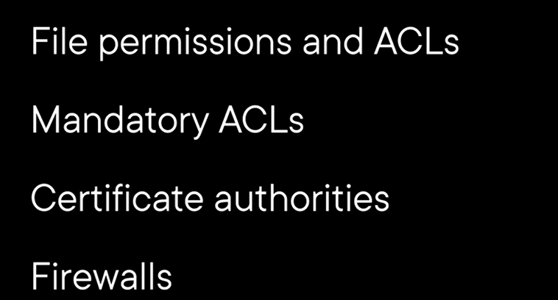

# Chapter 2: Securing Linux Systems

## Chapter 2.1: Introducing Linux Security

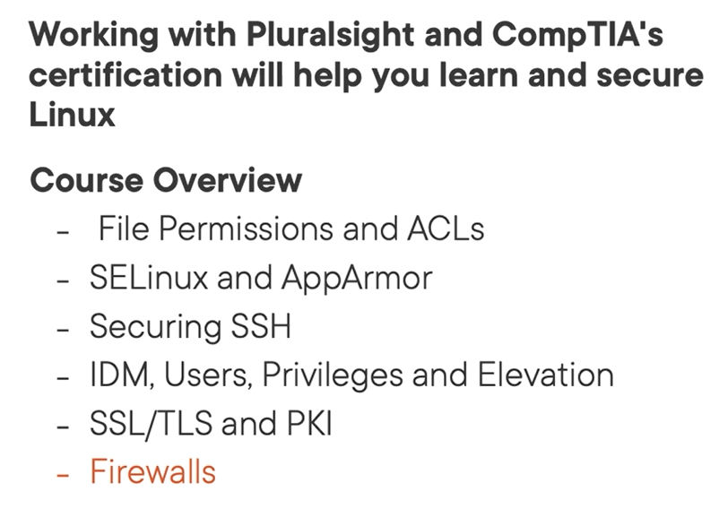

## Chapter 2.2: Web Server Startup and Permissions

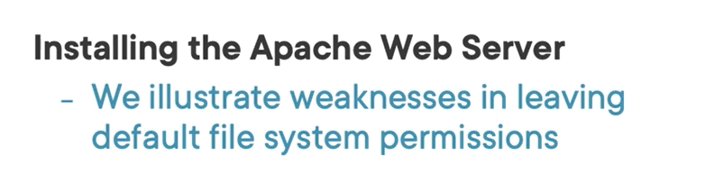

Most of Linux distribution have a default permission on /var/www/html cause some problem.

## Chapter 2.3: Documentation May Not Always Be Correct

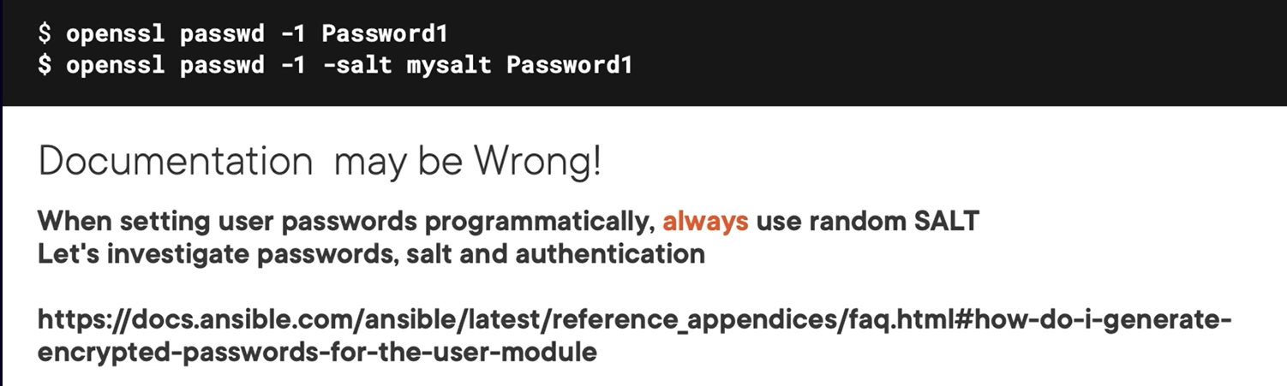

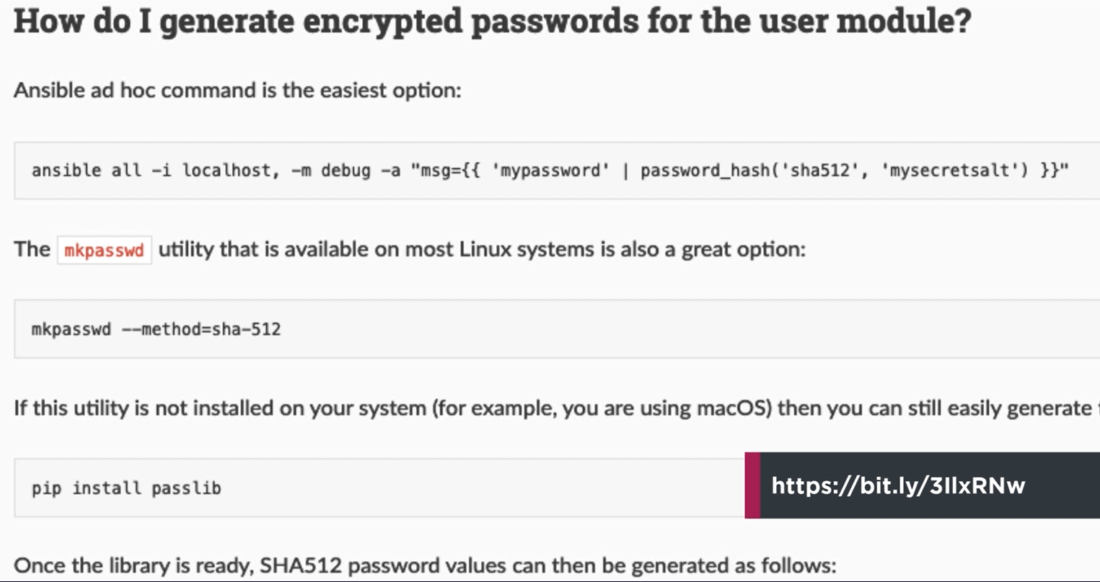

Note: you shouldn’t use salt value it will be more secure than use default/same salt value for many user

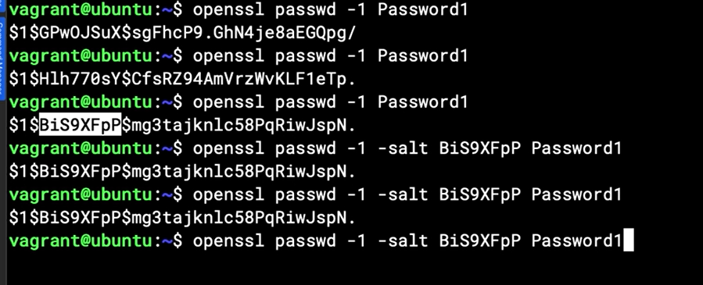

Note: just supplying salt value when keeping authentication process, not supplying salt value when generate password. Without supply the salt, we will get the random salt value

## Chapter 2.4: Certificate Trusts

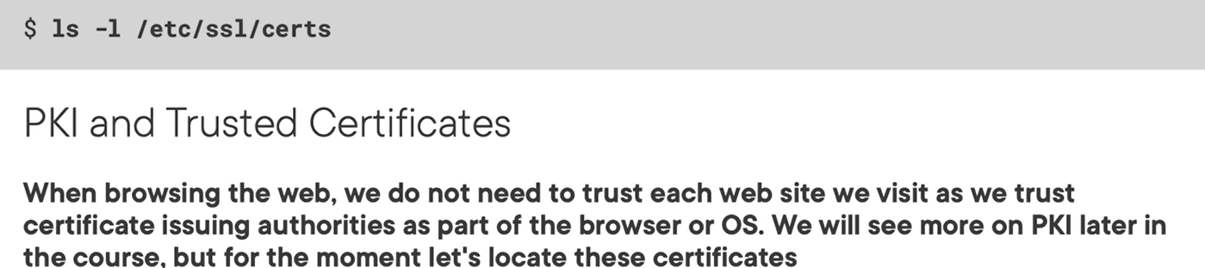

# Chapter 3: Understanding the File Mode or Permissions

## Chapter 3.1: Welcome to the Linux File Mode

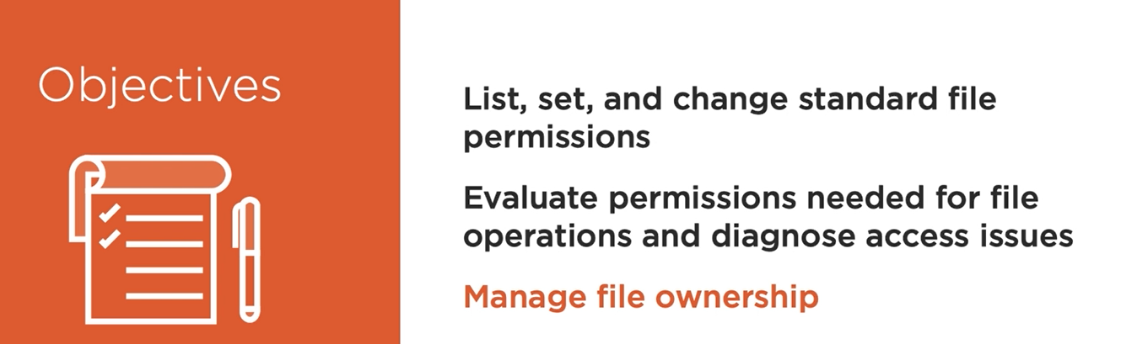

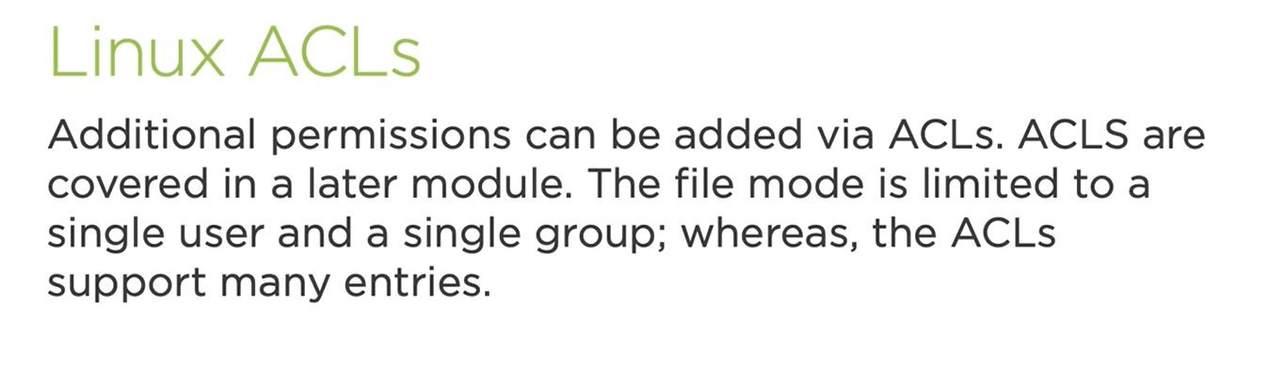

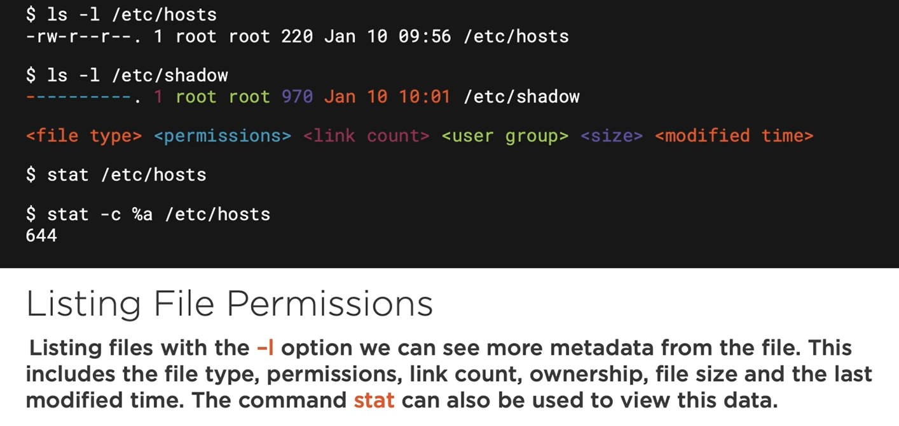

Some of file types in linux

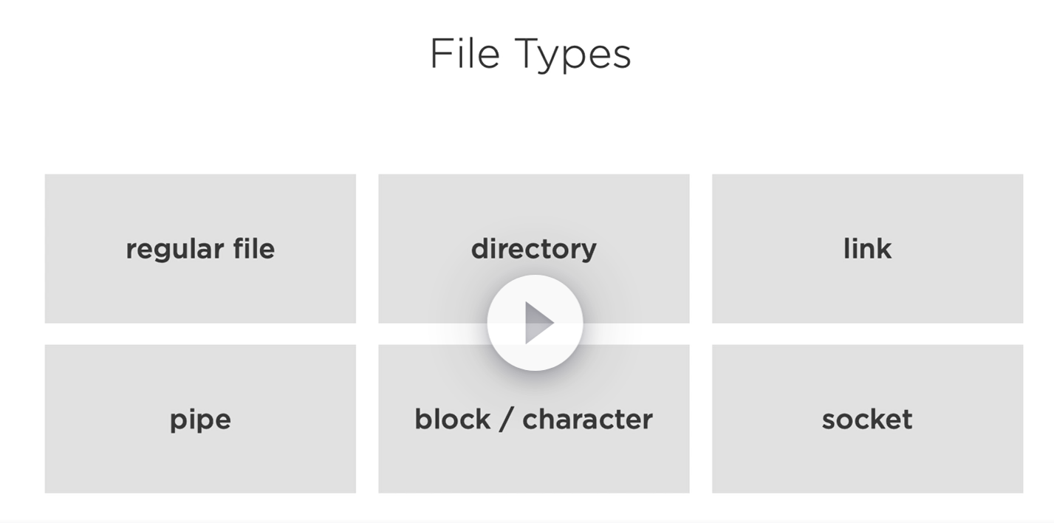

## Chapter 3.2: Working with the Umask and Default Permissions

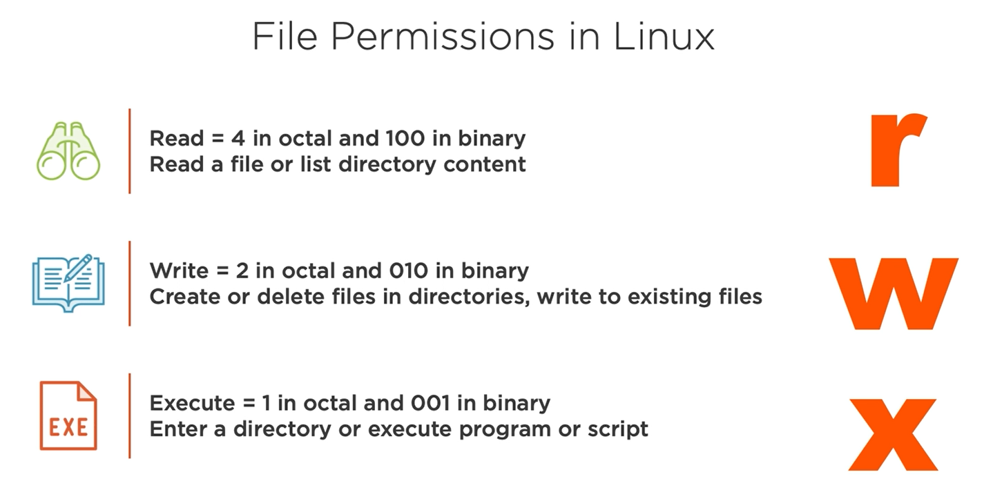

Umask command and default permission is 0002

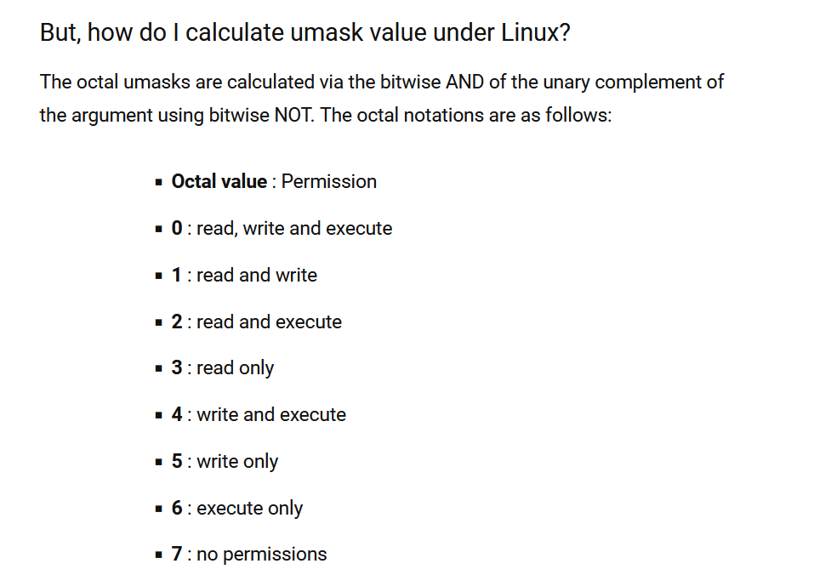

You can calculate umask value by default number of dir or file subtract permission number of dir or file respectively.

## Chapter 3.4: Understanding the Command Chmod

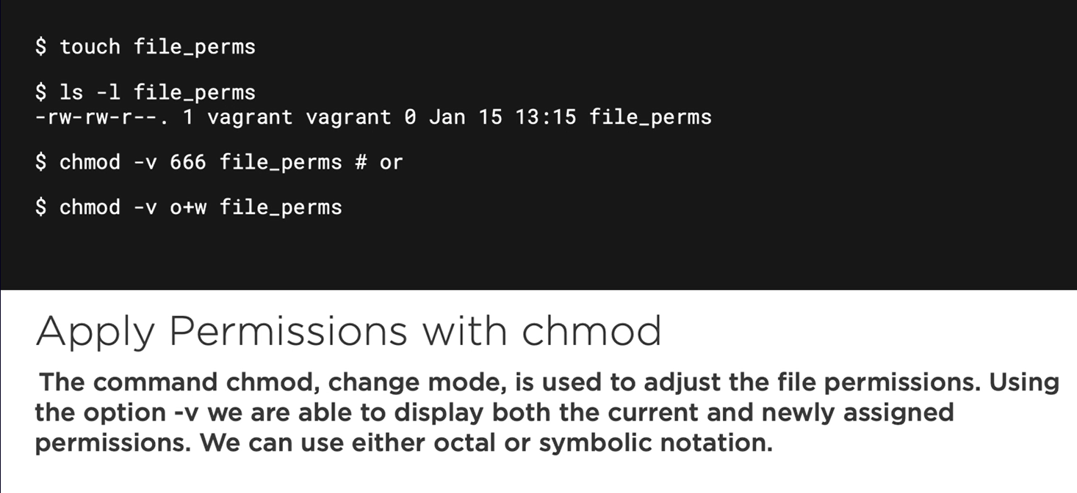

Note: option -v will detail display permission

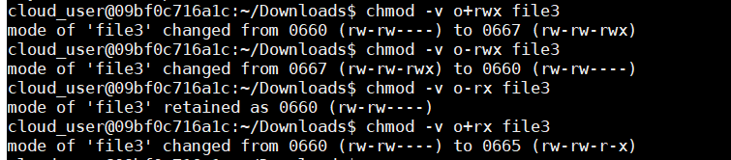

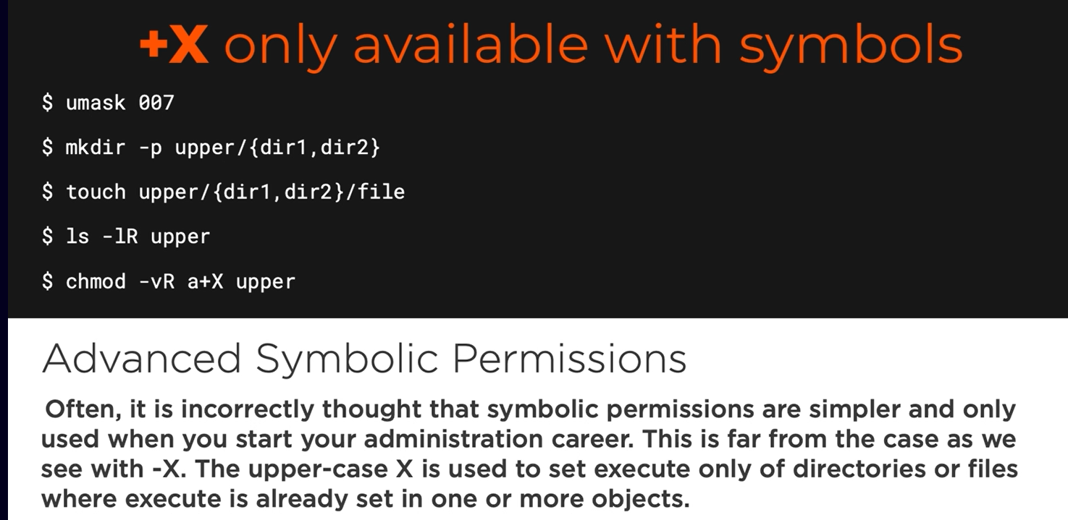

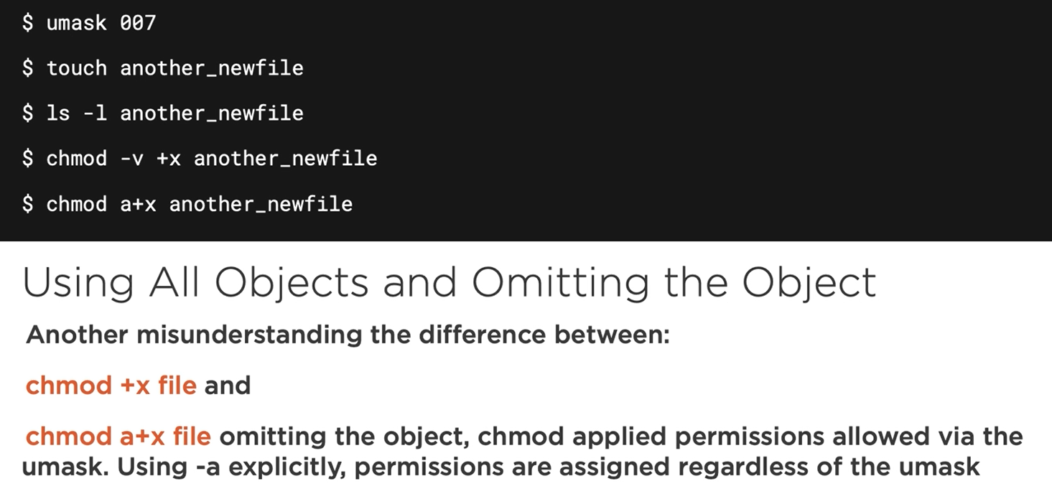

## Chapter 3.5: Using Chmod to Manage Permissions

## Chapter 3.6: Using Advanced Symbolic Notation

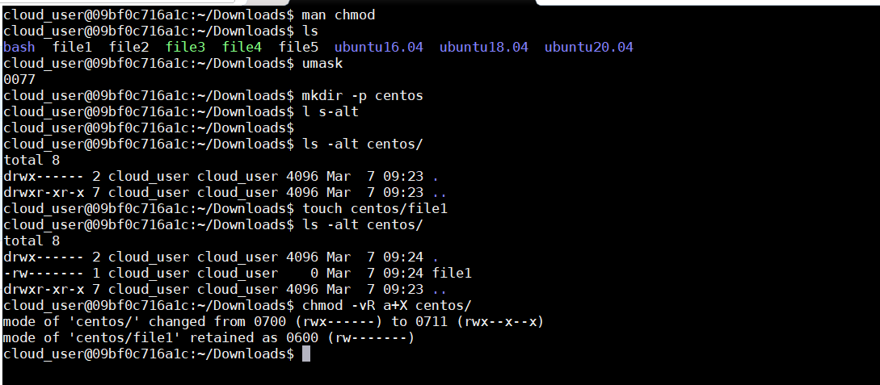

## Chapter 3.7: Changing File Ownership

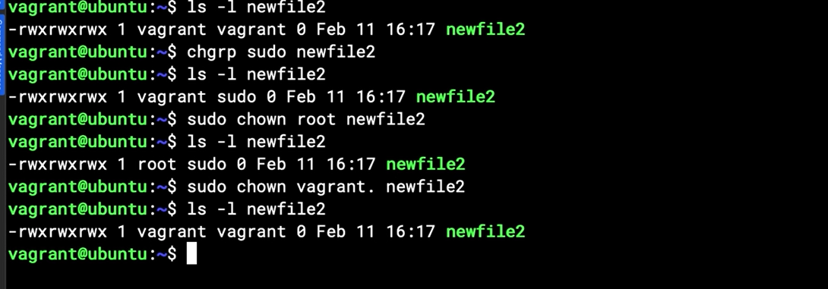

## Chapter 3.8: Setting Execute Only on a Directory

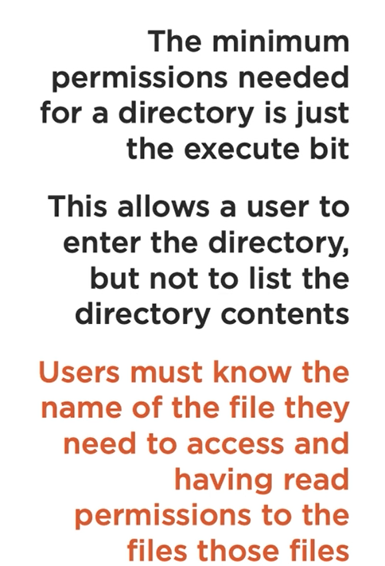

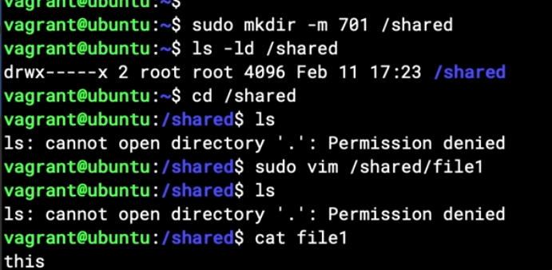

## Chapter 3.9: summary

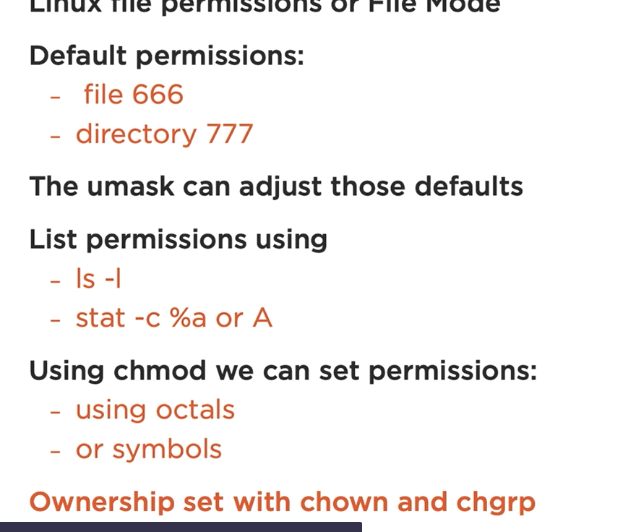

# Chapter 4; Managing Special File Permissions

## Chapter 4.1: What Are Special Permissions

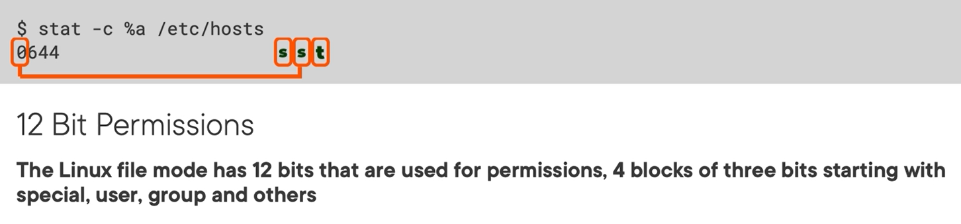

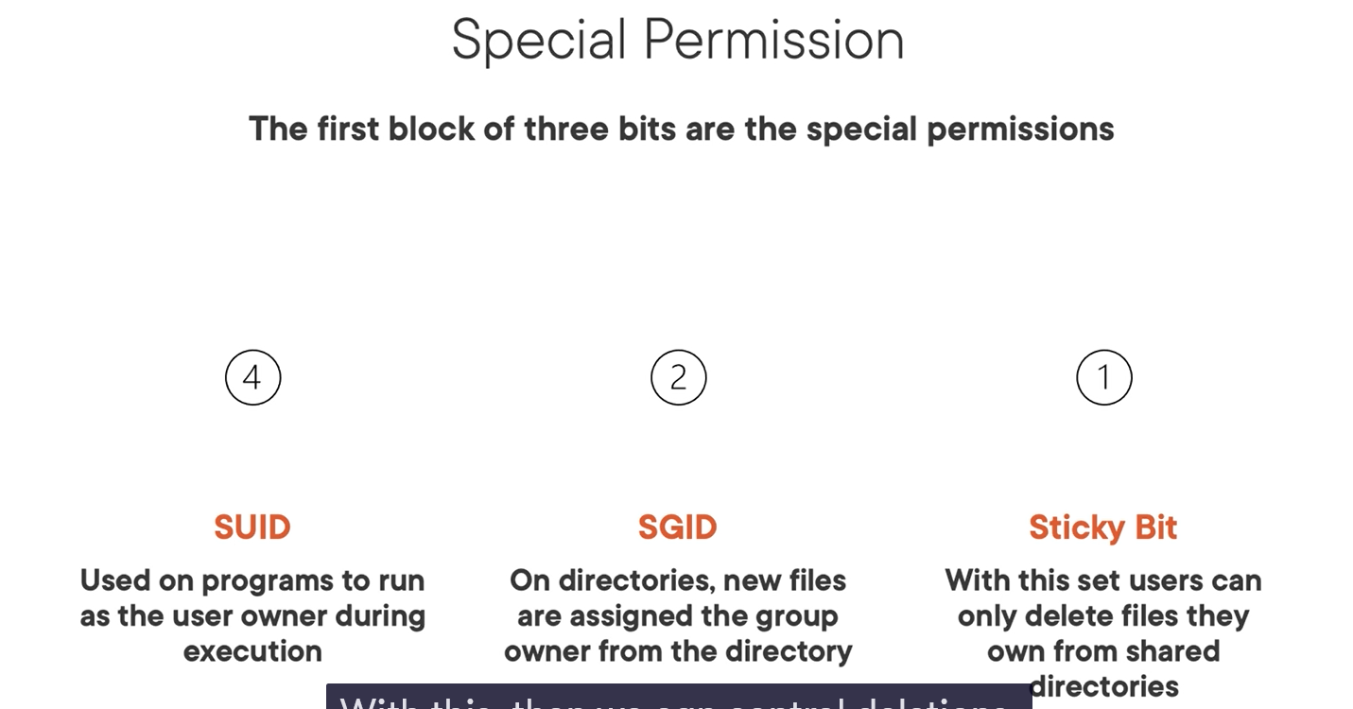

## Chapter 4.2: finding list and setting special permissions

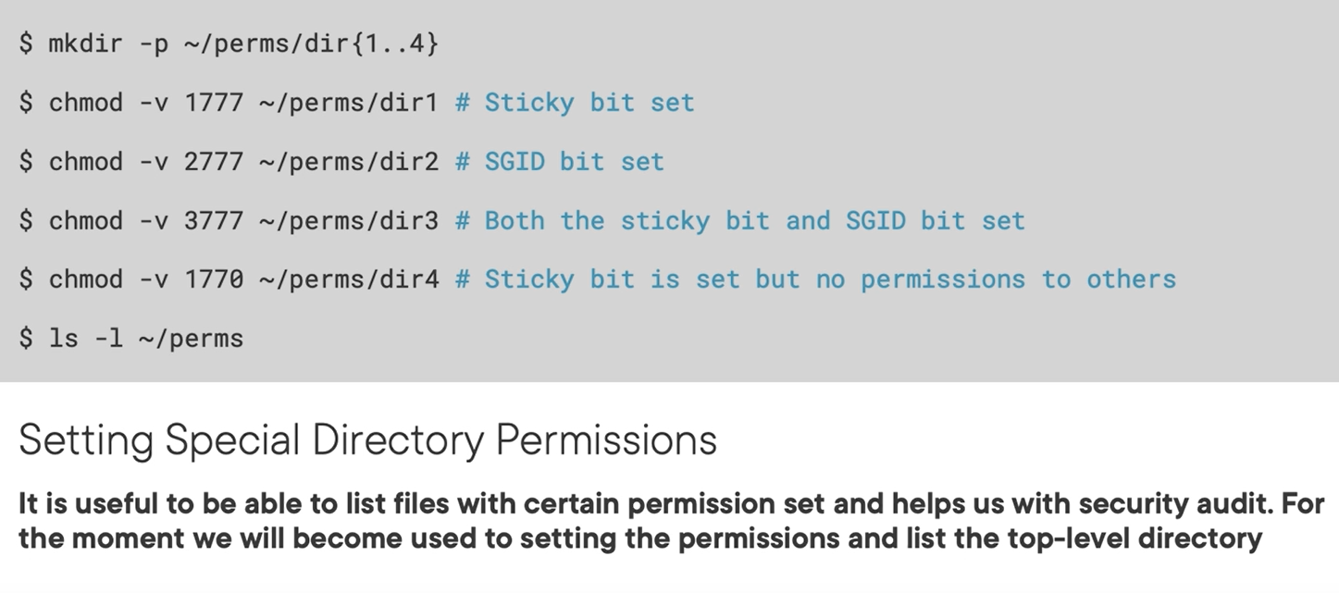

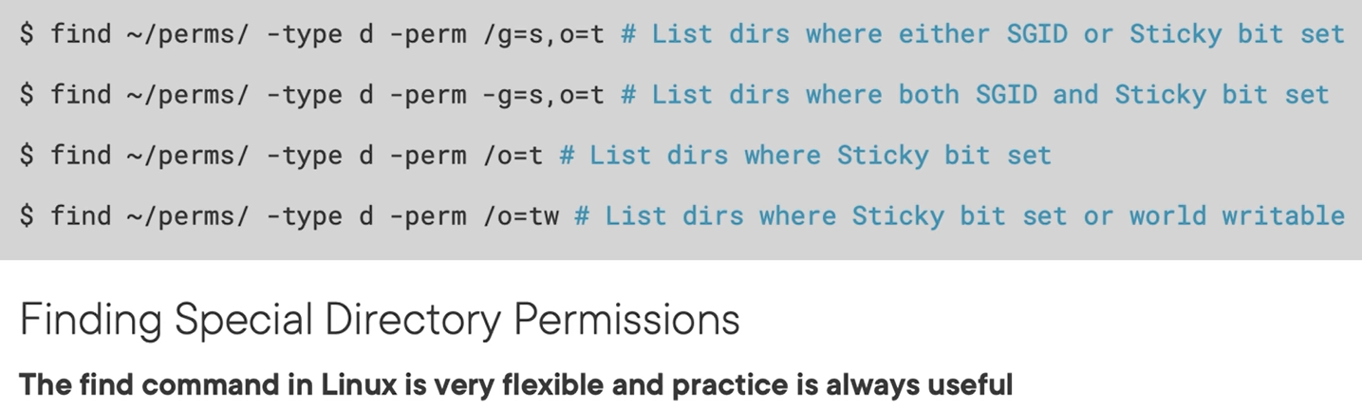

Demo:

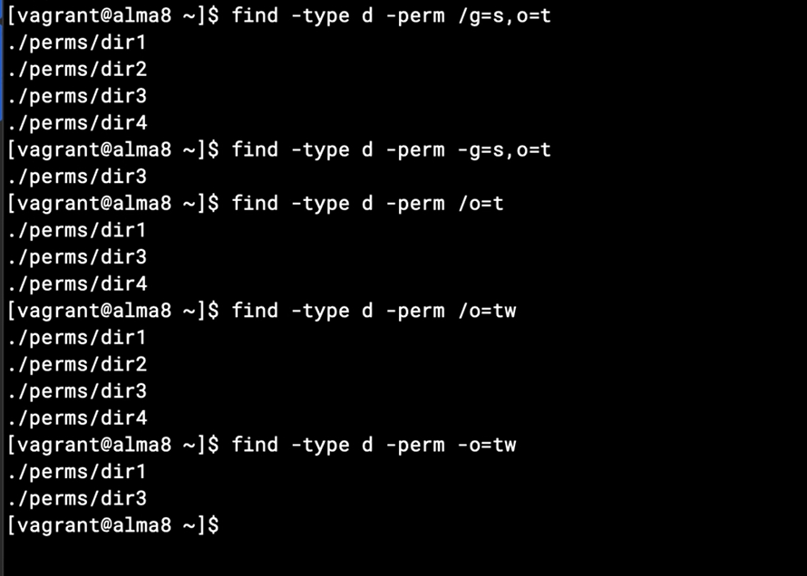

## Chapter 4.3: Using the Sticky Bit to Prevent Deletions

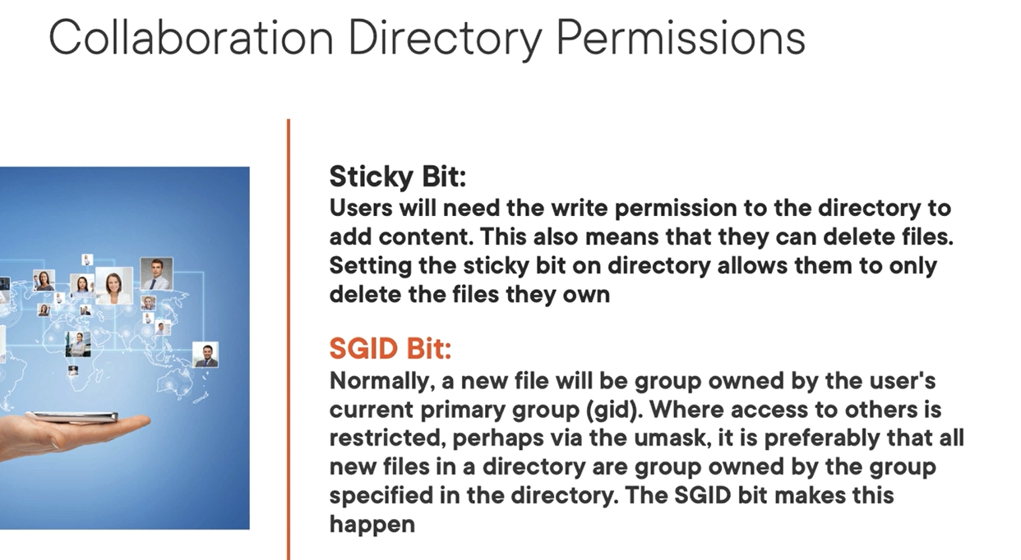

## Chapter 4.4: Setting the SGID Bit on Directories

## Chapter 4.5: Showing Collaborative Permissions with the Apache Web Server

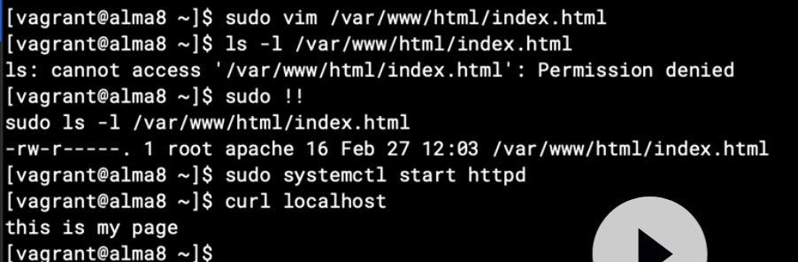

## Chapter 4.6: Special Permission on Executables

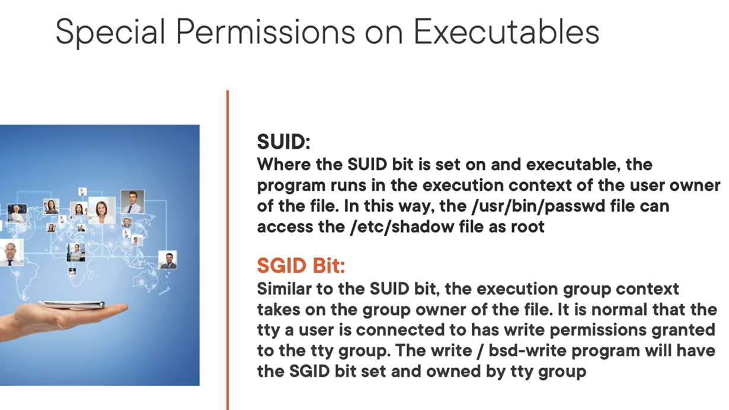

## Chapter 4.7: Using Linux Capabilities

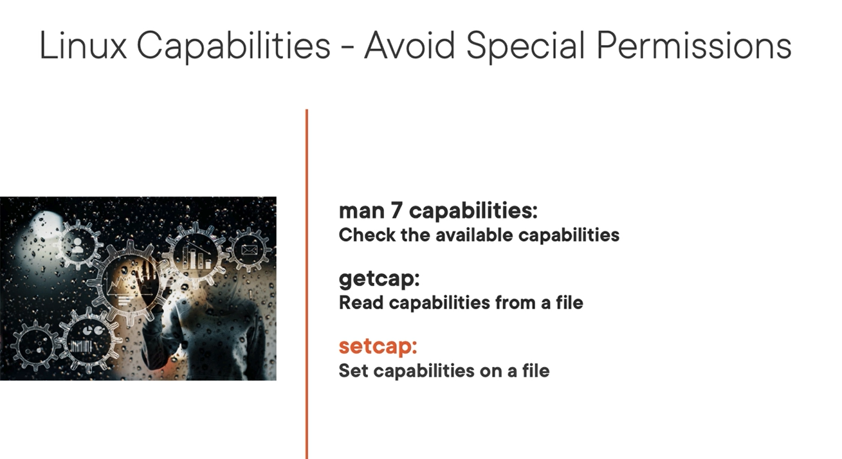

Check capabilities

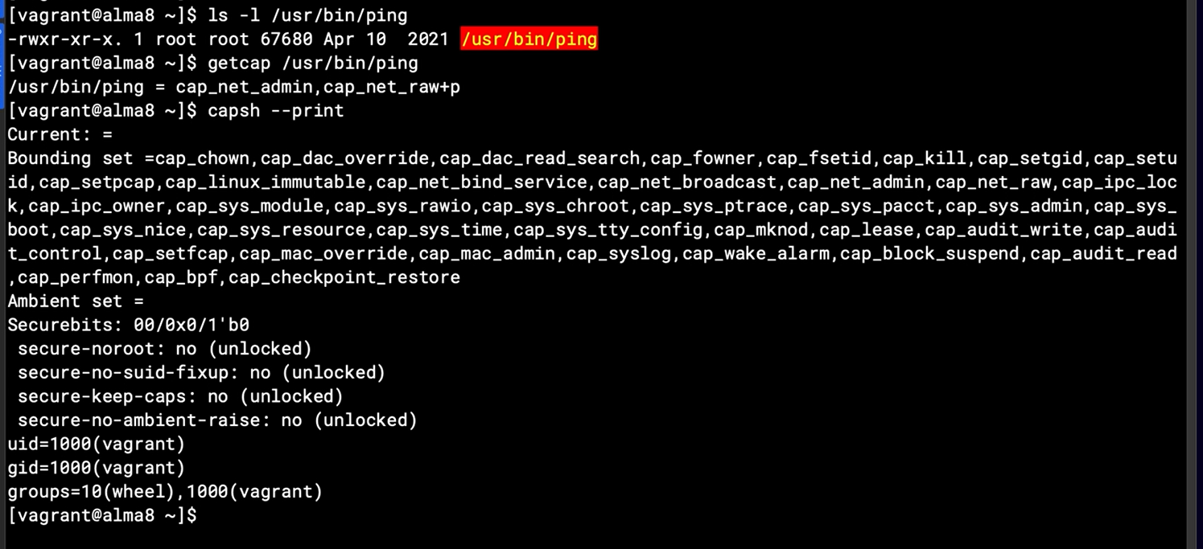

## Chapter 4.8: Summary

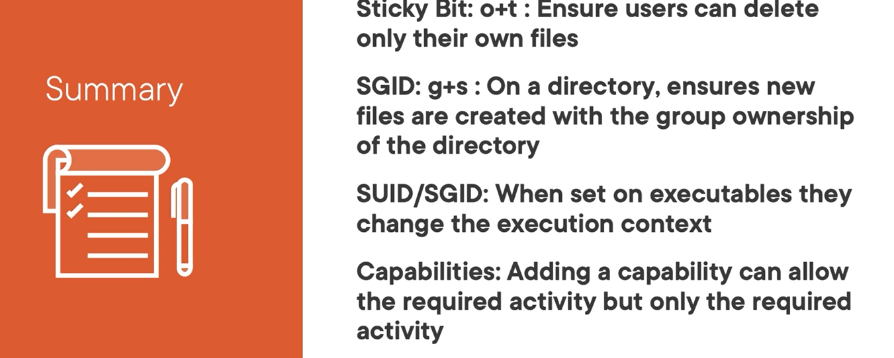

# Chapter 5: Extending the File Mode with ACLS

## Chapter 5.1: Understanding the File Mode Limits

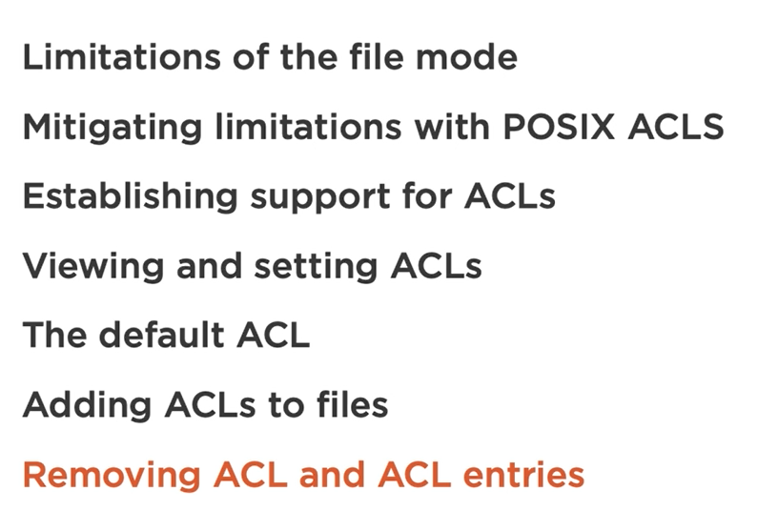

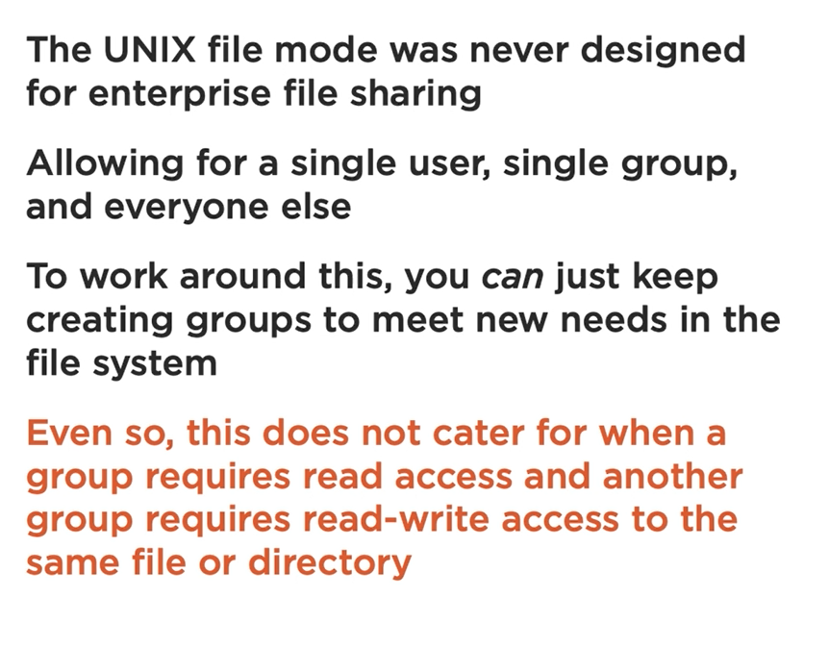

Posix ACLs

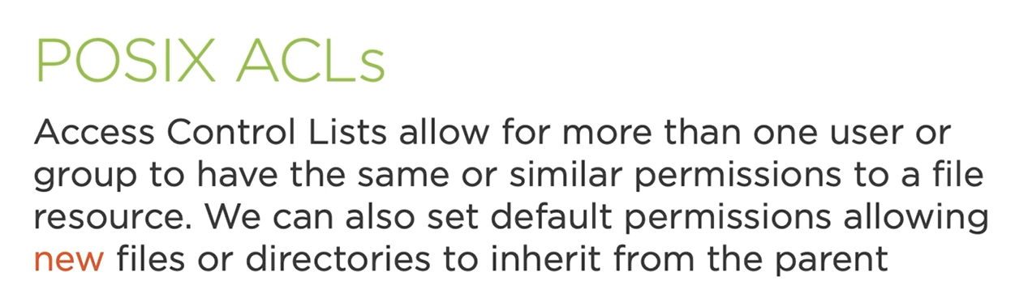

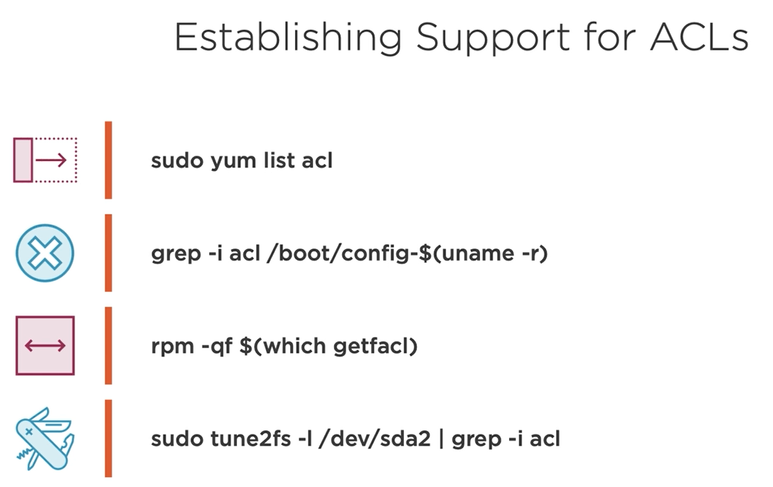

## Chapter 5.2: Checking for ACL Support

Checking ACL support on system

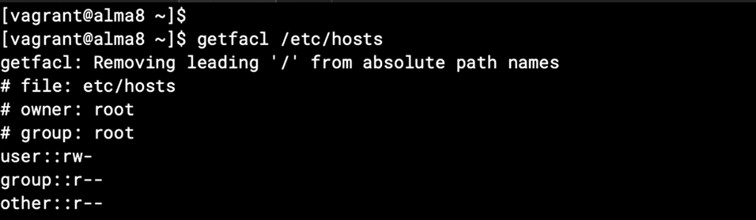

Using some command “getfacl” to check acl rule on certain file for sure

Above screen we have only standard mode so it indicate that no acl mode in this system.

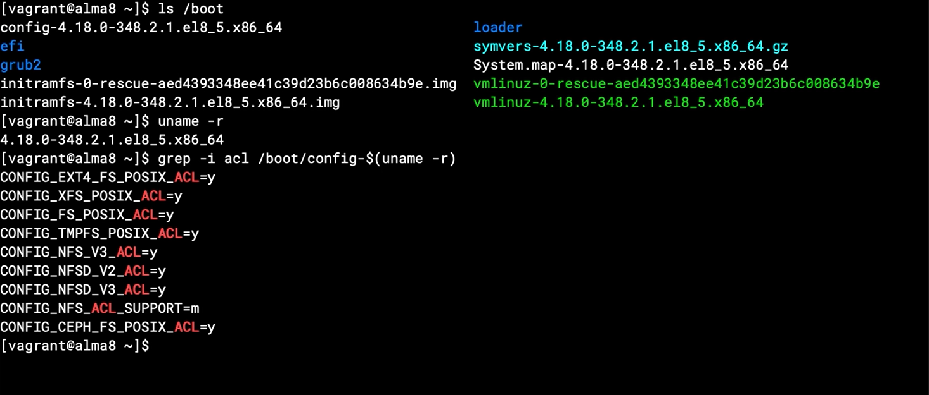

Checking more file system which is used on this system for suring it support xfs by default

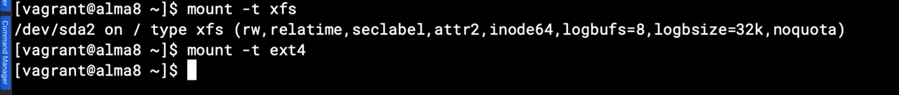

Noe: xfs file system supported acl by default, ext4 also supported acl but need to enable it.

## Chapter 5.3: Configuring HTTPD Securely with ACLS

Note: the apache/http services will be not affect if already installed before, you need reinstall then take affectively.

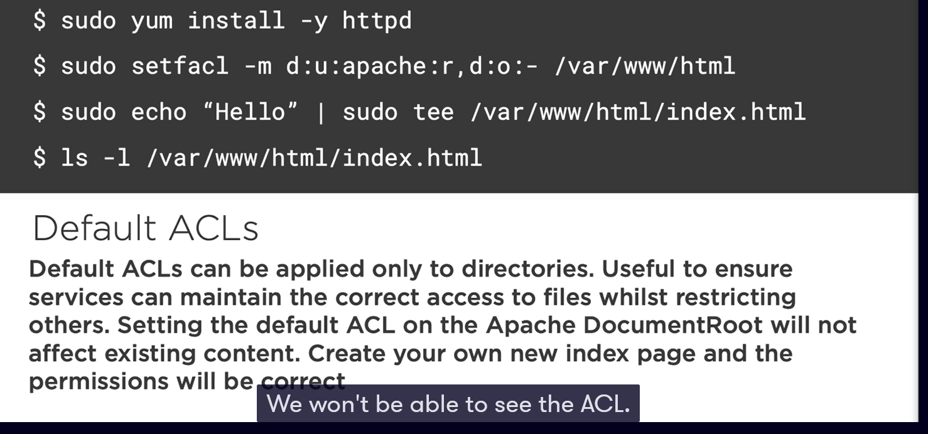

Notation:

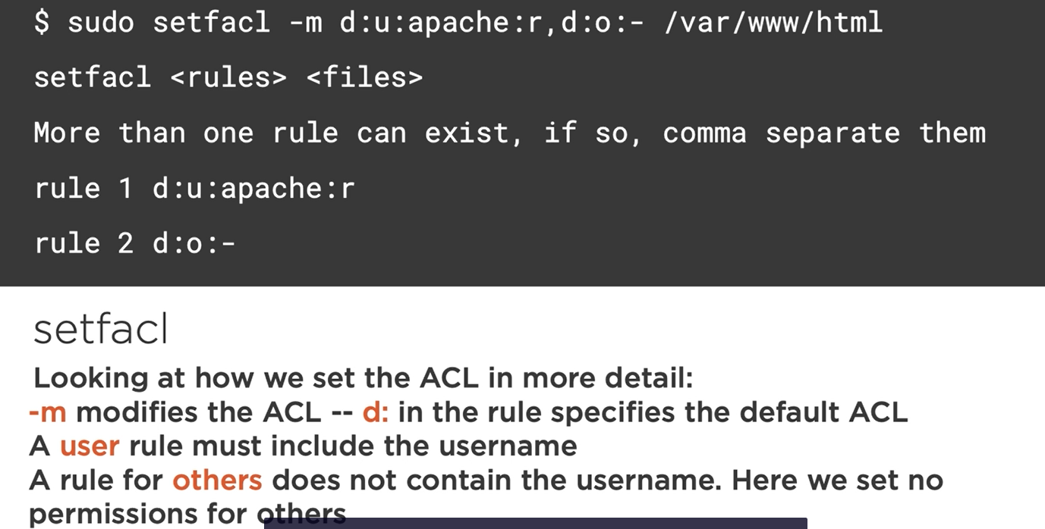

Checking acl are applying

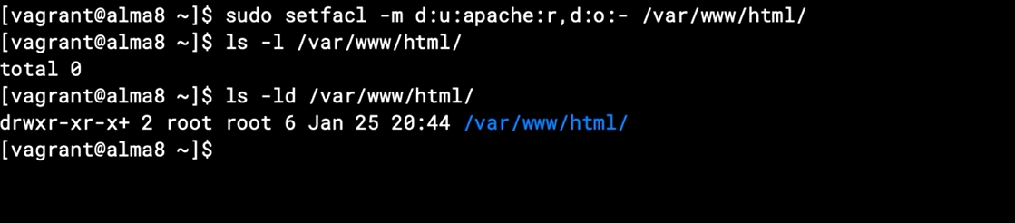

Note: the plus sign at the end indicate that extend file mode acl being applied.

If you want to read that you can “getfacl” command

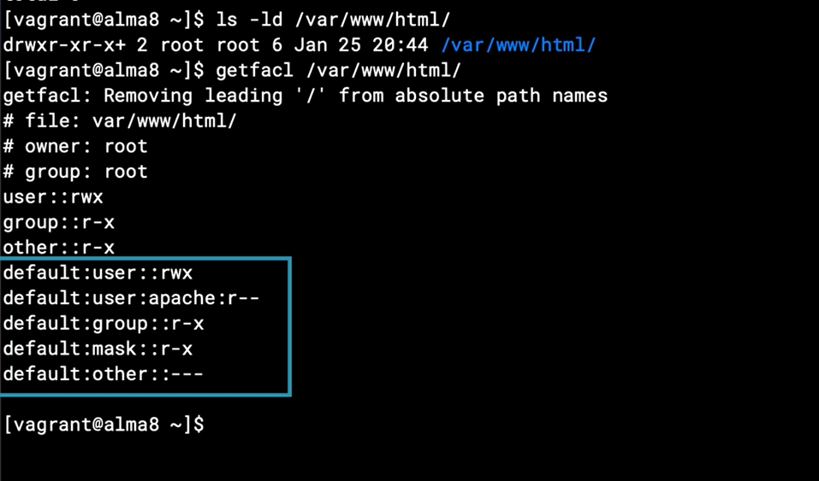

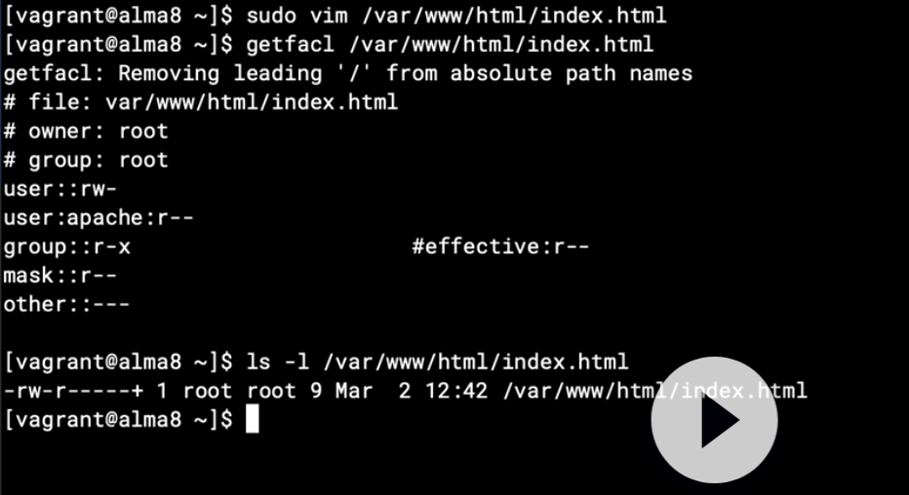

Note: when you are using acl, don’t care about the umask value

## Chapter 5.4: Understanding ACLS

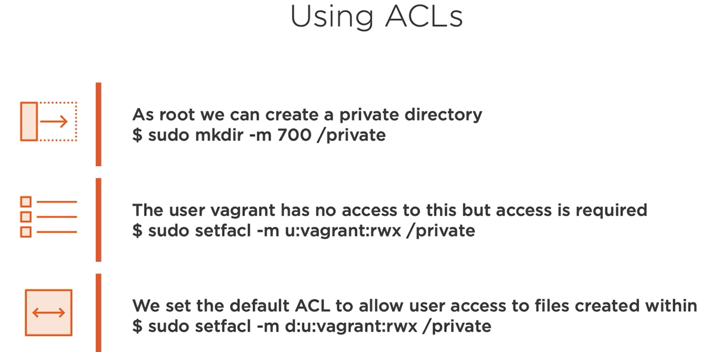

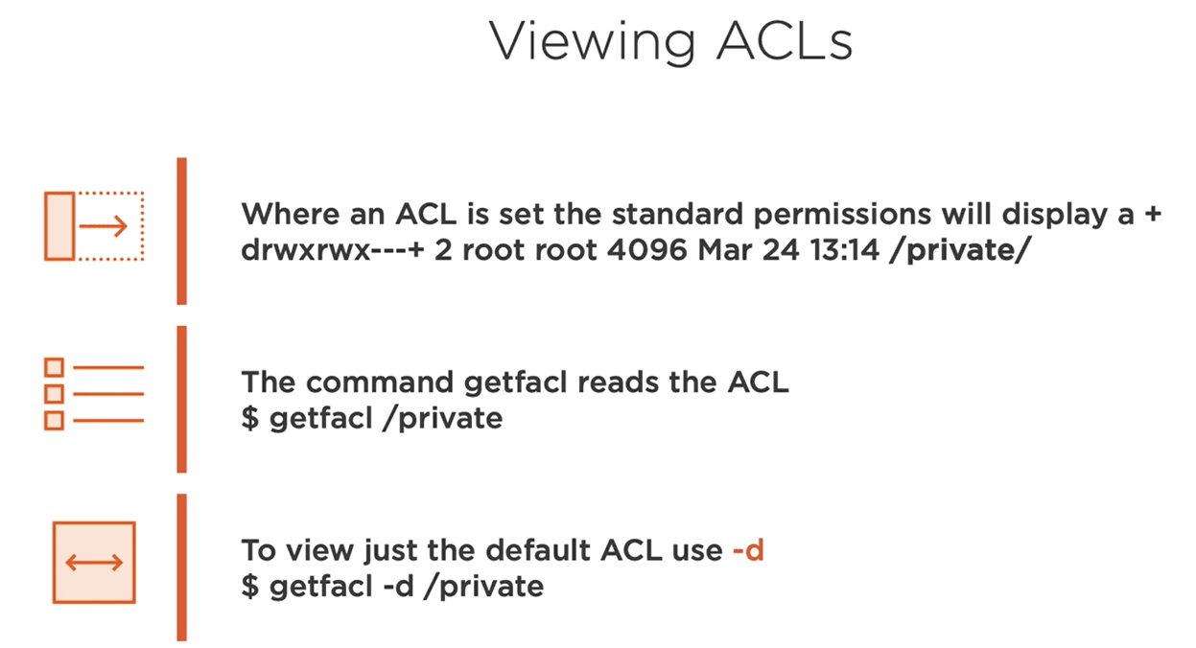

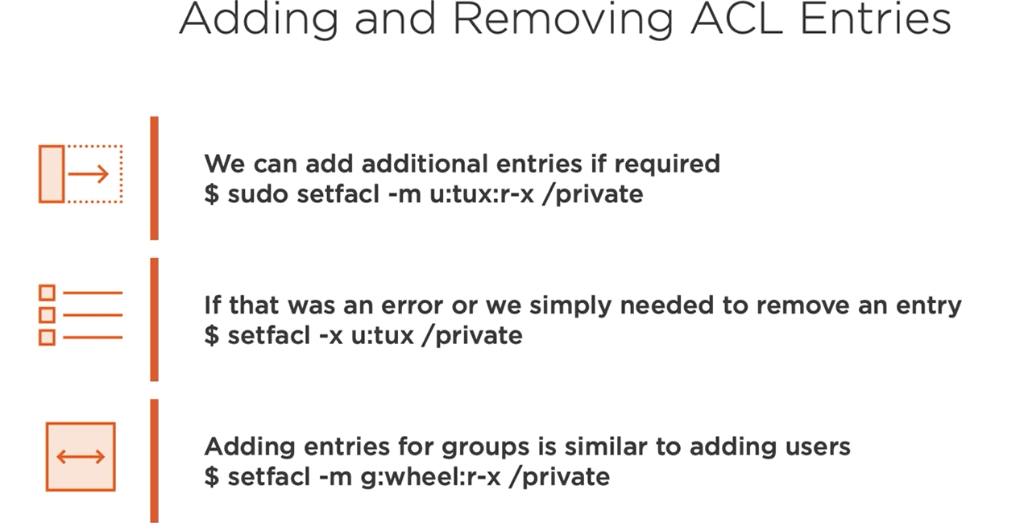

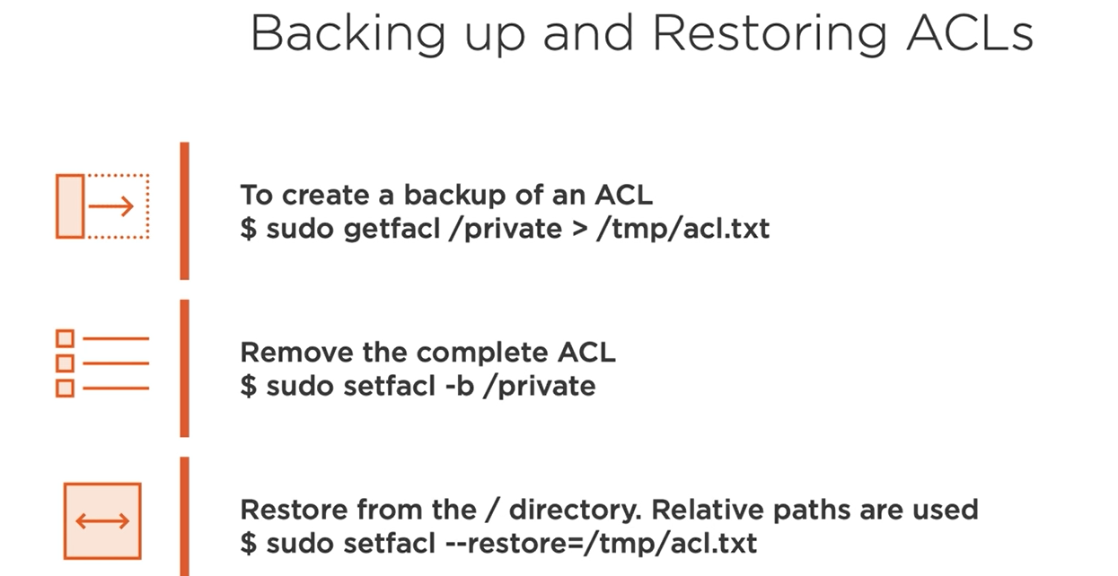

## Chapter 5.5: Working with ACLS

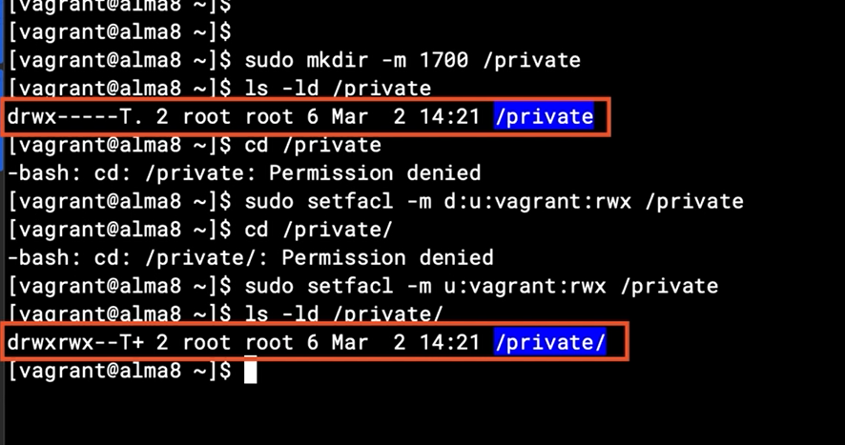

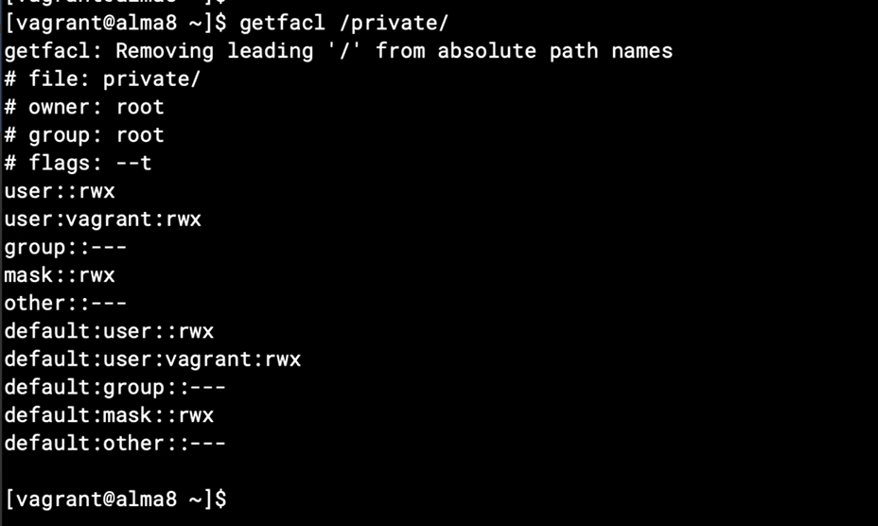

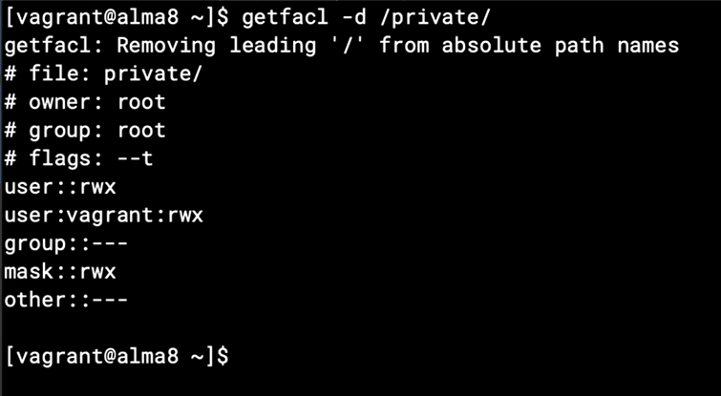

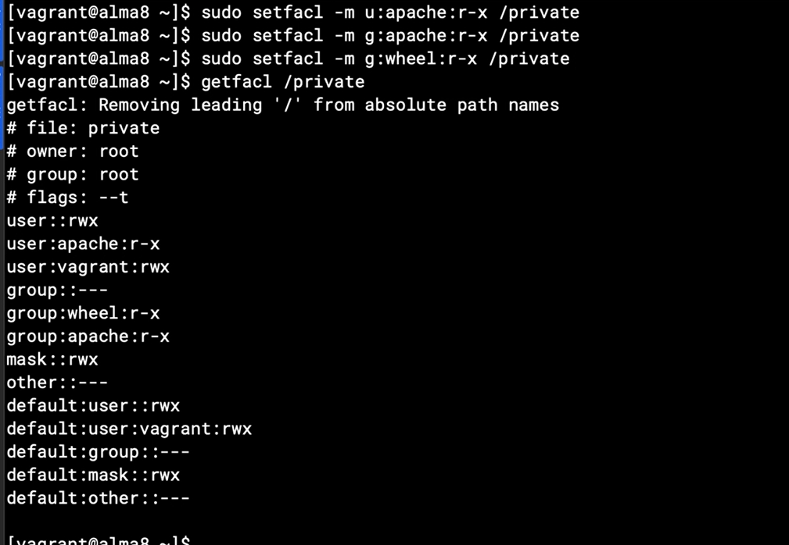

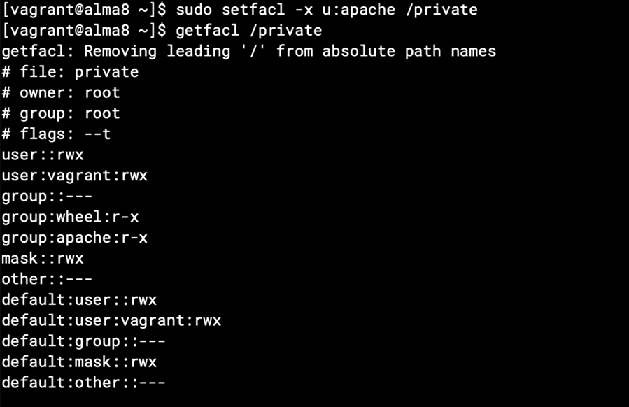

Delete all acl

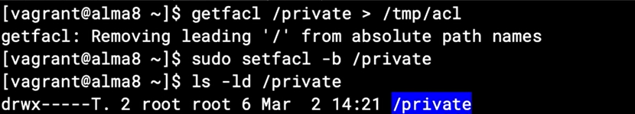

Restore acl

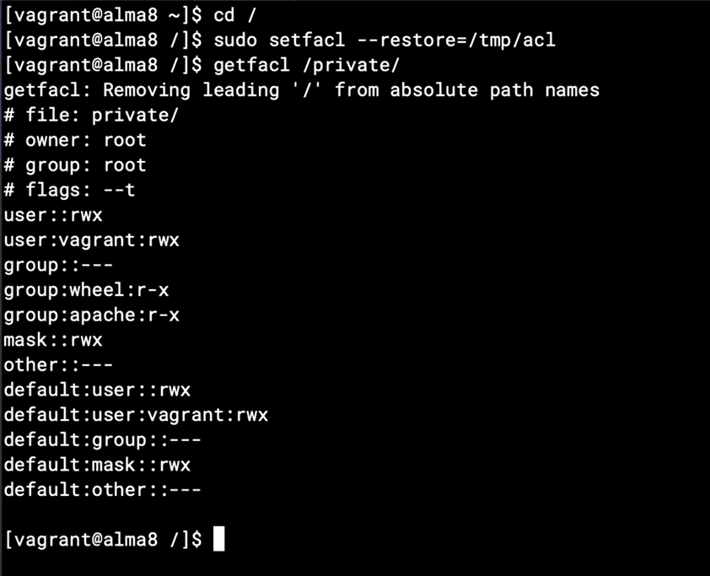

# Chapter 6: Implementing SELinux

## Chapter 6.1: Welcome to SELinux

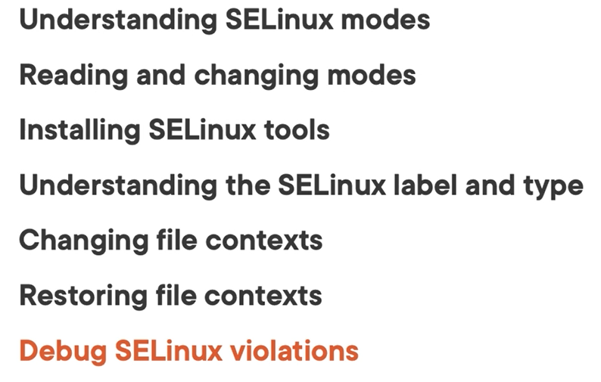

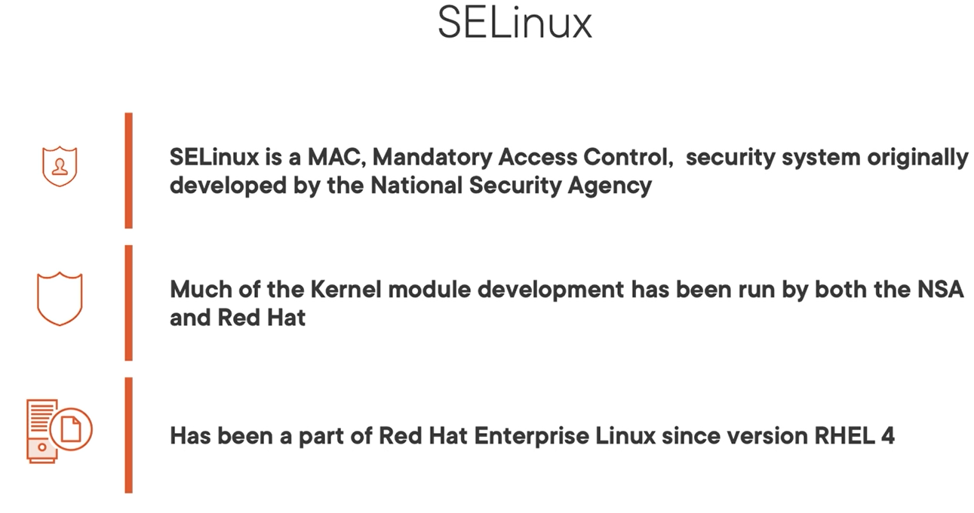

Note: with SELINUX you can control root access to your system

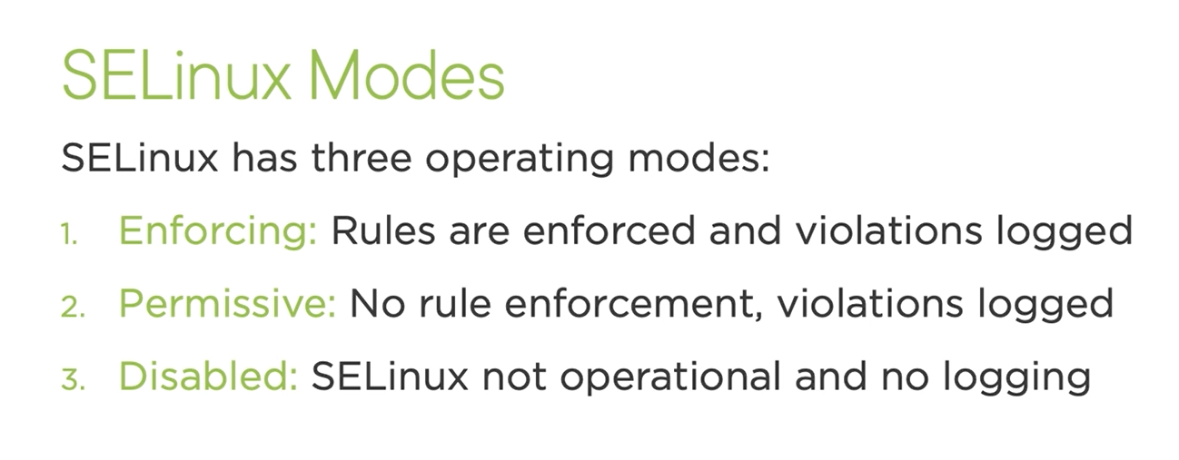

Enforcing: recommended. It enforce rule and violation actions will log into audit log

Permissive: no rule being enforced, violations logged

Disabled: not recommended, and have no logging.

## Chapter 6.2: Managing SELinux Modes

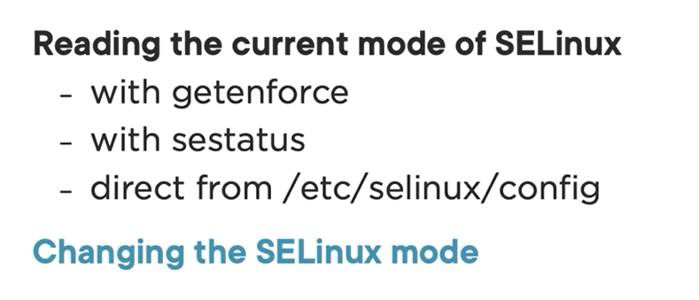

To change to permissive in SELINUX you can do via command line

But to disable you must config on system selinux file directly then reboot to take effectively.

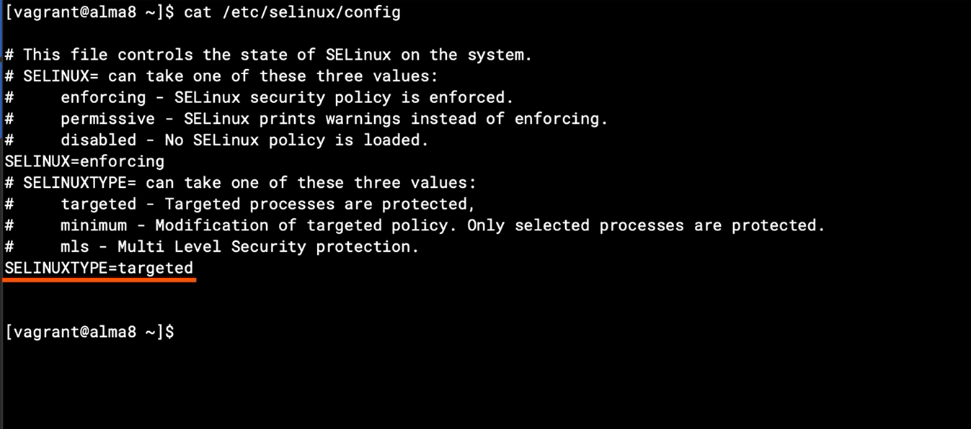

Change context for test

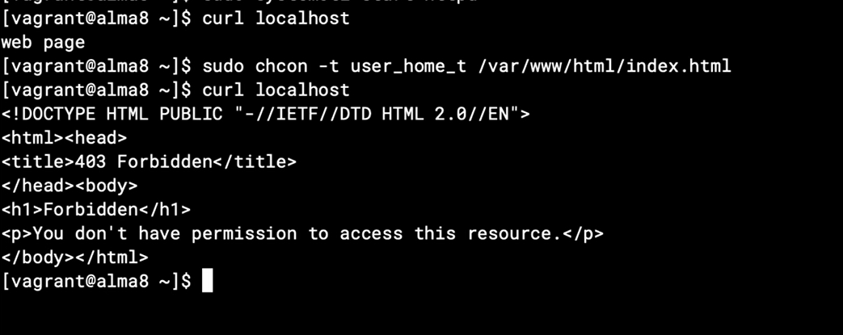

Check audit log for violation

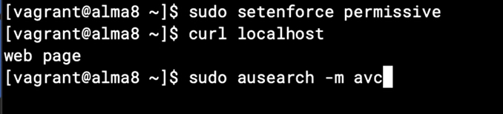

-m: module

Avc: access vector control

Look at the final line

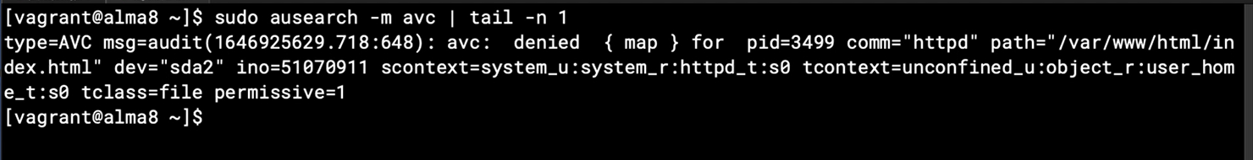

Change context again



## Chapter 6.3: Configuring SeLinux Booleans

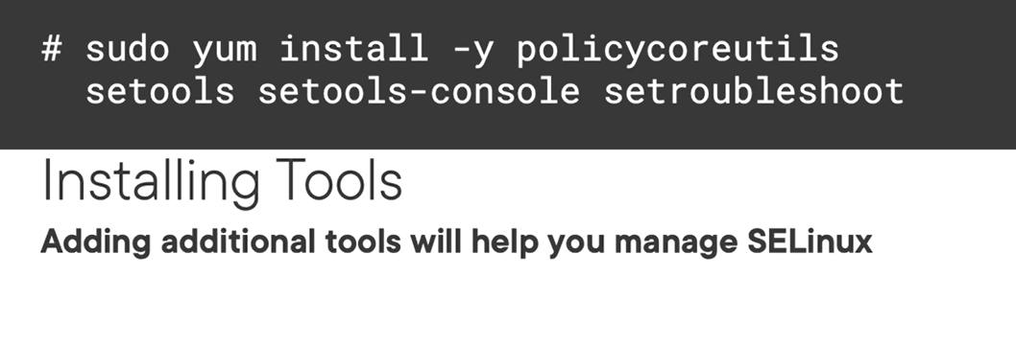

## Chapter 6.4: Configuring SELinux Booleans

You can adding additional tools for helping you manage selinux.

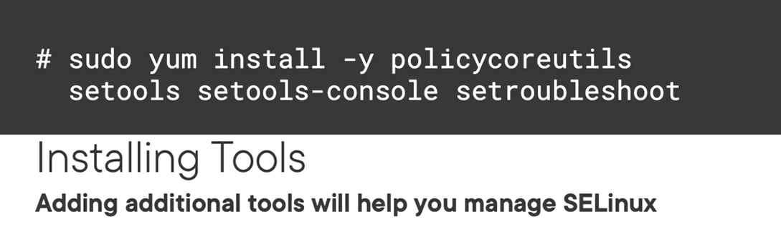

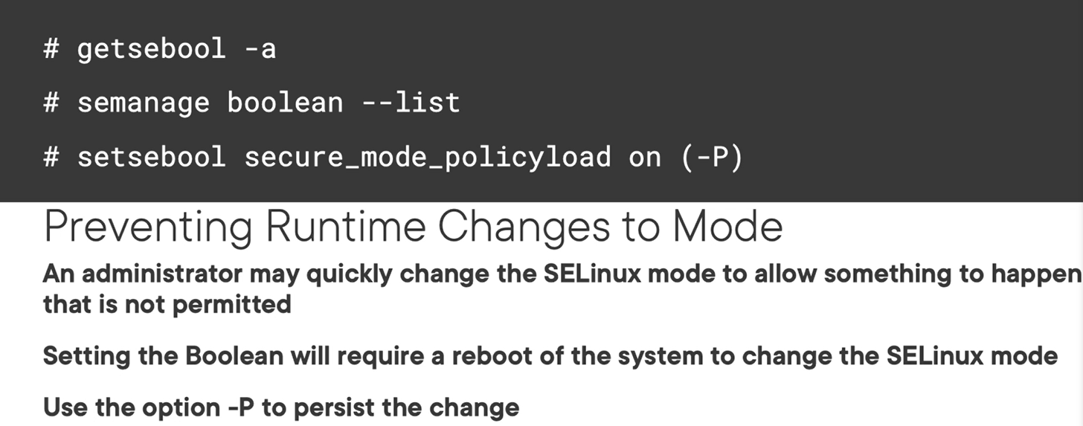

Demo

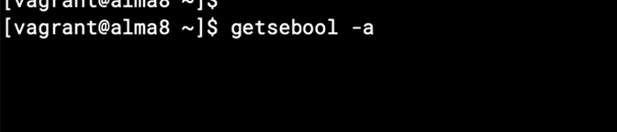

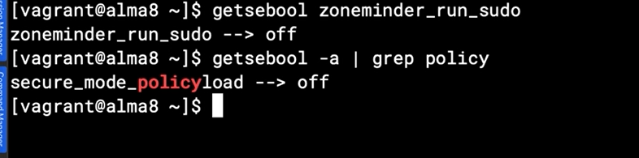

Show infor Boolean rule

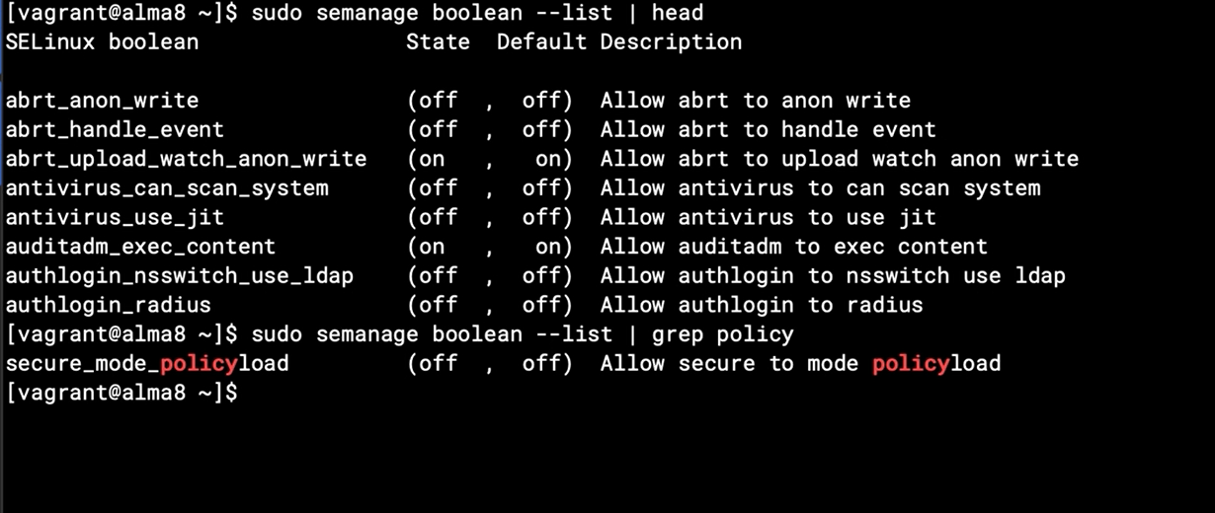

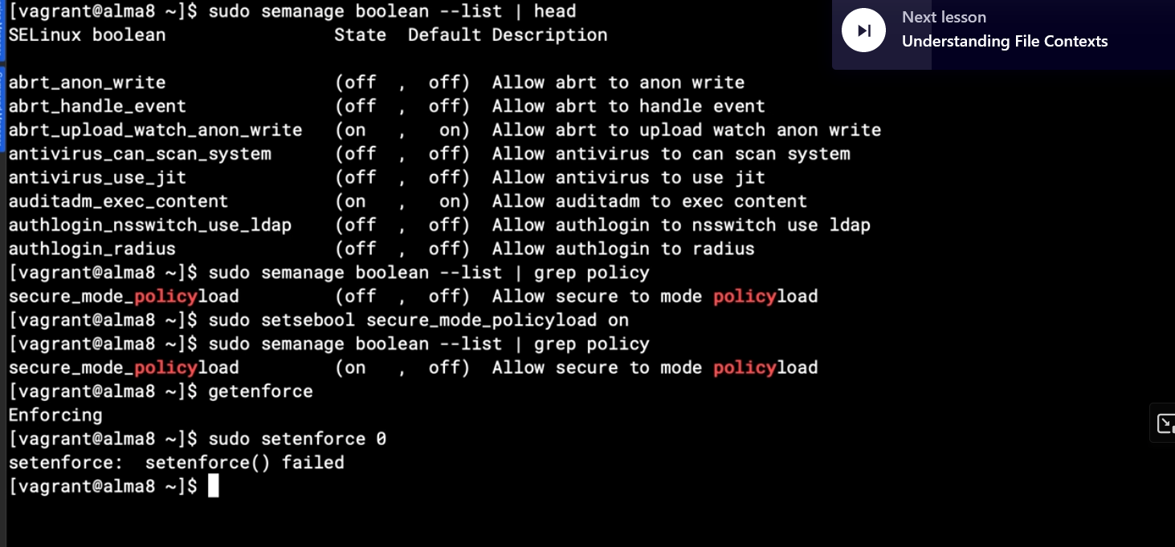

Note: if you want to change default state, need use option -P

## Chapter 6.4: Understanding File Contexts

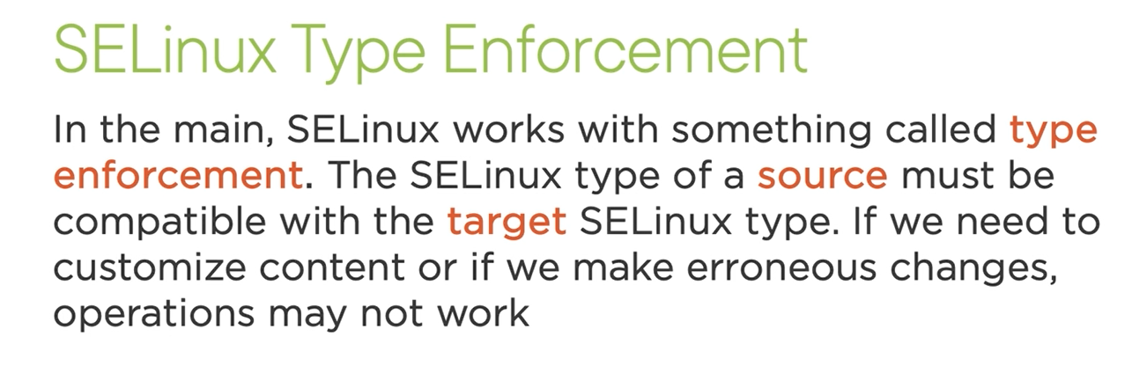

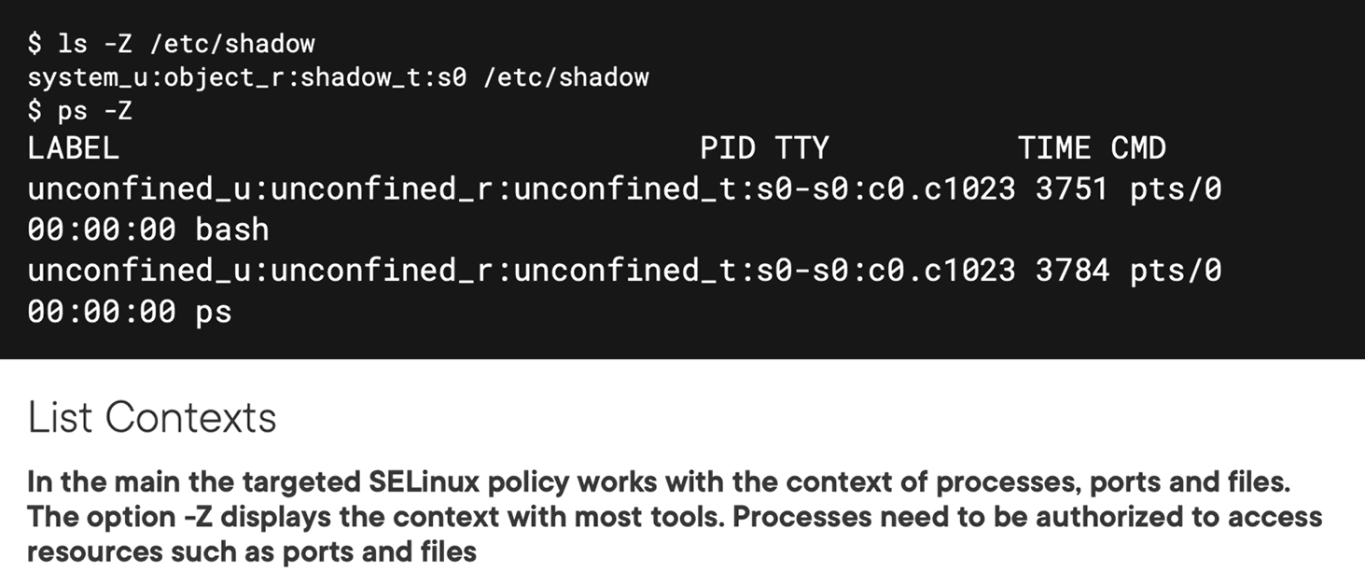

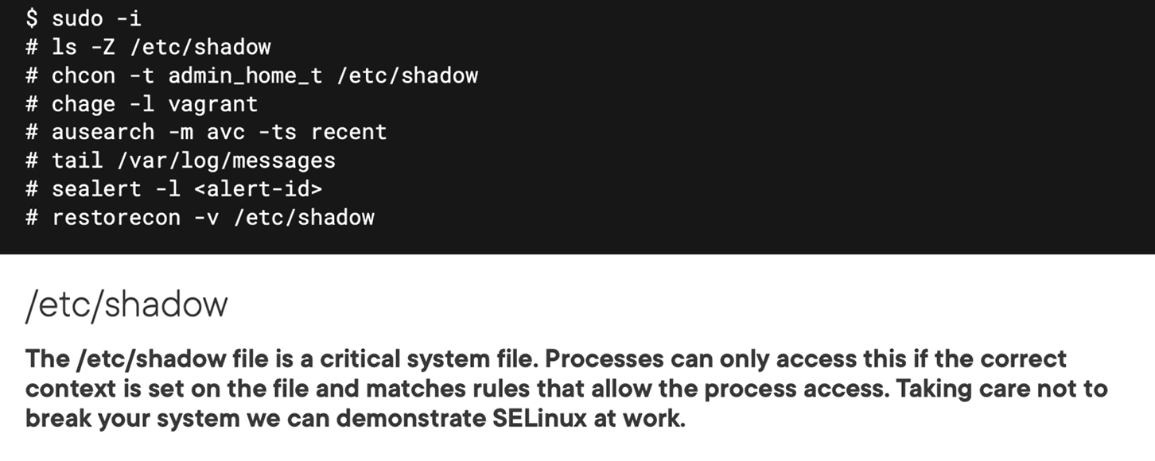

## Chapter 6.5: Managing File Contexts

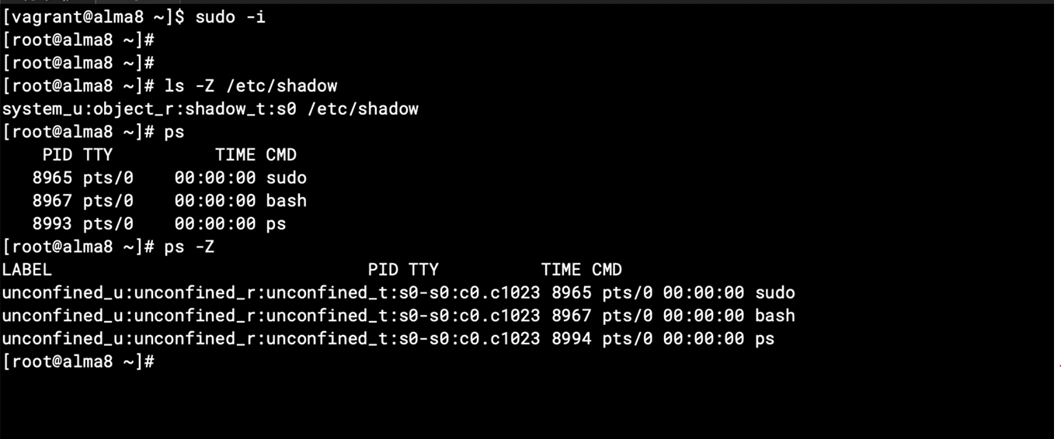

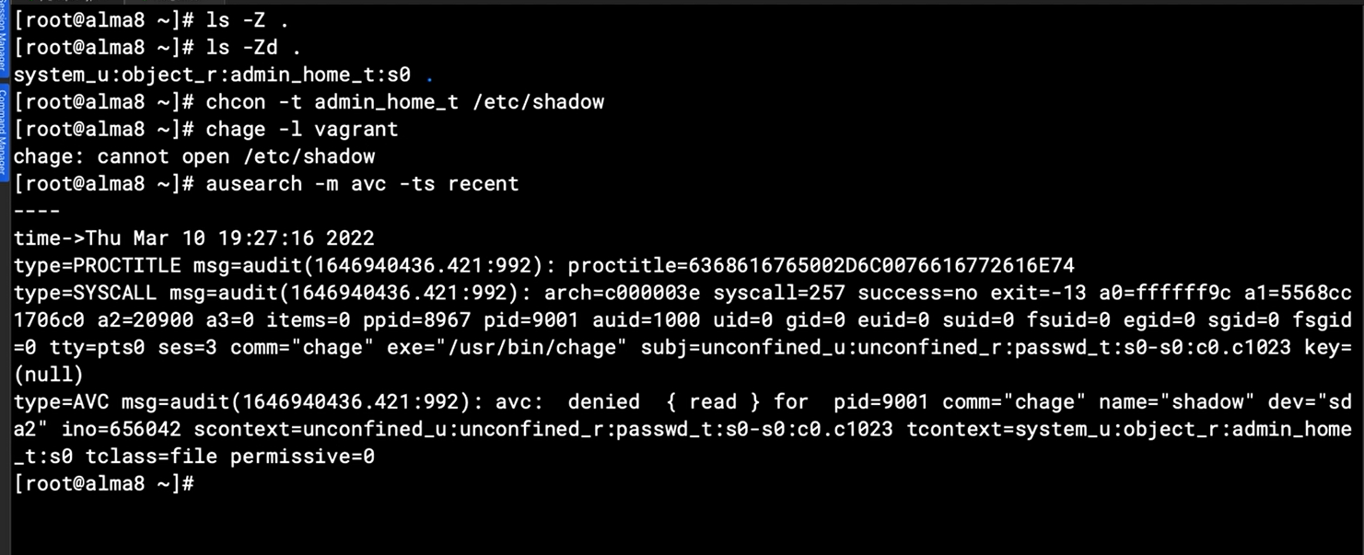

Using sealert for find issue related to selinux

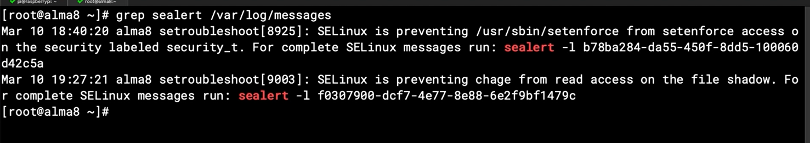

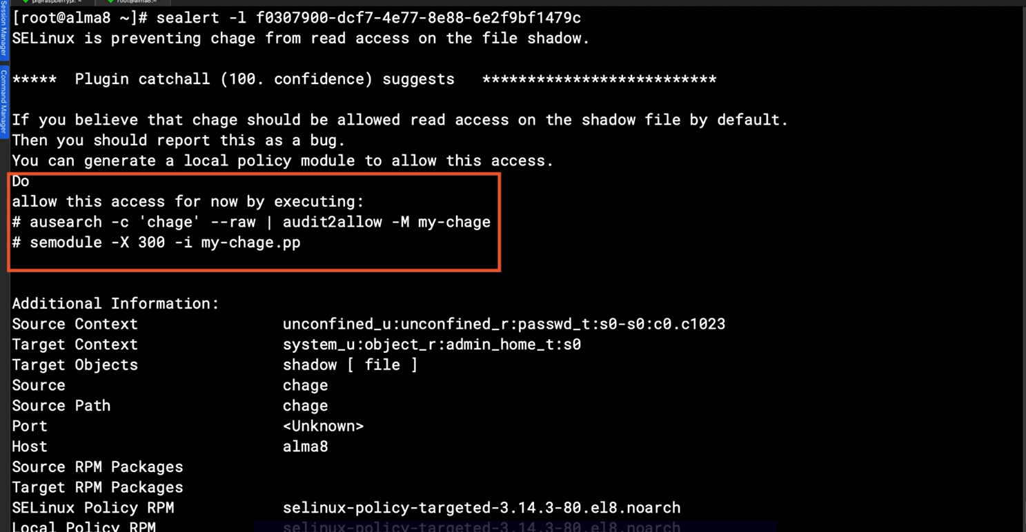

Above log show me some solution to fix but it’s not fix aline. Just restore the context for troubleshooting

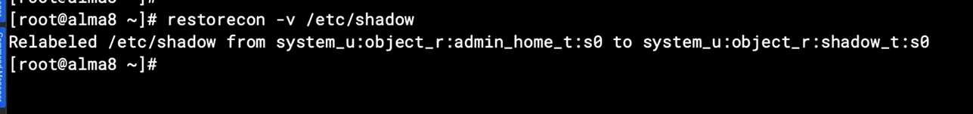

## Chapter 6.6: Relocating User Home Directories

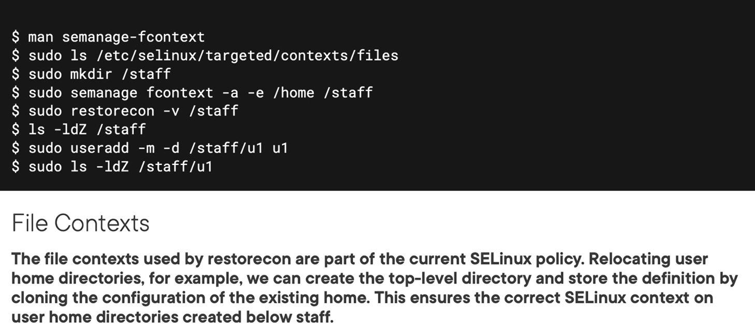



Demo

List file context of home directory, it’s home_root_t context

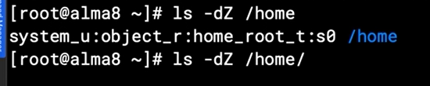

You need to reboot for create new directory for new context as below

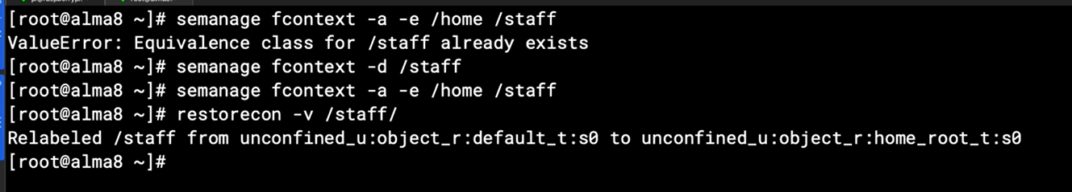

## Summary

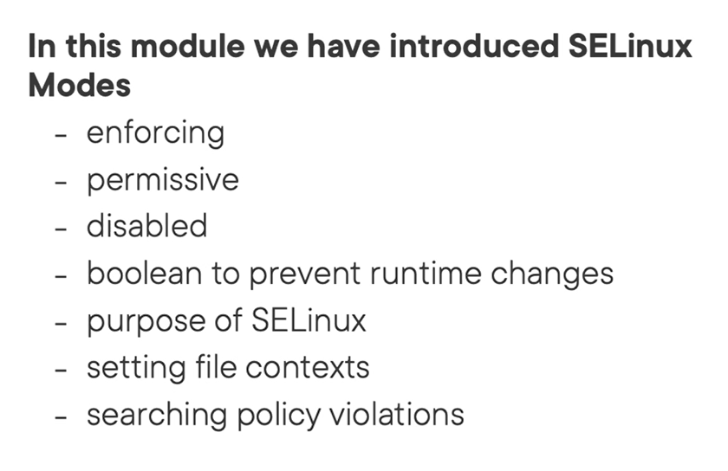

Note:

default mode is enforcing (enforcing rules and logging activity to audit log)

permissive mode don’t enforce rules but logging activity to audit log

disable mode have rule and also log. But you need to reboot when switching to this mode.

Boolean ….

Selinux will restrict access if you want for event highest privileged root user.

Searchin policy violation with “ausearch” tool

Setting file contexts with “semanage” tool

Review again Boolean and chapter 6

# Chapter 7: Working with AppArmor

## Chapter 7.1: Understanding AppArmor

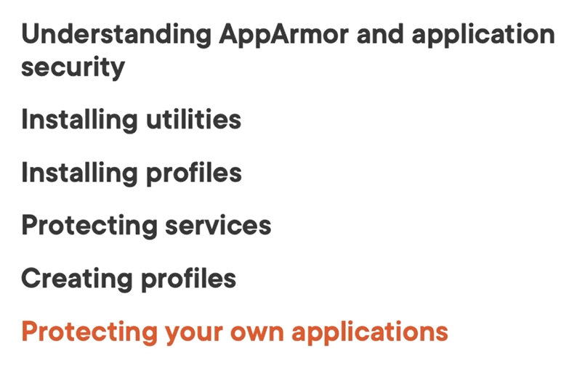

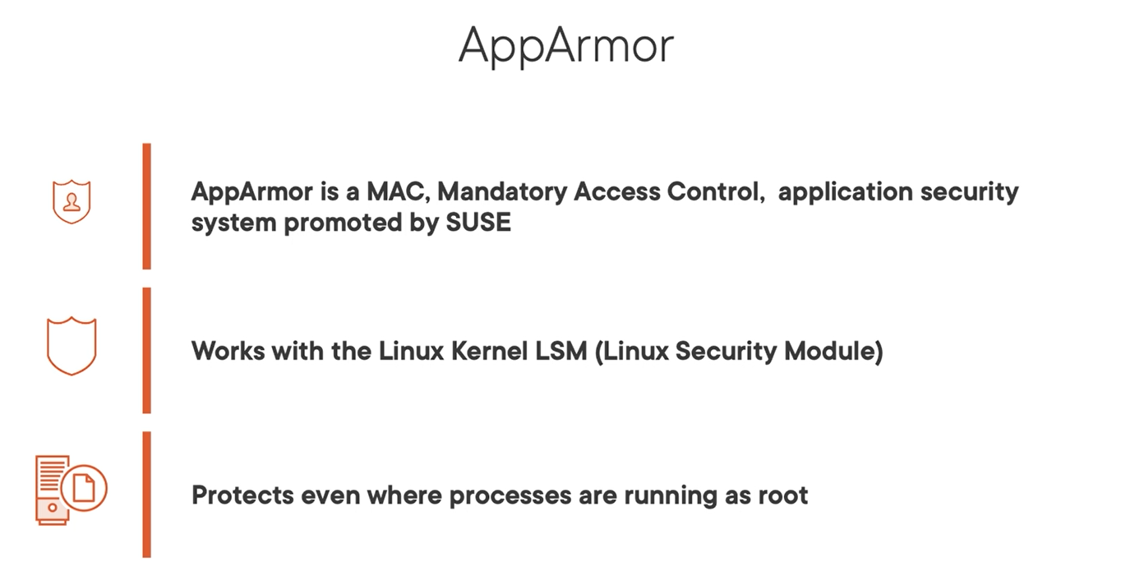

This chapter using suse, install tool is zypper

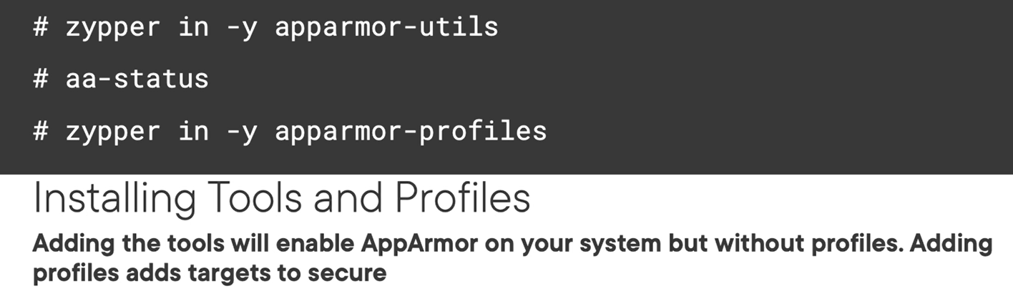

## Chapter 7.2; Installing AppArmor Components

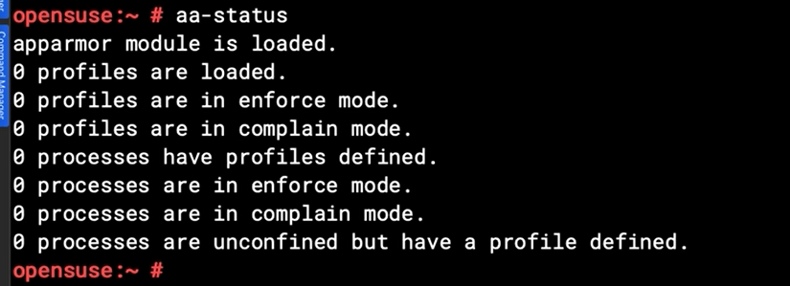

No profile loaded in current state

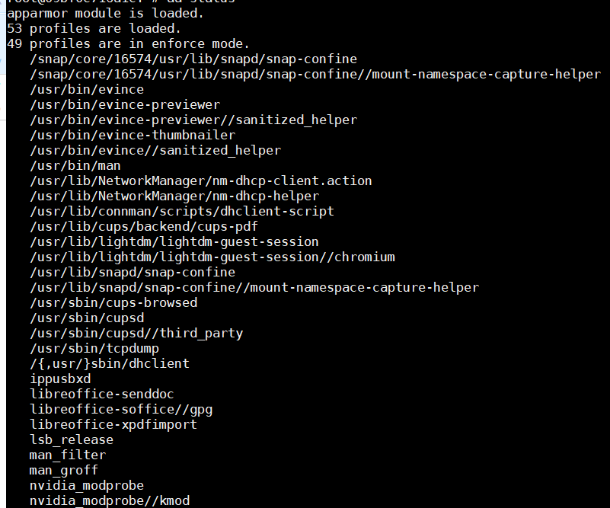

Above screen is apparmor profiles are loaded.

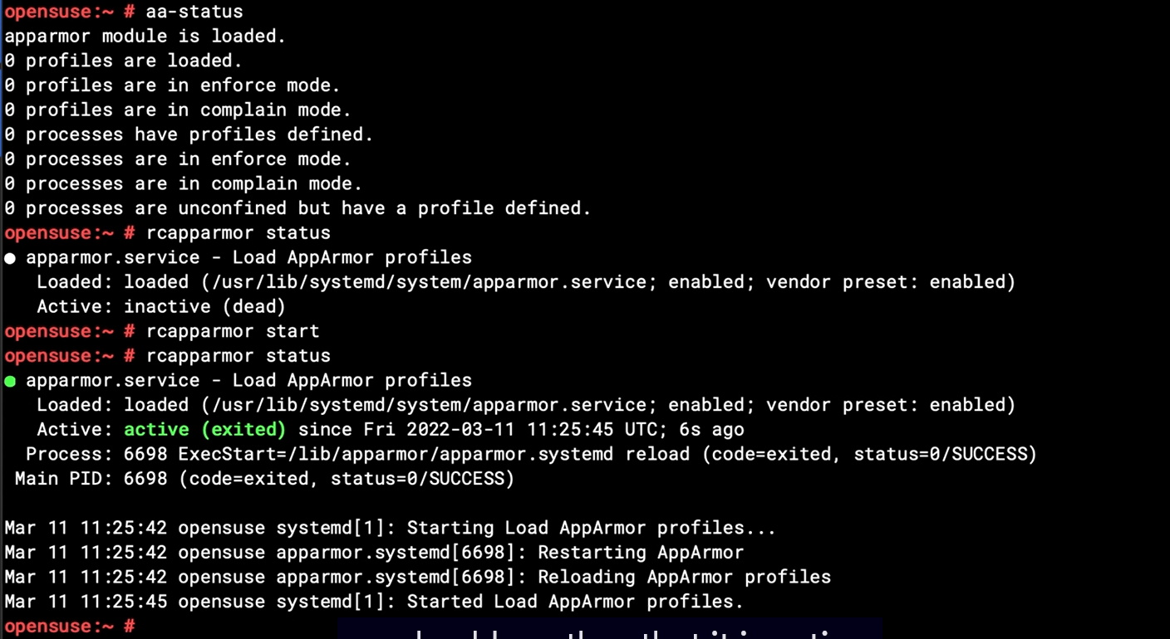

No process are running in this profile

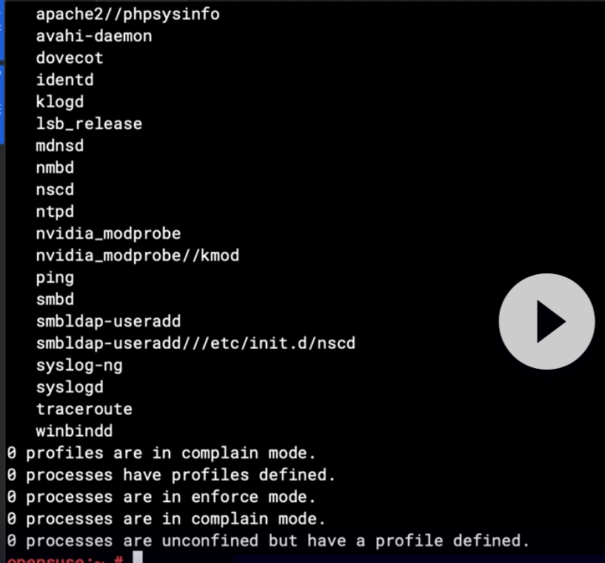

## Chapter 7.3: Viewing Active Profiles

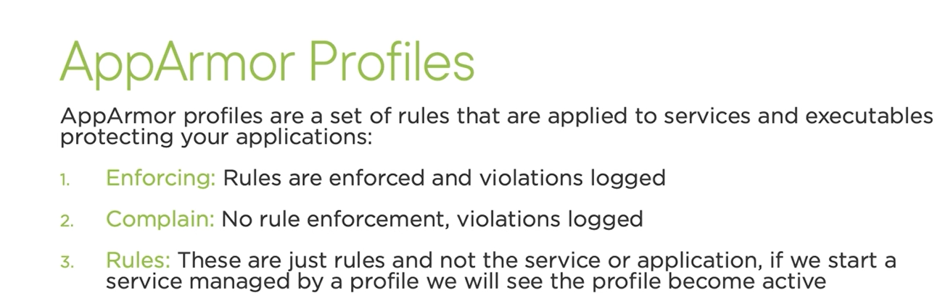

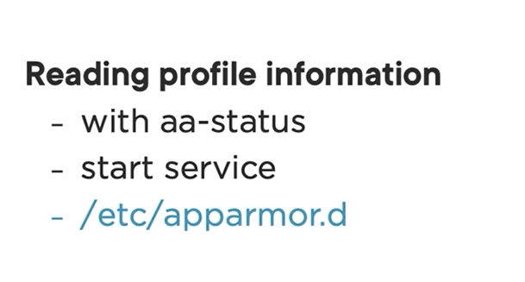

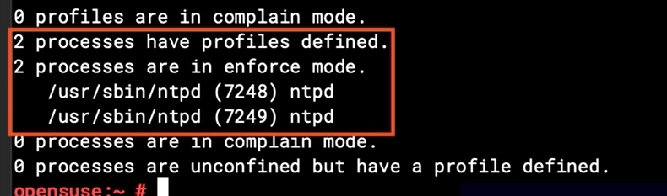

Above screen show that ntp processes are managed by apparmor after its started

Checking if a process being manged by our apparmor with “ps -Zp” command

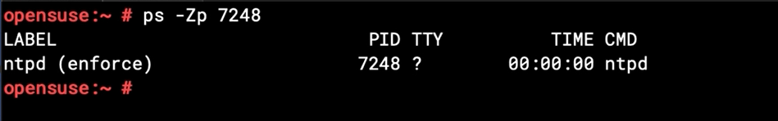

List all profile are loaded in apparmor

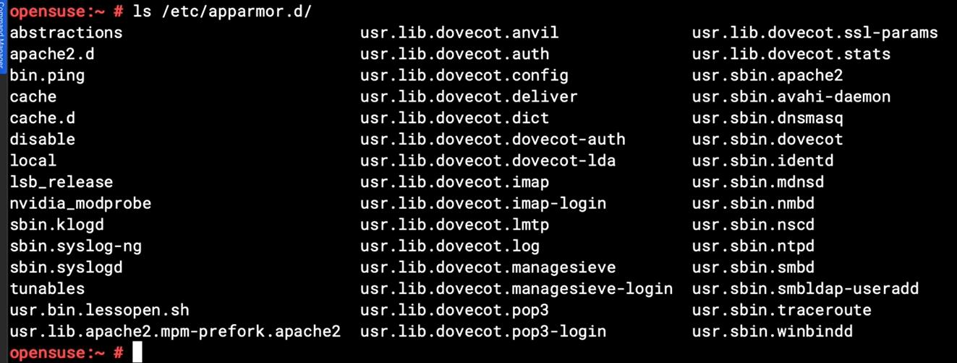

## Chapter 7.4: Creating Python Script

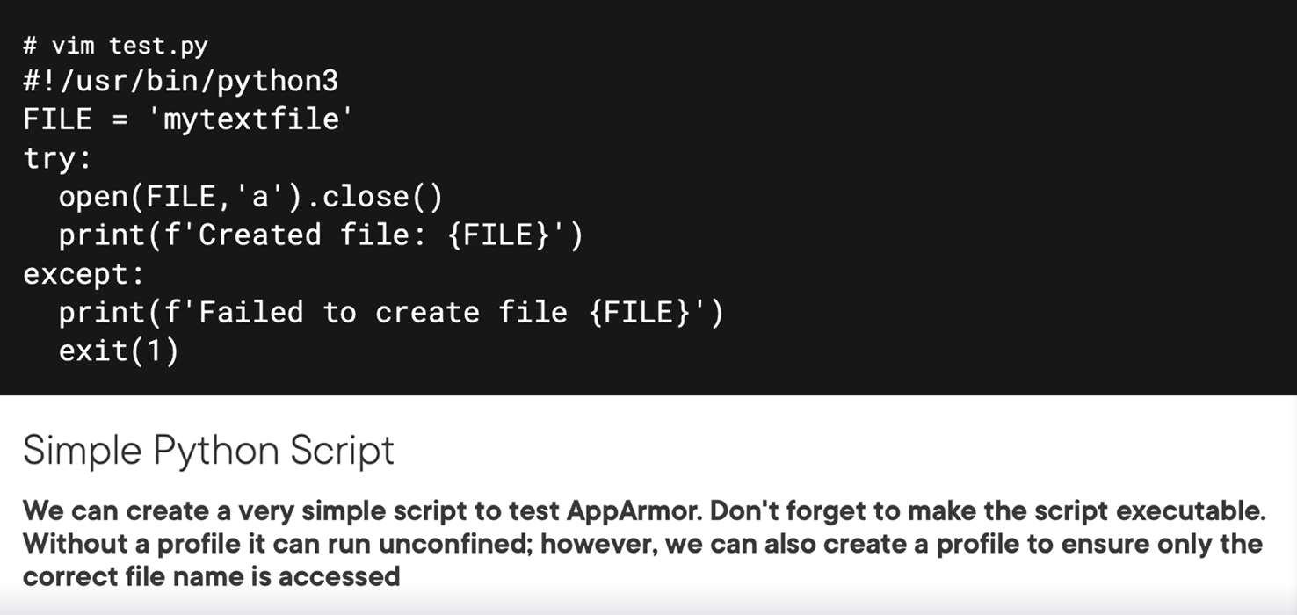

## Chapter 7.5: Generating a Profile for the Script

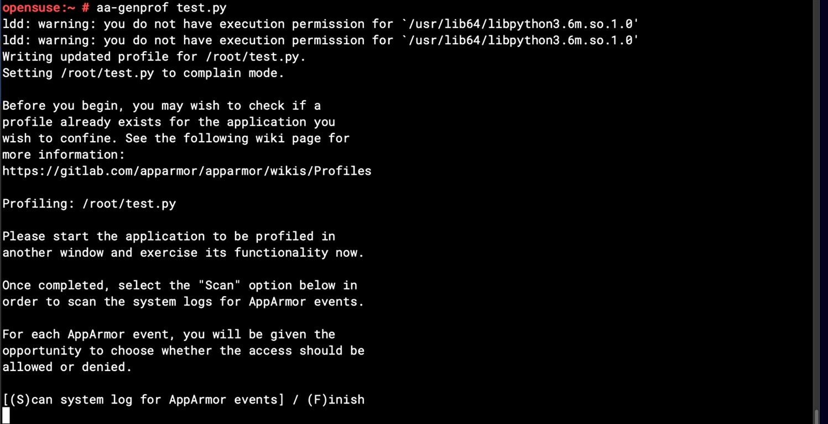

## Chapter 7.6: Using Logprof to Update Profile

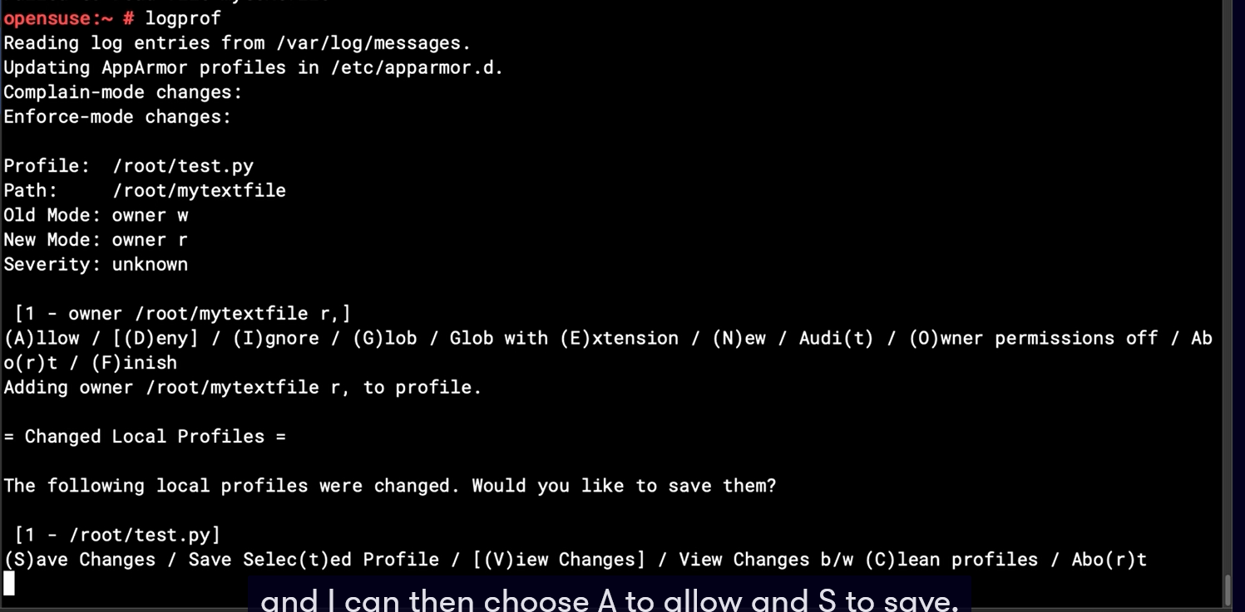

Above screen that test.py don’t have permission to read file, then you need allow profile with “logprof” to update profile then save.

## Chapter 7.7: Summary and What's Next

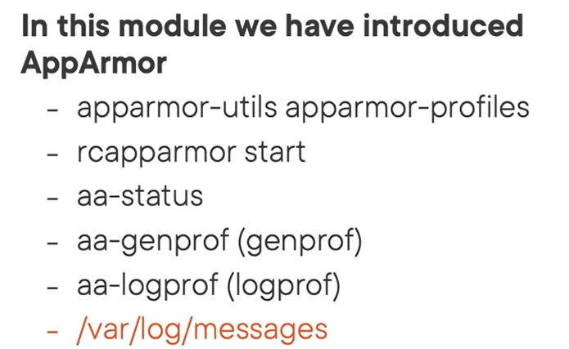

# Chapter 8: Managing SSH Servers and Connections

## Chapter 8.1: Managing Secure Connections in Linux

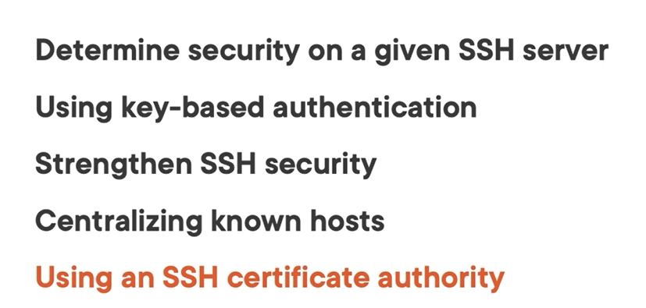

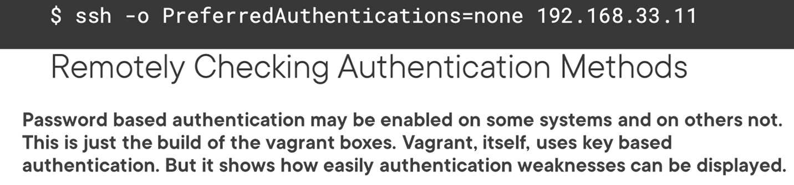

## Chapter 8.2: Understanding Available Authentication Methods

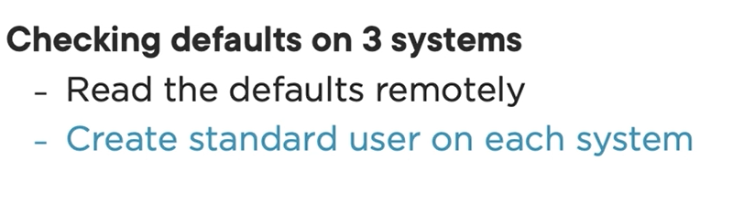

Checking the authentications methods on target server

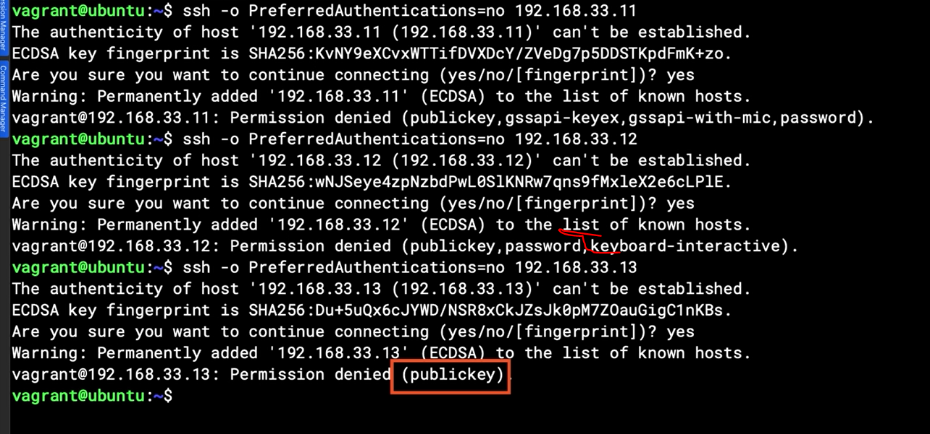

Above screen talking about method using 2fa

## Chapter 8.3: Managing Known SSH Servers or Hosts

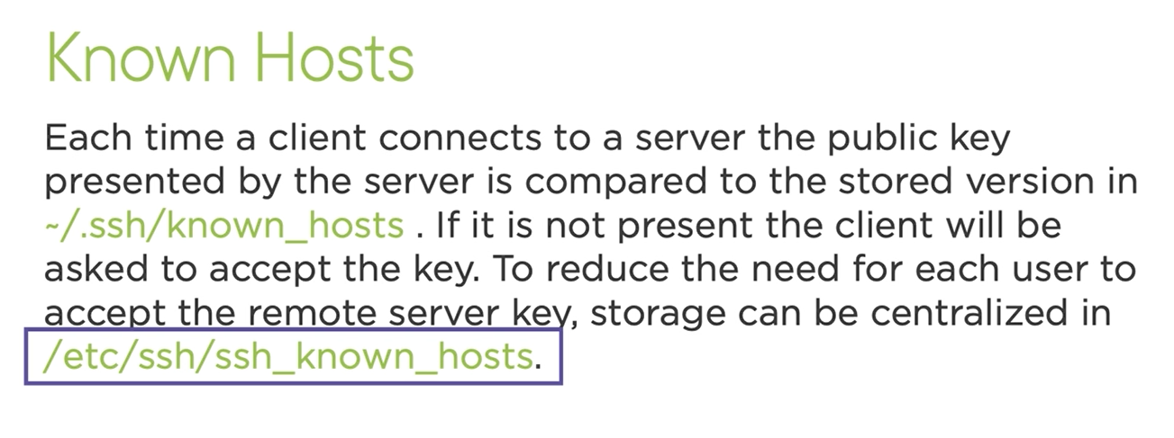

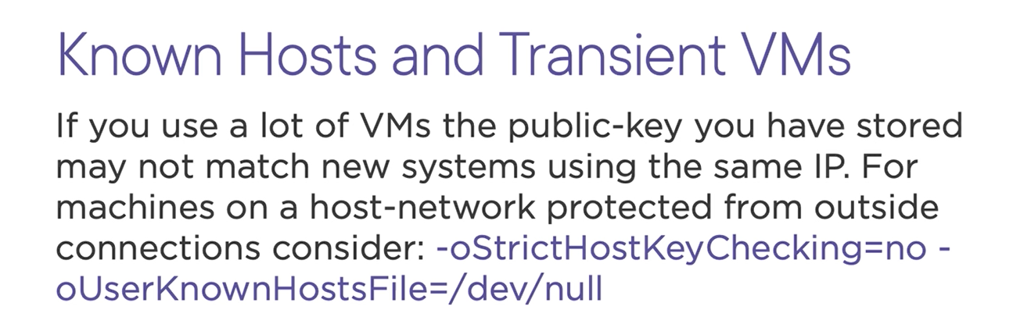

## Chapter 8.4: Working with Known Hosts Storage

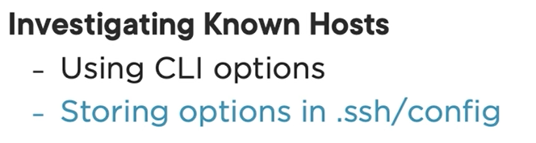

You can store this content in ./ssh/config for take advantage when ssh to some servers without store publickey.

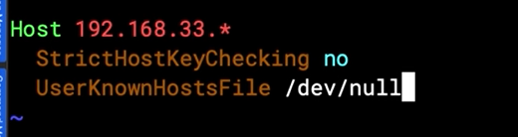

## Chapter 8.5: Centralizing Known Hosts

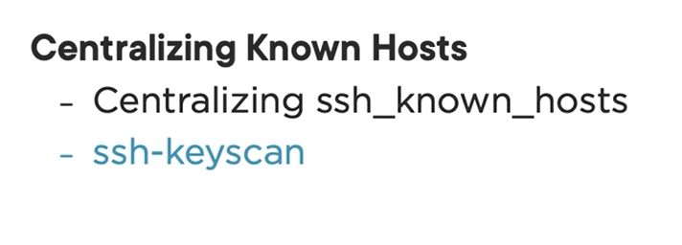

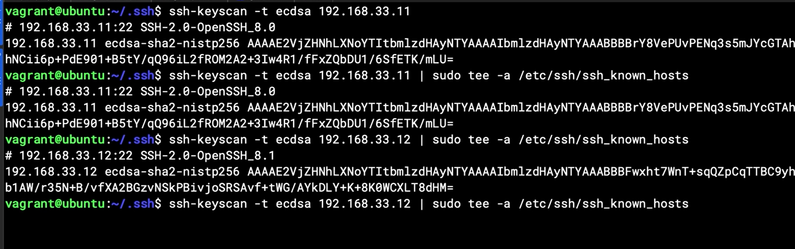

## Chapter 8.6: Authenticating SSH Clients

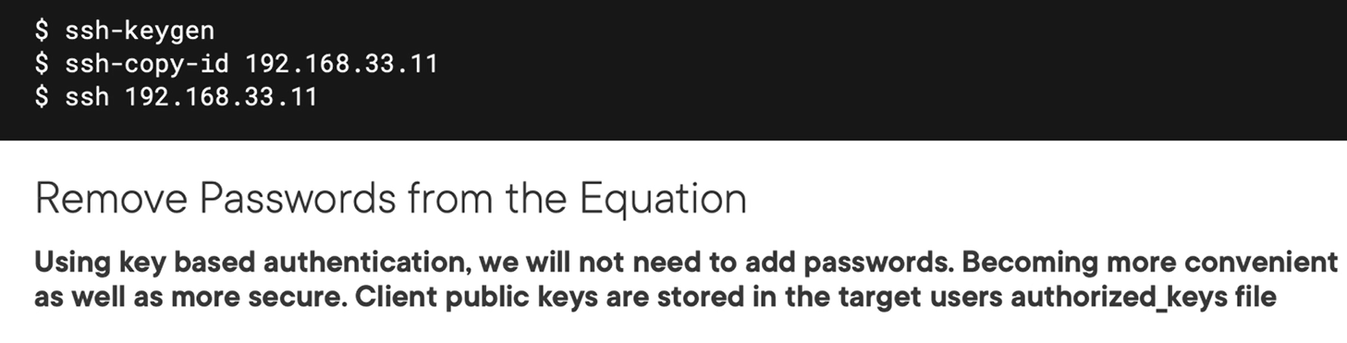

Note: to avoid pass phrase prompt you use ssh cache agent to by pass

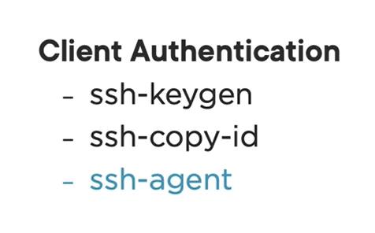

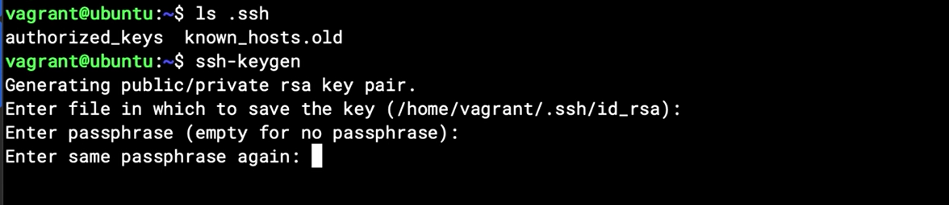

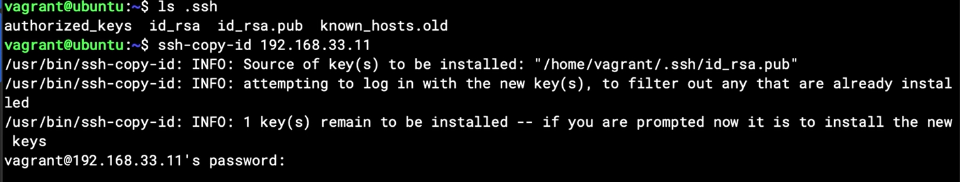

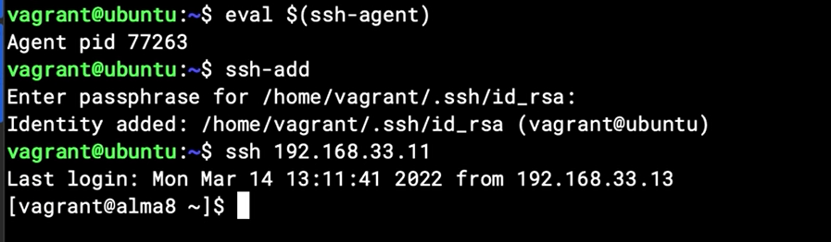

## Chapter 8.7: Understanding the SSH CA

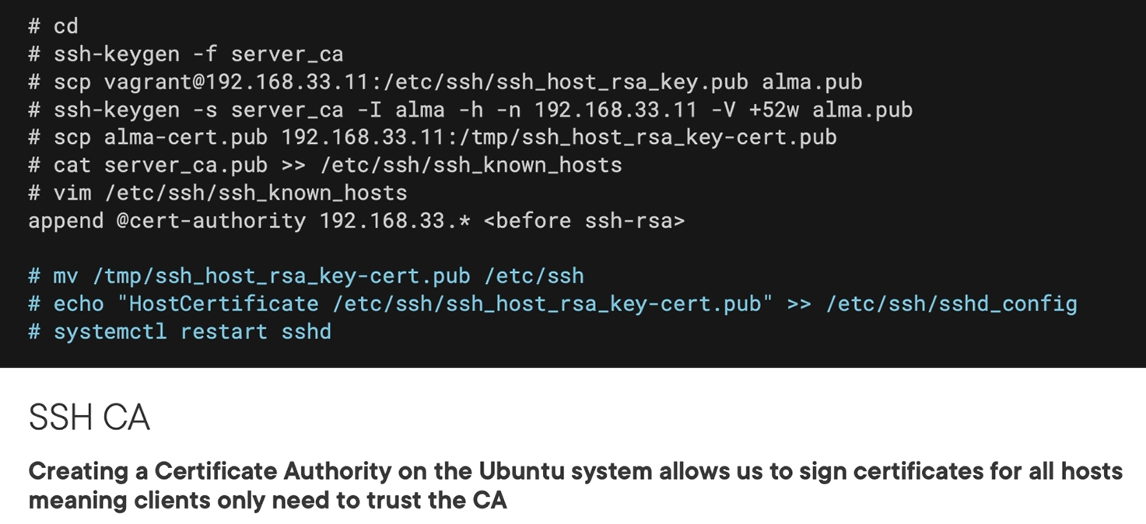

## Chapter 8.8: Implementing an SSH CA

Create CA on server

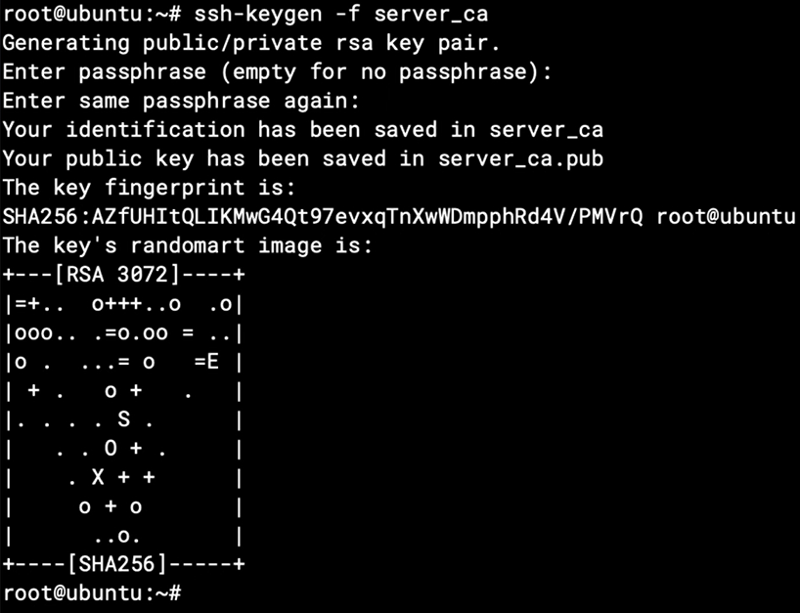

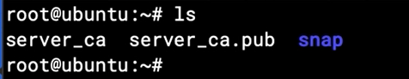



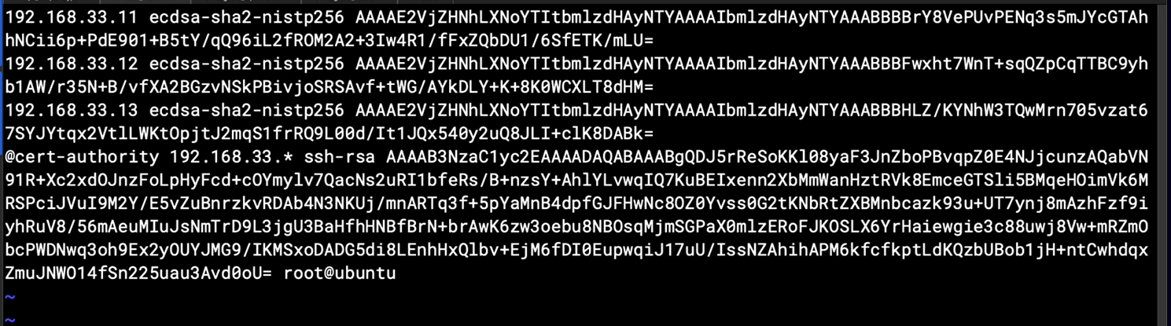

## Chapter 8.9: Signing Server Keys with the CA

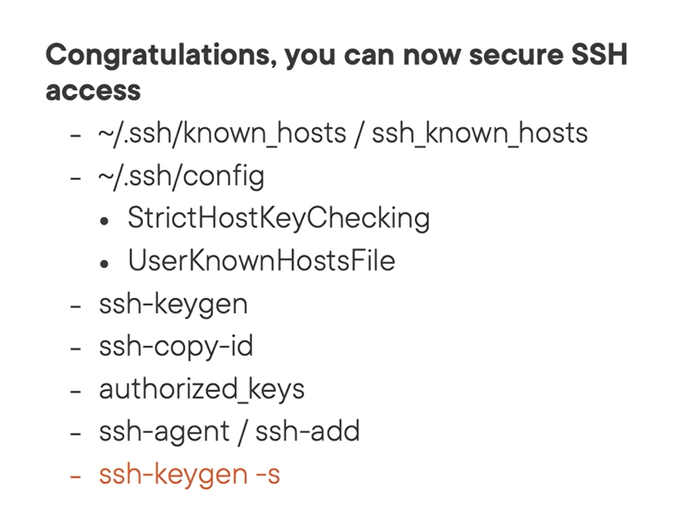

Generate CA cert for client



On target Server

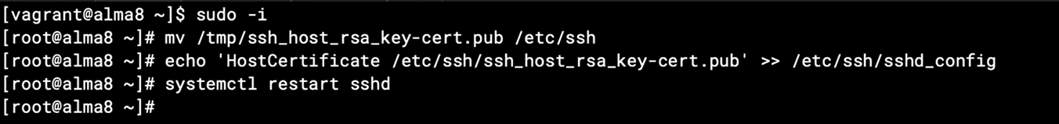

# Chapter 9 Elevating privileges in linux

## Chapter 9.1: Becoming the Boss

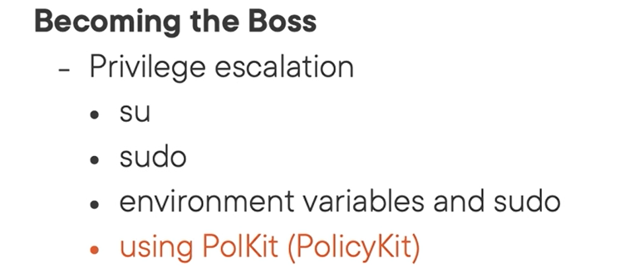



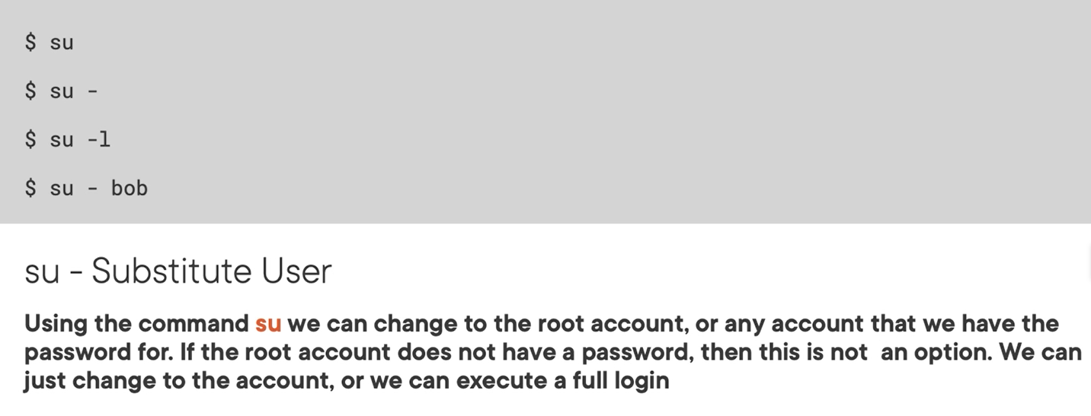

## Chapter 9.2: Using Su

Login full shell privilege with “su –“

Login without full shell privilege with “su “

## Chapter 9.3: Understanding Sudo

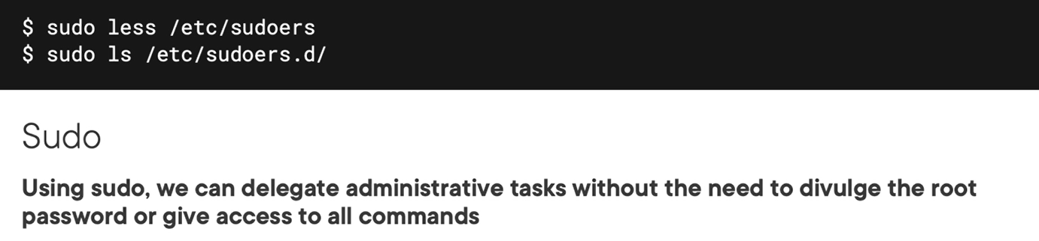

Note: 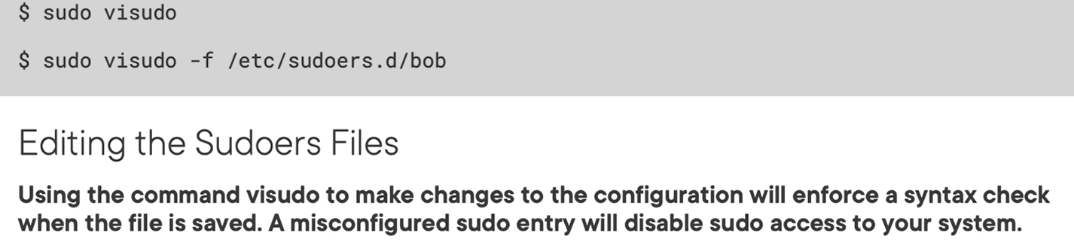

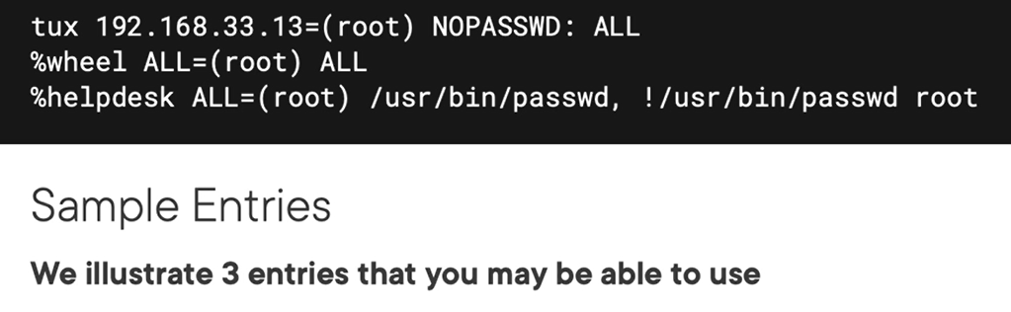

## Chapter 9.4: Using Sudo

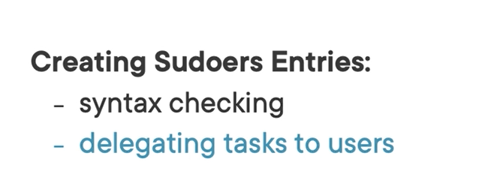

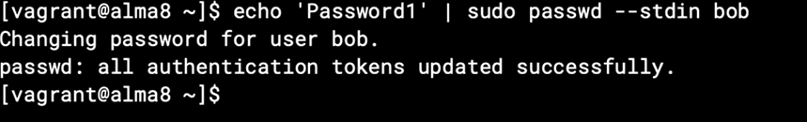

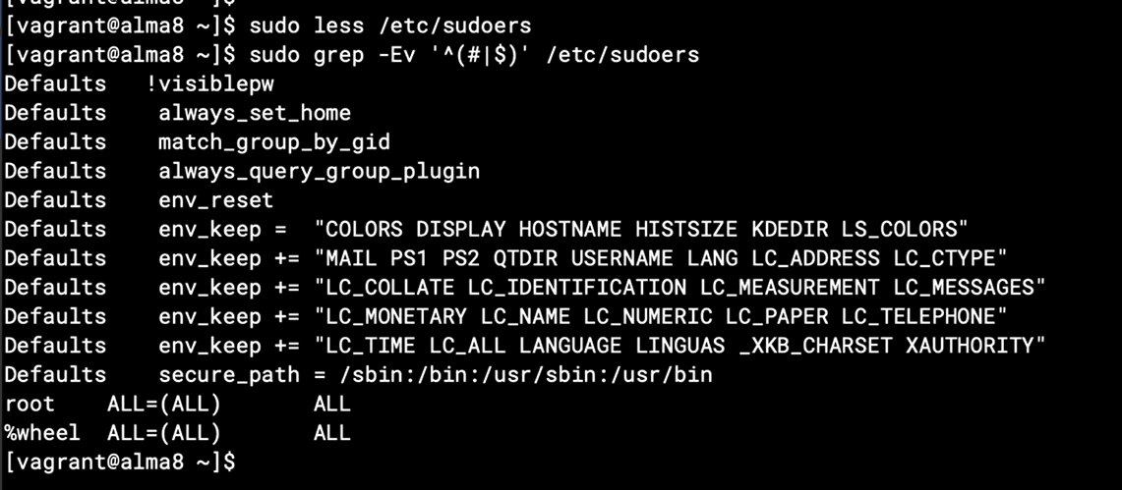



Note: visudo with another file different sudoer file need an options -f



Explain:

From user tux on every (ALL) system, can do anything to root user without password (NOPASSWD:) command is (/usr/bin/passwd) and don’t support command (/usr/bin/passwd) for user root (root)

## Chapter 9.5: Environment Variables and Sudo

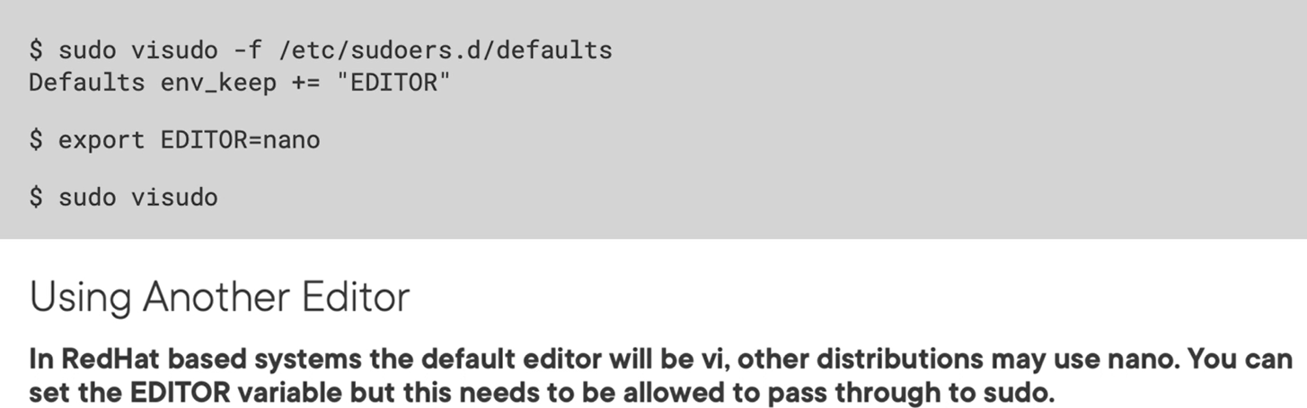

Change default editor app on system via sudo

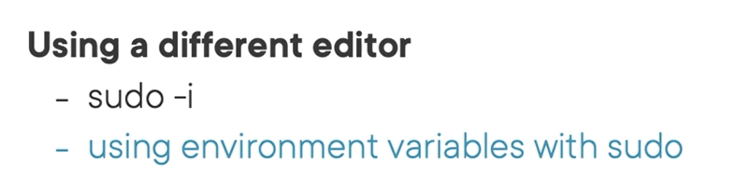

## Chapter 9.6: Understanding PolKit

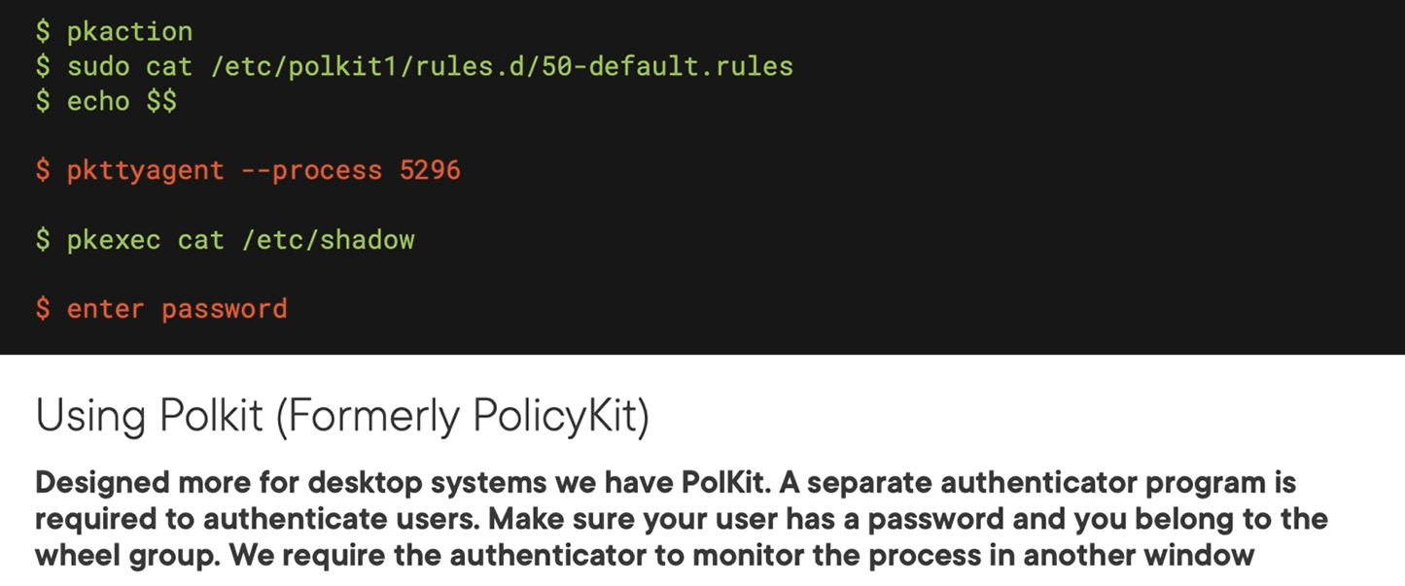

## Chapter 9.7: Recovering Broken Sudo Systems Using Polkit

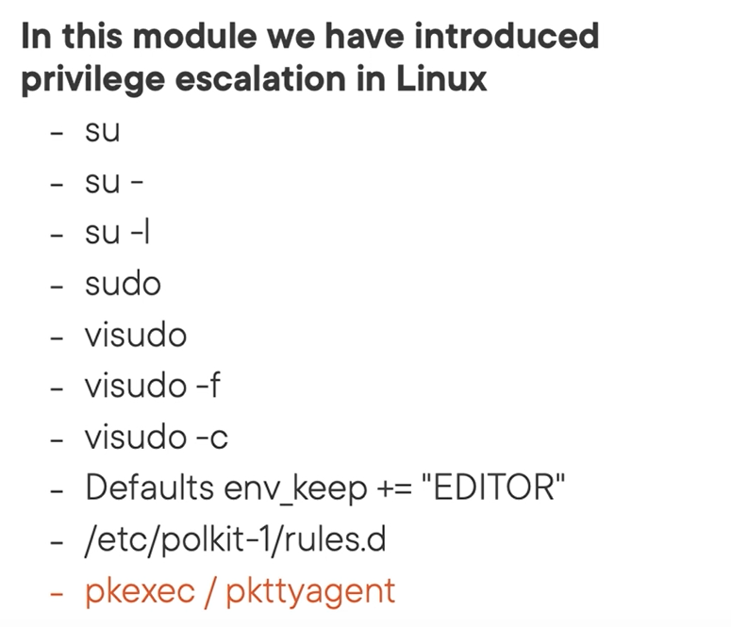

# Chapter 10: Managing Local Users

## Chapter 10.1: Managing Local Users and Groups

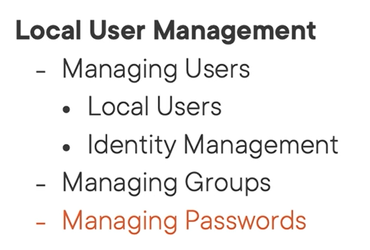

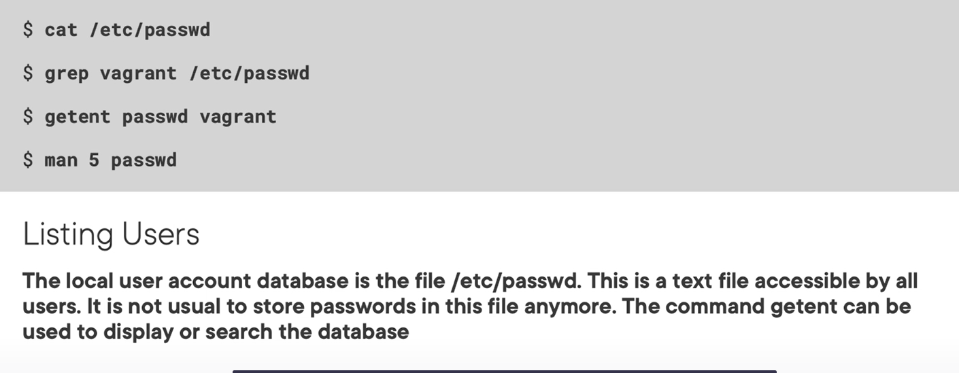

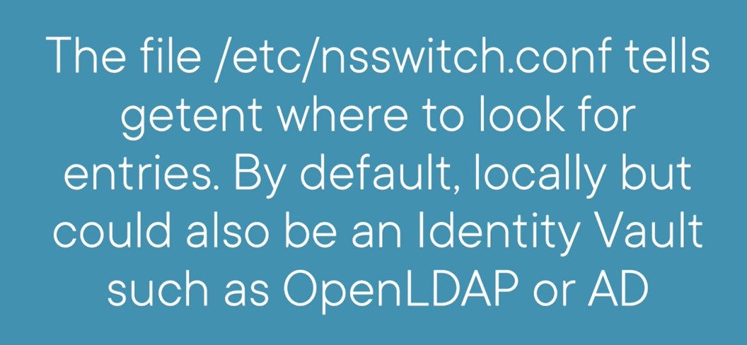

## Chapter 10.2: Listing Users

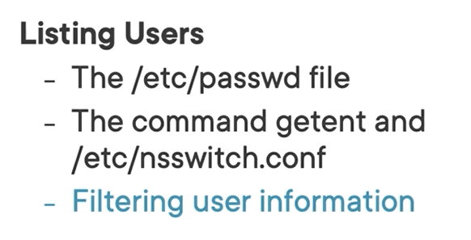

Using awk or cut command to show infor

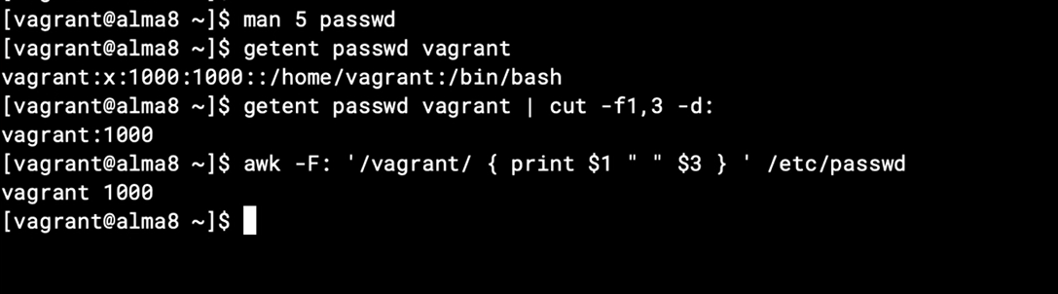

## Chapter 10.3: Working with User Default Settings

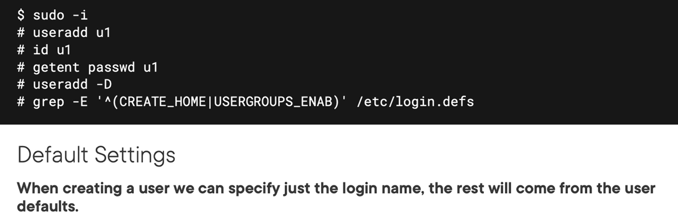

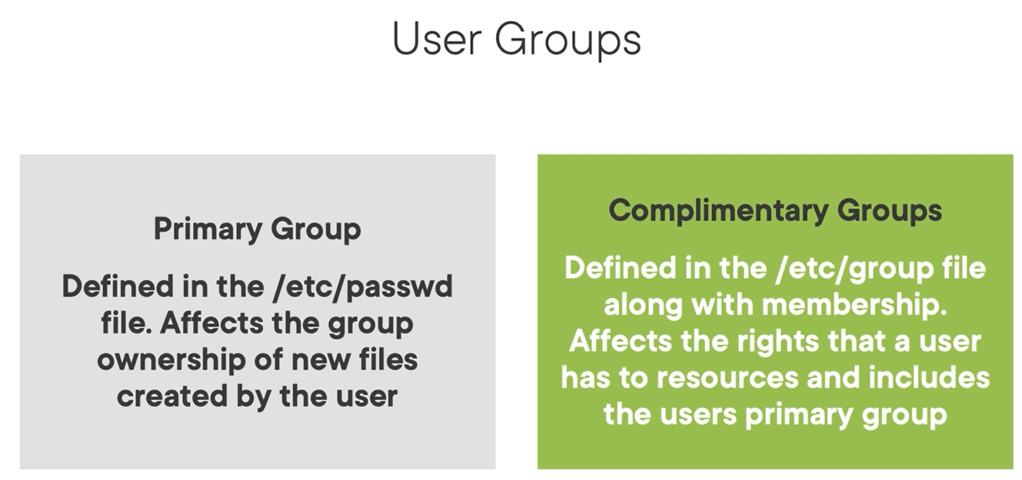



## Chapter 10.4: Managing New Users

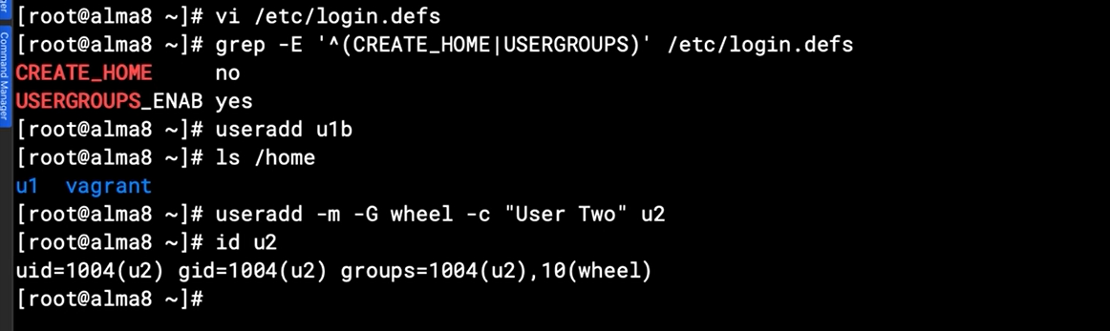

## Chapter 10.5: Modifying and Deleting Users

## Chapter 10.6: Understanding Password Shadow Data

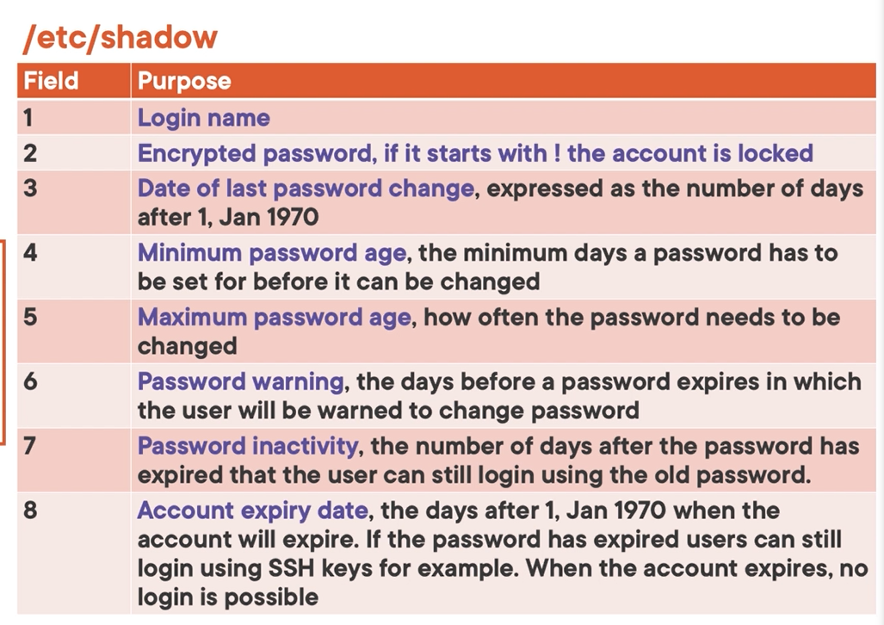

## Chapter 10.7: Working with Shadow Data

## Chapter 10.8: Understanding Password Encryption

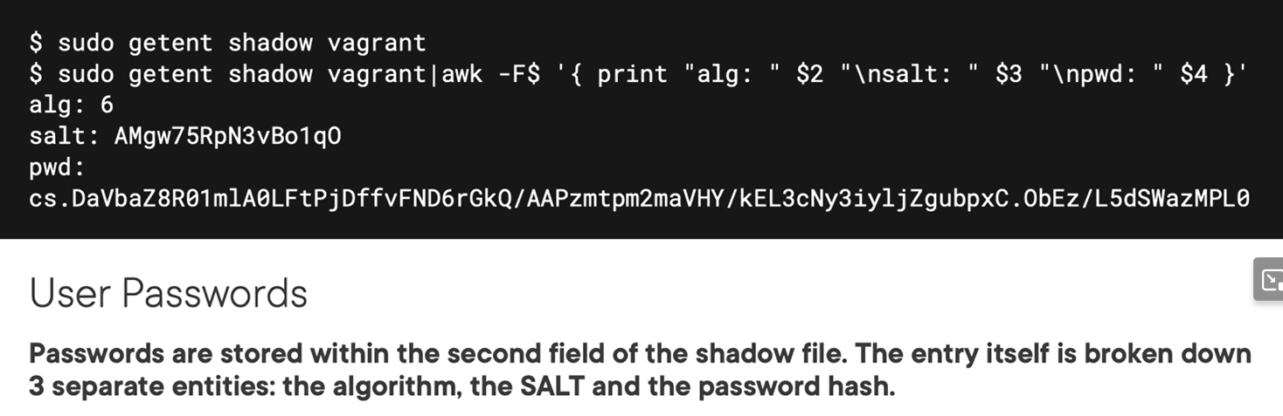

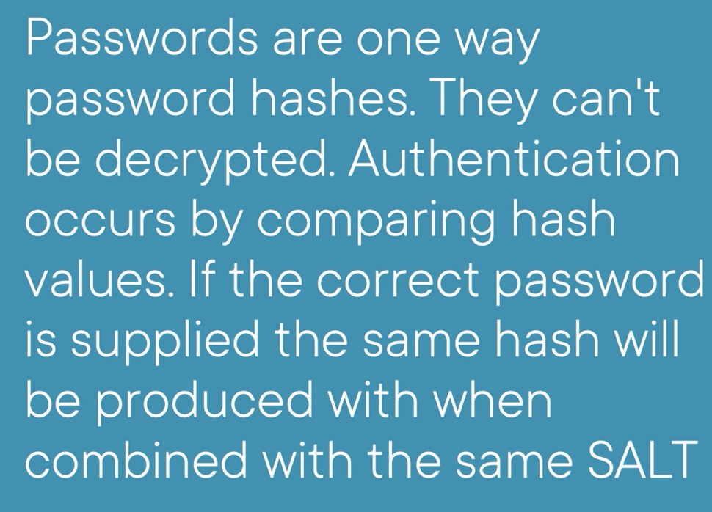

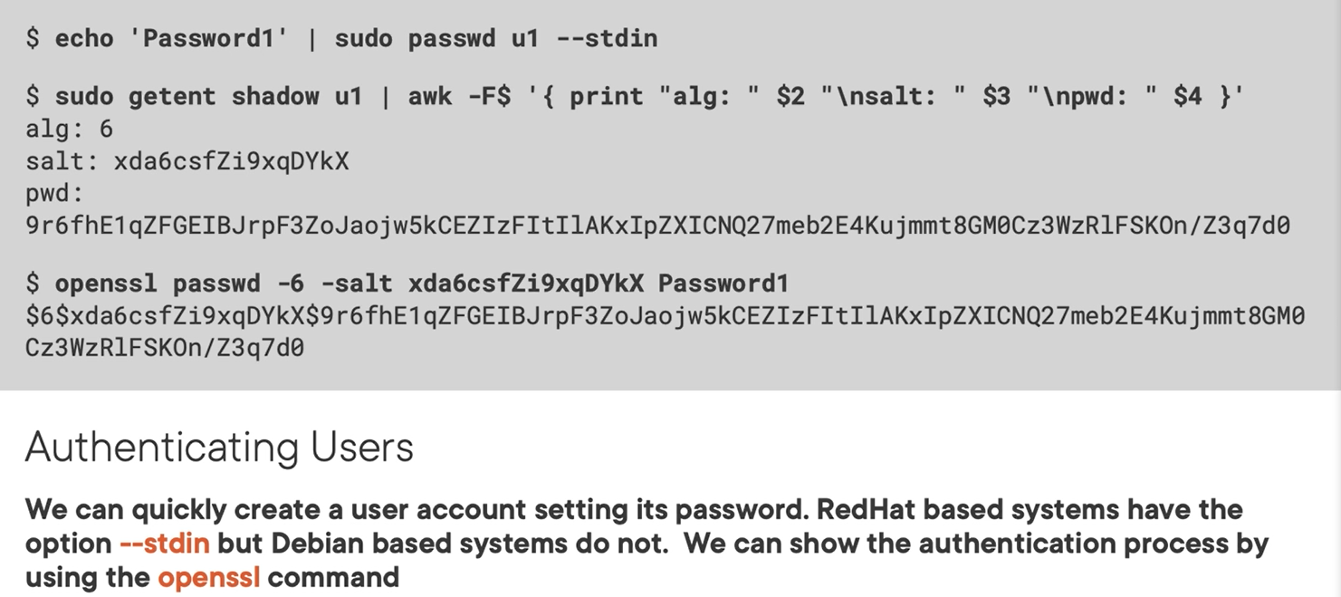

## Chapter 10.9: Working with Passwords and Understanding Authentication

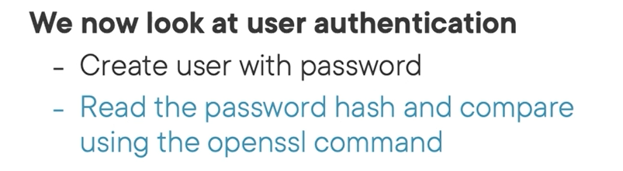

Show detail infor of password

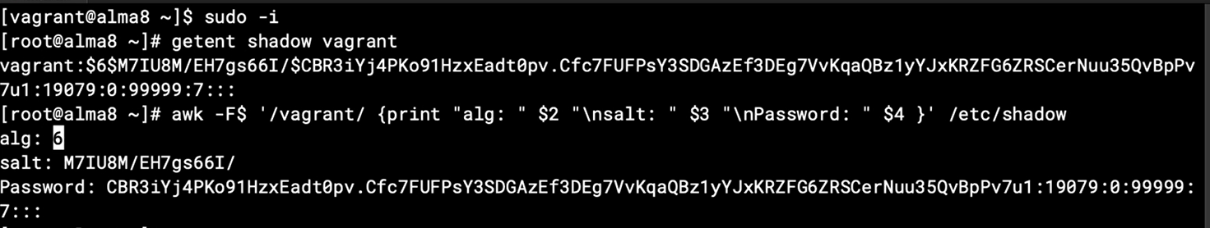

## Chapter 10.10: Managing User Passwords

Default definition file decided what user’s password will be /etc/login.def

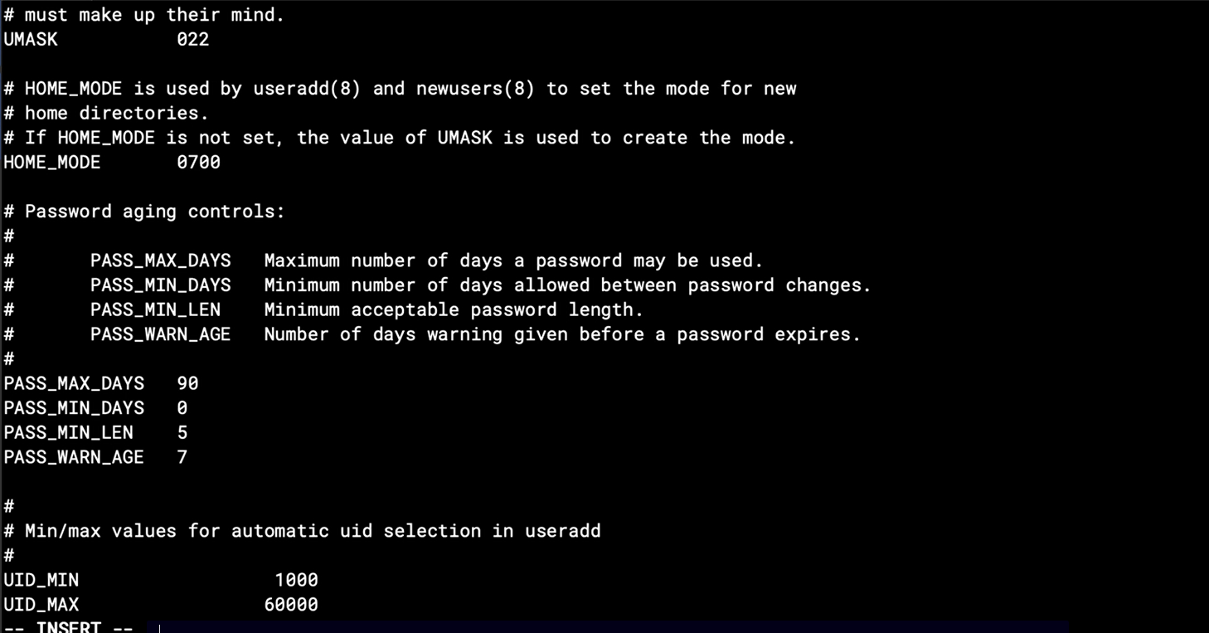

Default file be created when create new user will be defined by /etc/default/useradd

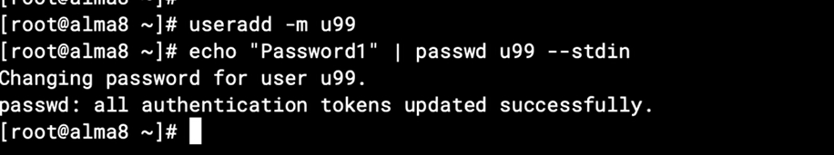

Create user and password without interactioin

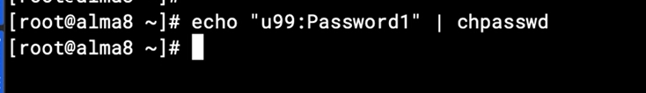

See the age of password

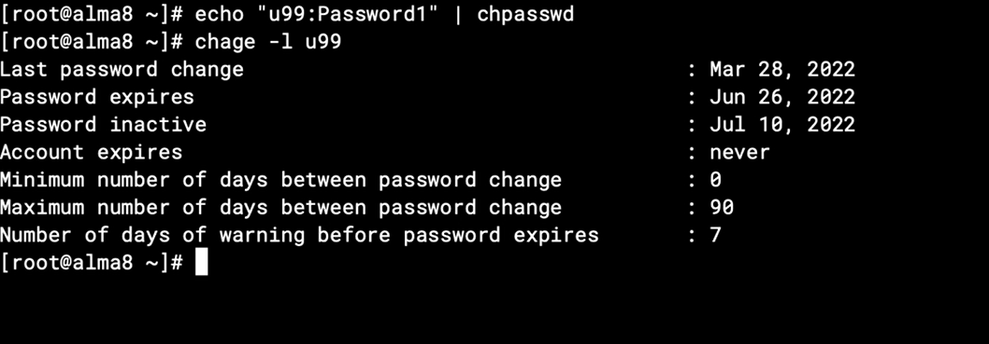

## Chapter 10.11: Managing Linux Groups

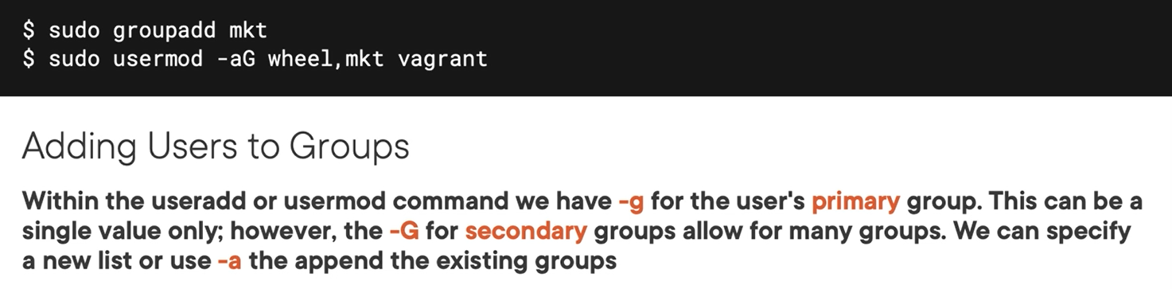

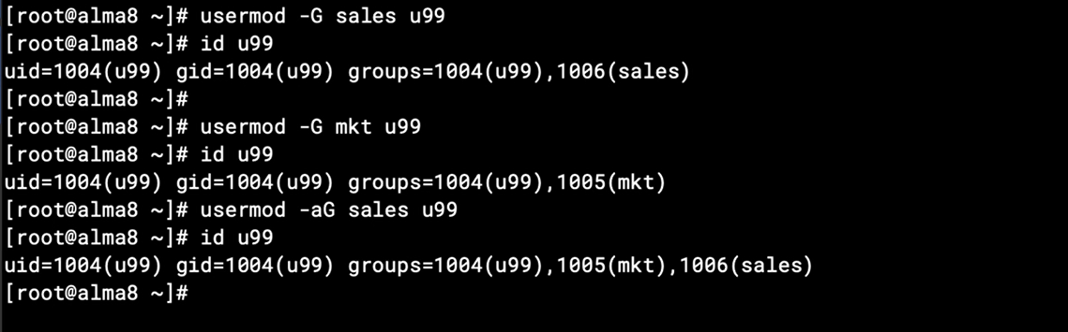

# Chapter 11: Implementing HTTPS with the Apache Web Server

## Chapter 11.1: HTTPS Self-signed Certificates

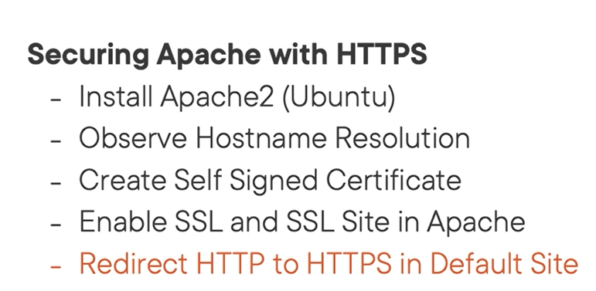

Install apache on ubuntu

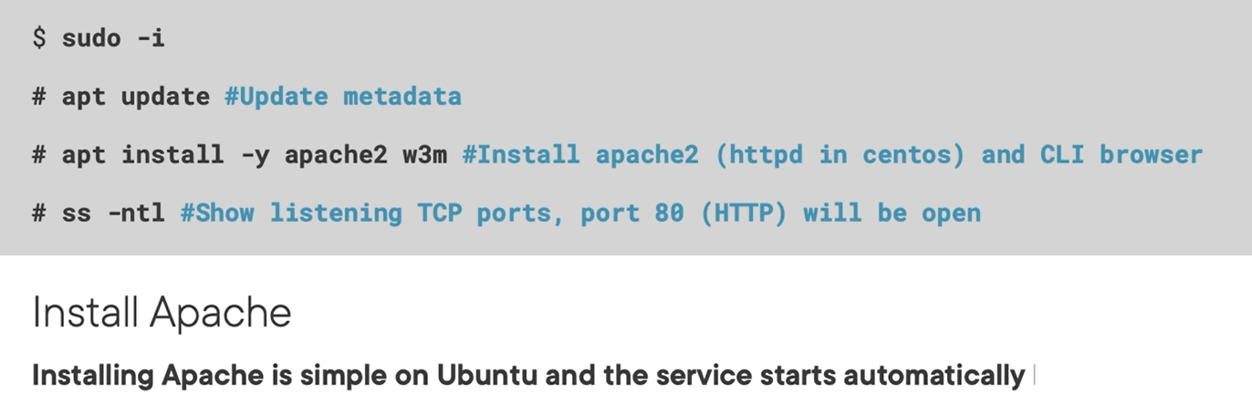

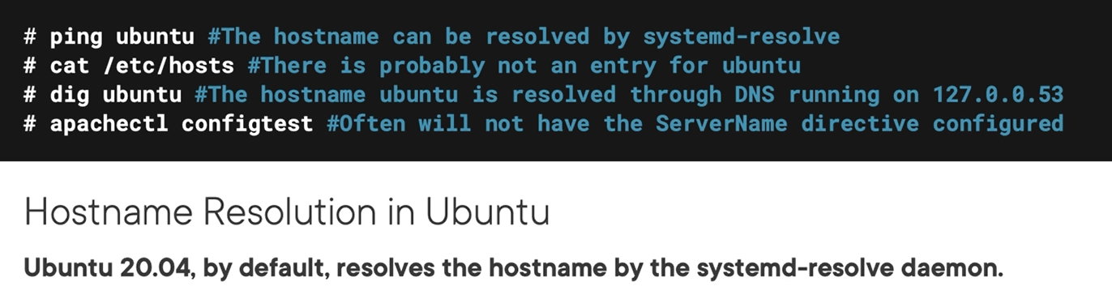

## Chapter 11.2: Installing Apache

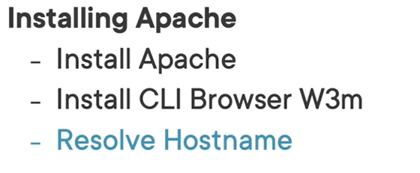

W3m the tools to view web page

## Chapter 11.3: Understanding the Ubuntu Apache Configuration

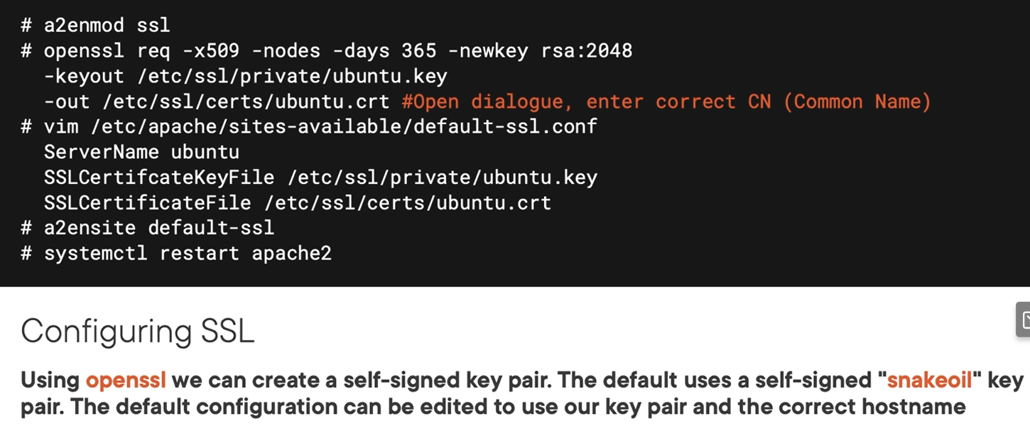

## Chapter 11.4: Configuring SSL on Apache

Enable “a2enmode ssl” for working with ssl by apache

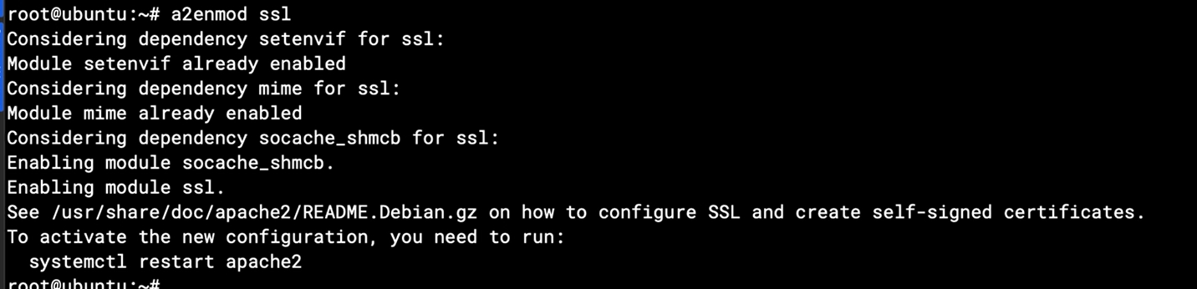

The register csr:

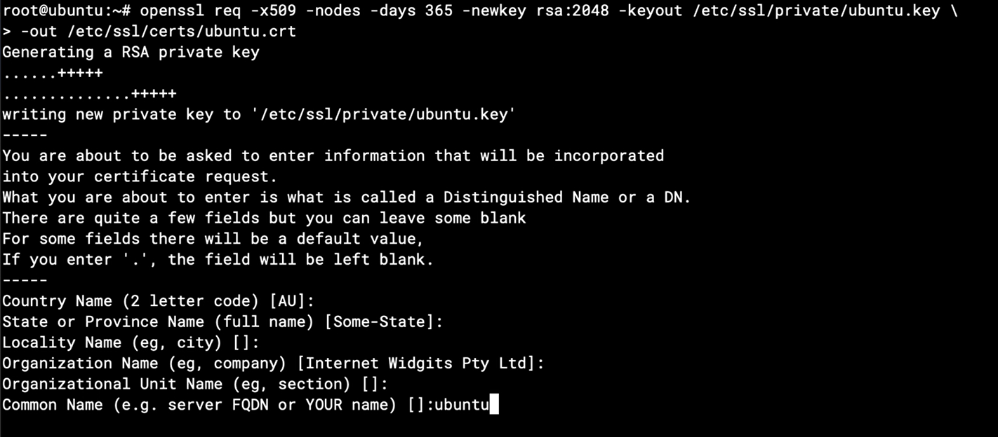

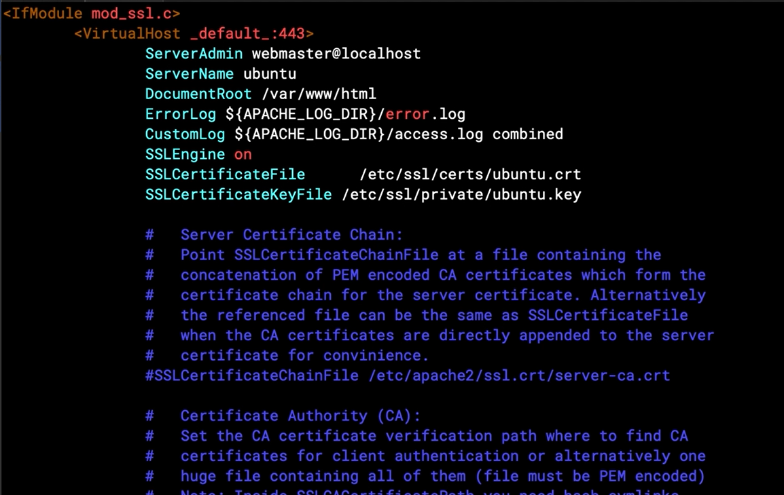

After that:

A2ensie default-ssl

Systemctl restart apache2

Checking:

Ss -ntl //checking listening port

W3m <https://ubuntu:443>

W3m https://localhost:443

## Chapter 11.5: Redirect HTTP to HTTPS

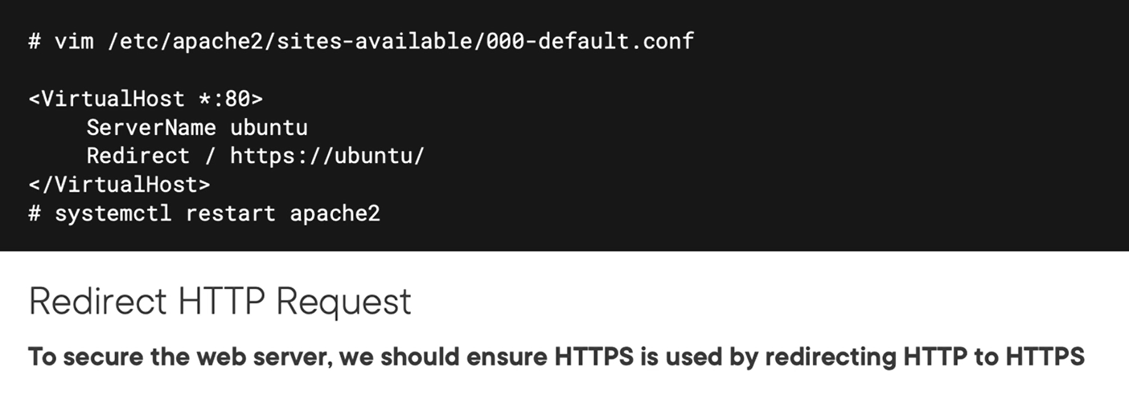

Demo

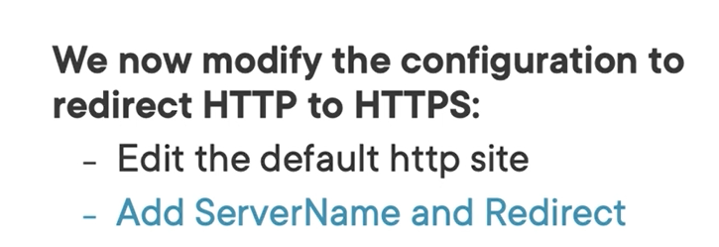

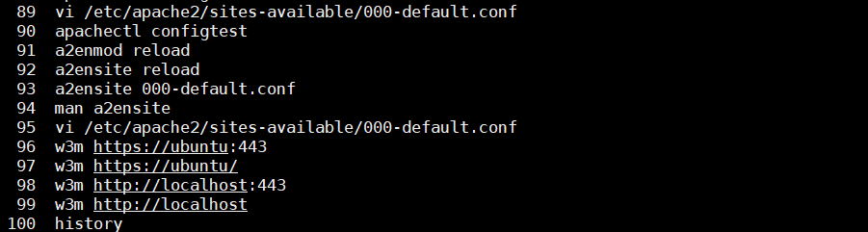

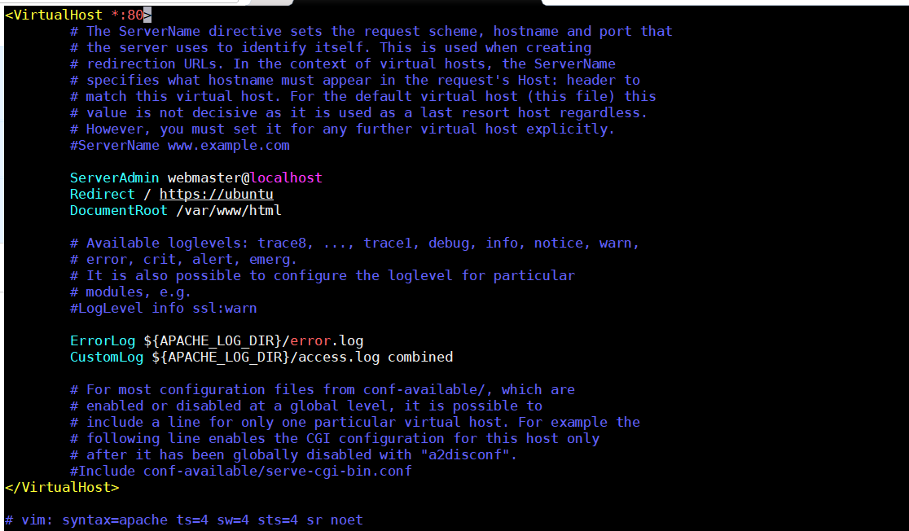

## Chapter 11.6: Investigating Certificate Chains with OpenSSL

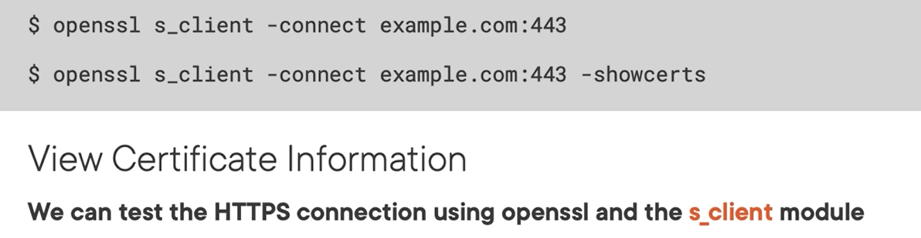

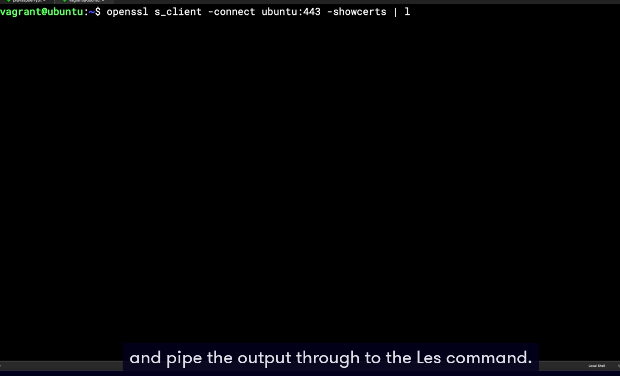

Using s_client module for test https connections using openssl

Deep dive with pluralsite.com

A little bit detail this cert chain

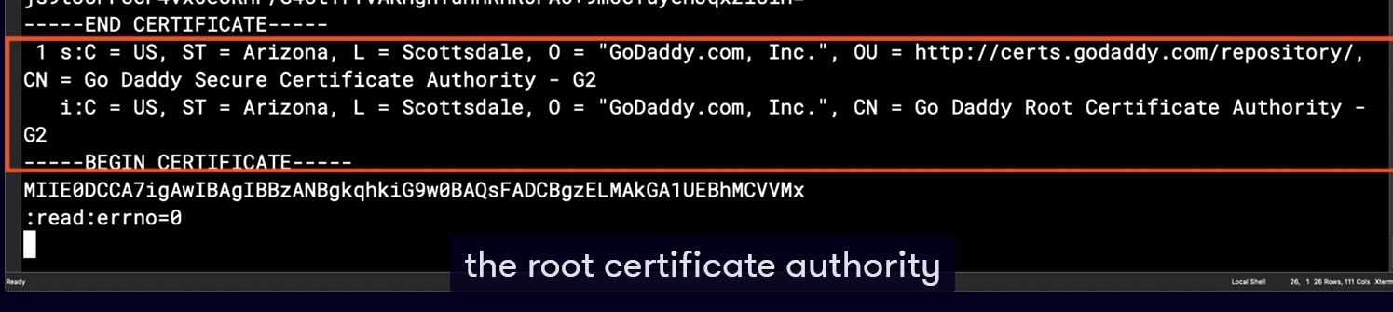

We have CA cert with subject and issuer is Godady

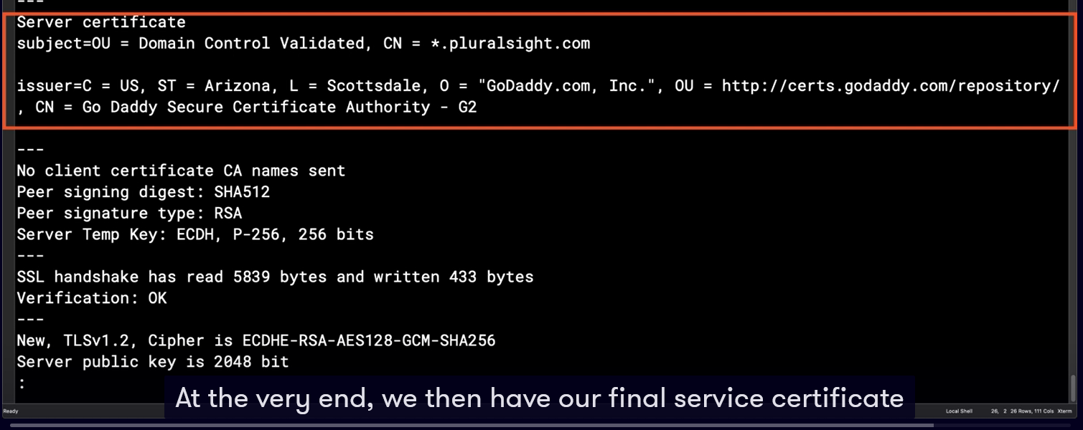

## Chapter 11.7: Summary and What's Next

The key point is trusted between issuer CA and and certificate which you created,

# Chapter 12: Implementing an openSSL Certificate Server

## Chapter 12.1: Using Certificate Authorities

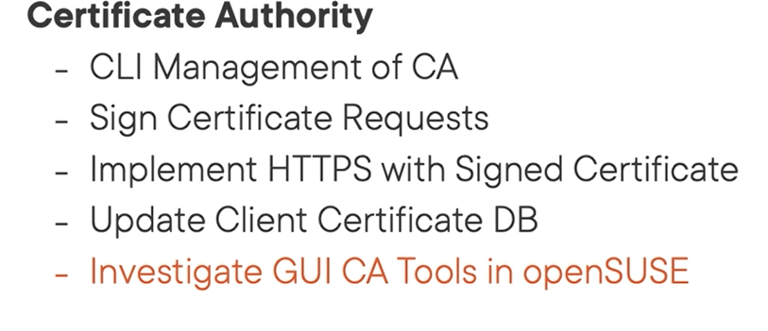

Demo

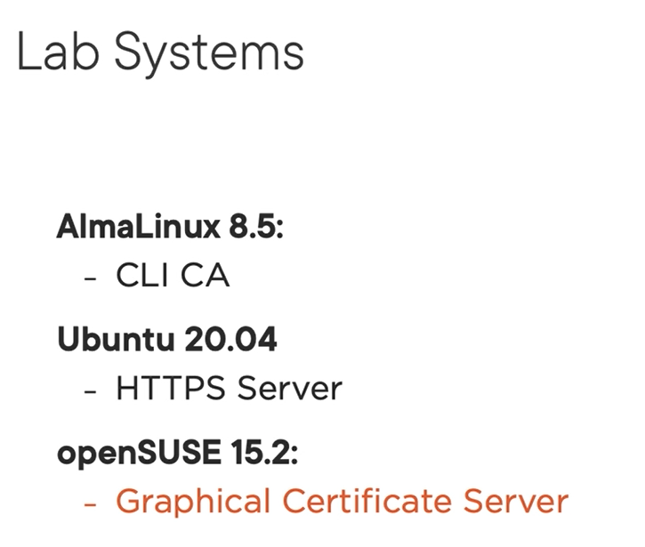

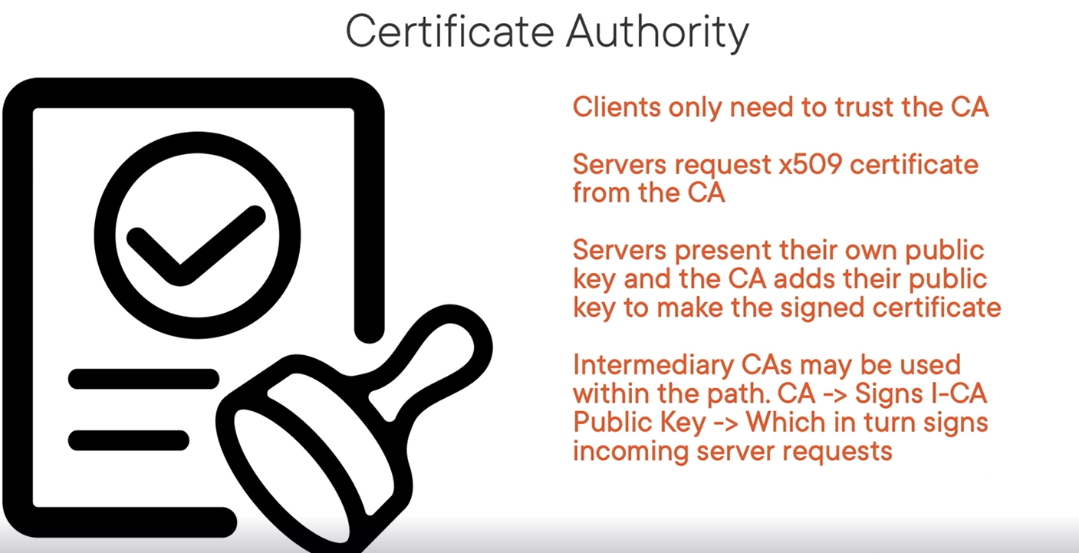

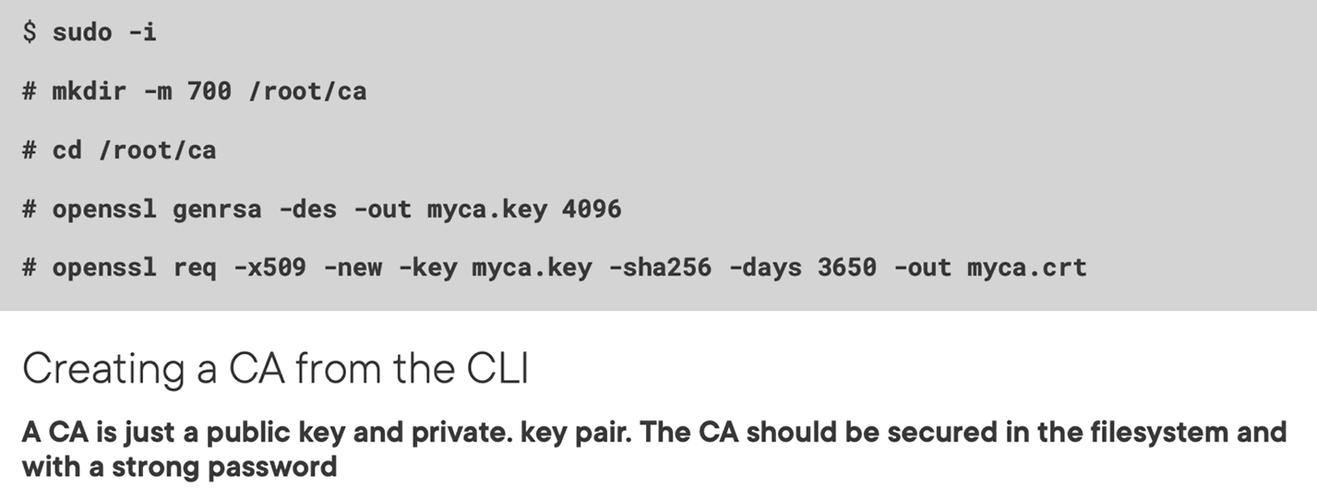

We will send public key myca.crt to

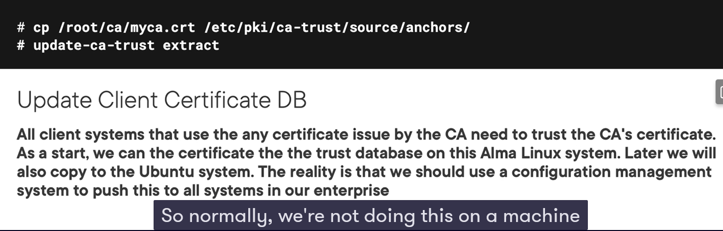

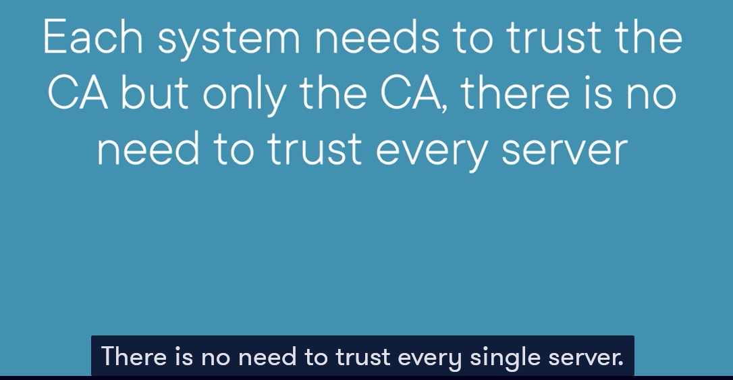

Only trust CA sever

## Chapter 12.2: Creating a CA from the CLI

Create private key

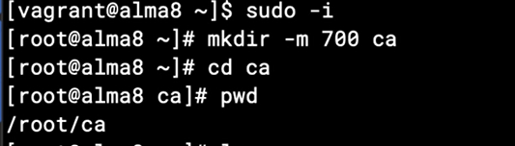

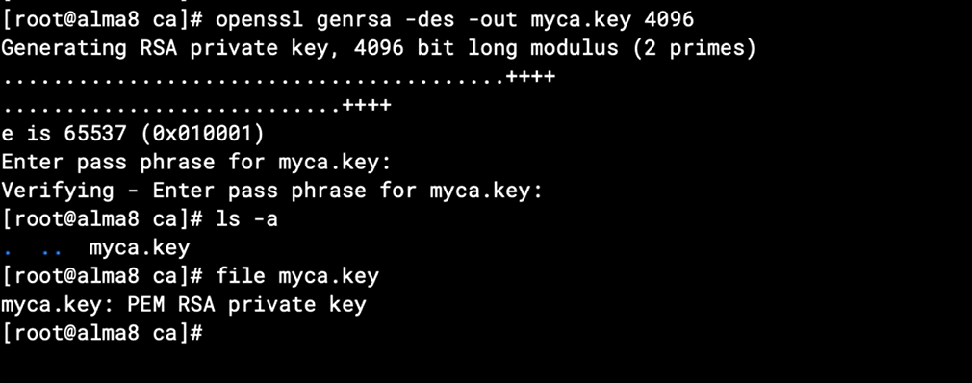

Create CA cert from pem key above duration 10 years

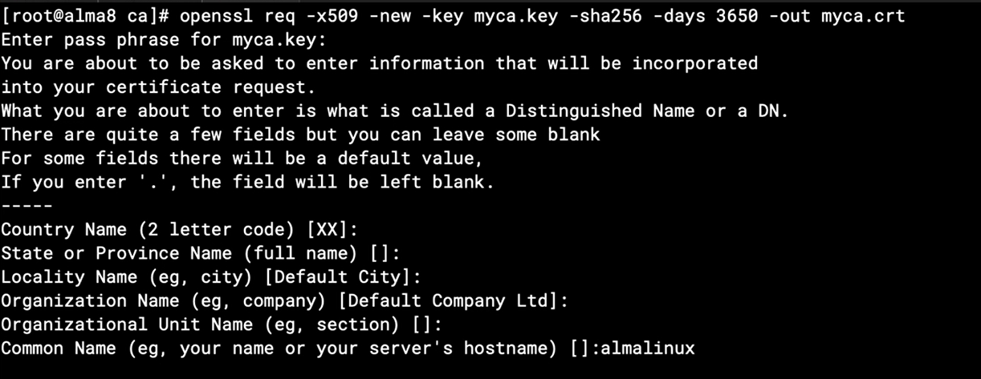

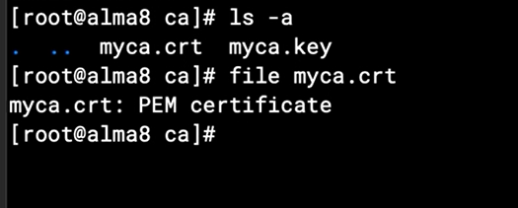

For the private env, all clients or devices must trust this CA cert for normal communication.

You could use group policies for windows env or puppet, ansible for linux env to push out the CA to whole the system.

Update the CA to database on server

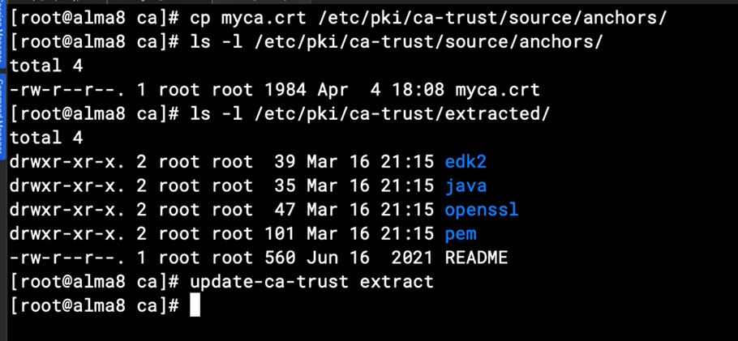

## Chapter 12.3: Creating a Certificate Signing Request

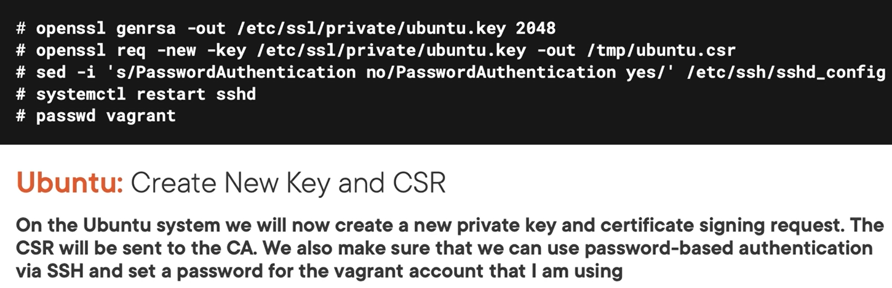

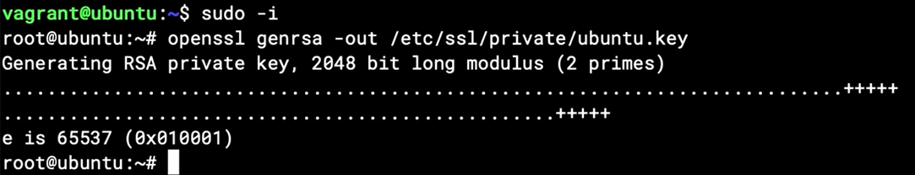

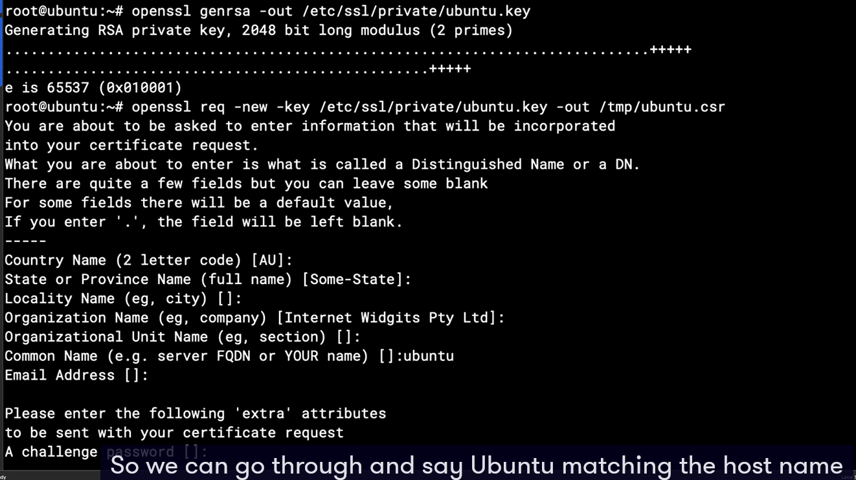

## Chapter 12.4: Signing the CSR

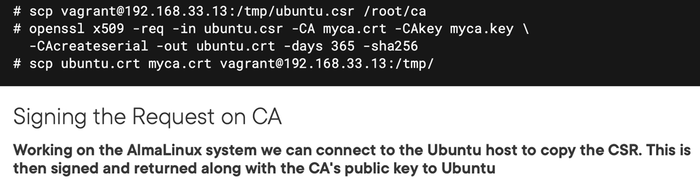

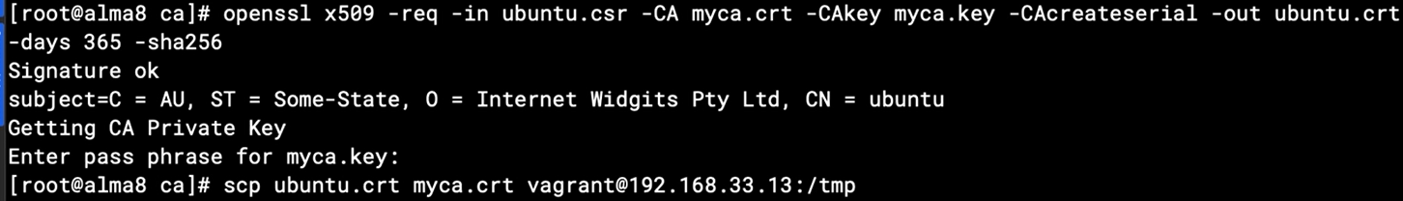

## Chapter 12.5: Configuring Apache with CA Certificate

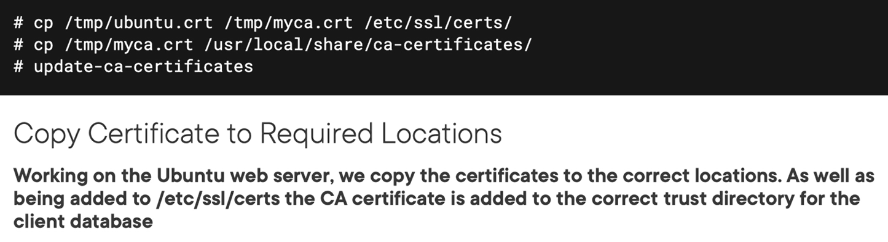

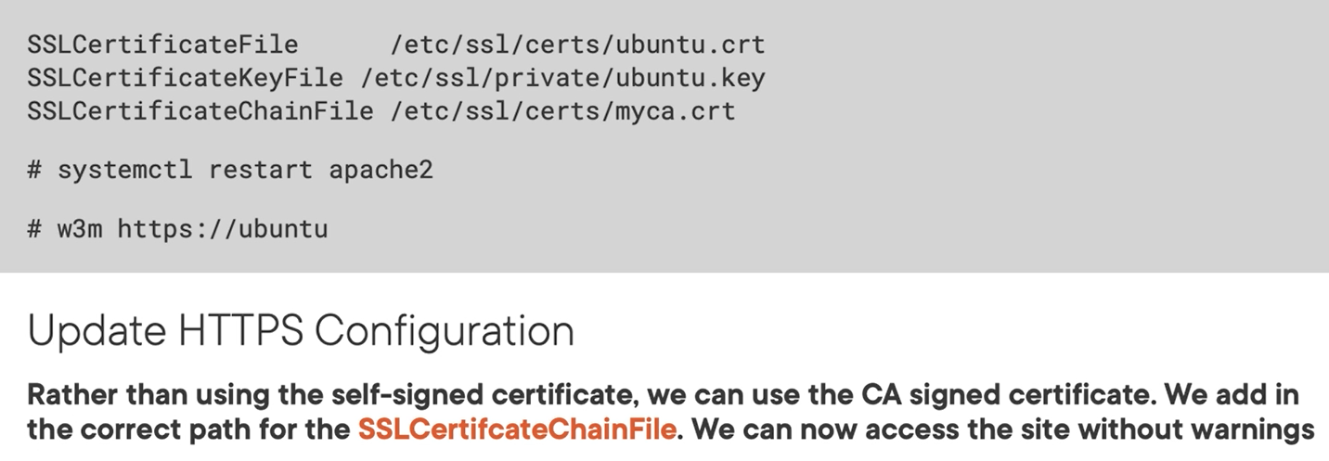

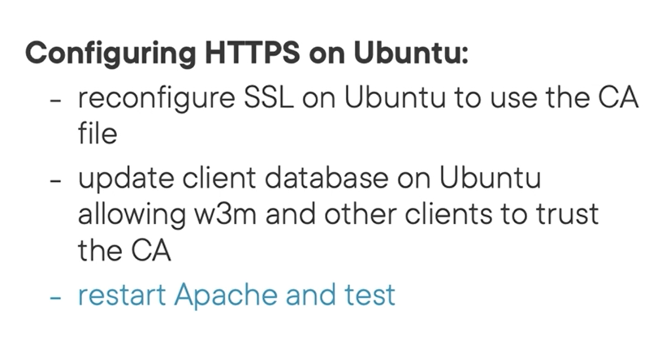

Config website configuraton fiel



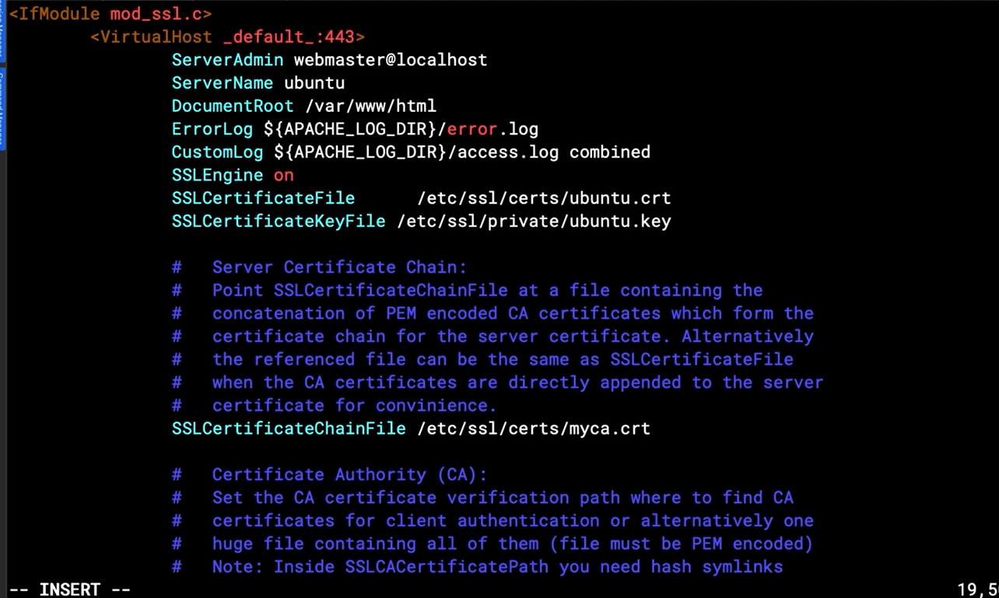

Restart apache server

## Chapter 12.6: Graphical Certificate Management on openSUSE

Certificate management graphical tool on Suse is yast tool

## Chapter 12.7: Summary and What's Next

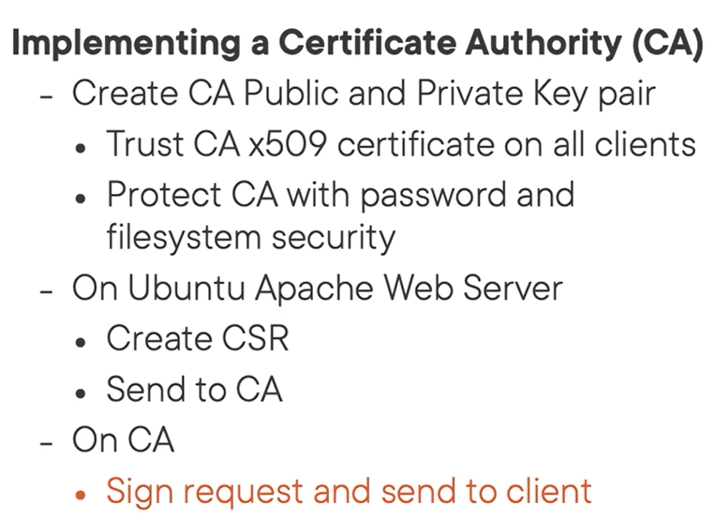

# Chapter 13: Implementing Identity Management with openLDAP and SSSD

## Chapter 13.1: Identity Management in Linux

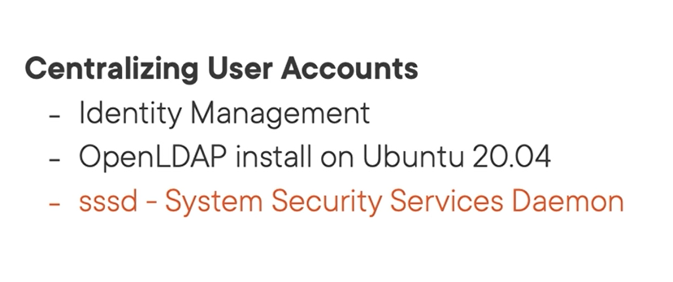

Sssd is client tool use to connect to different active directory such as Openldap

Demo

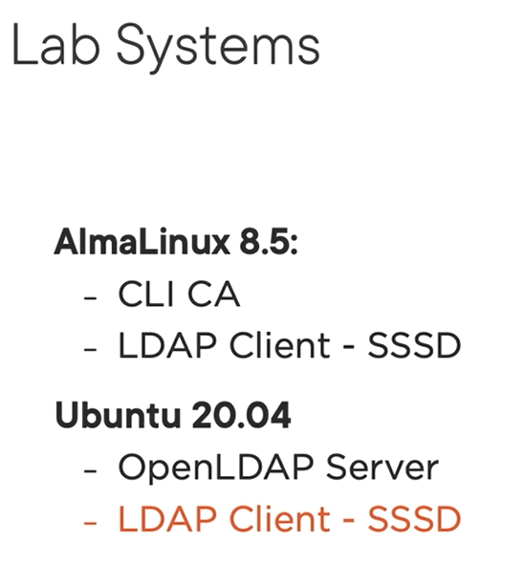

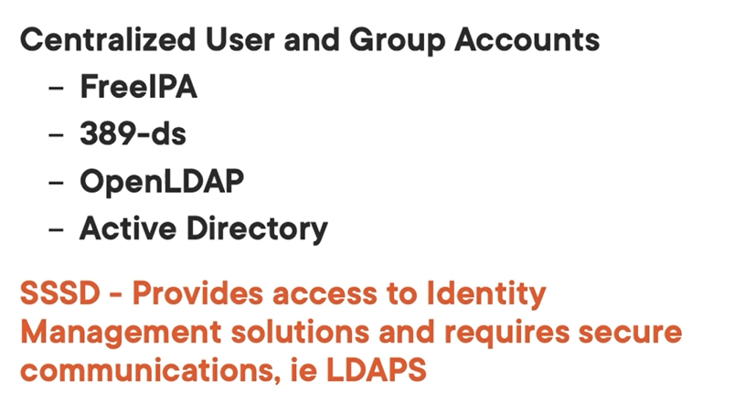

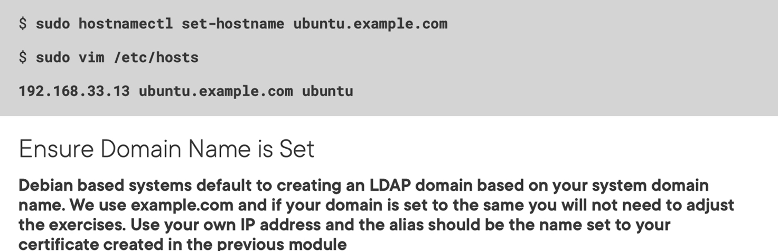

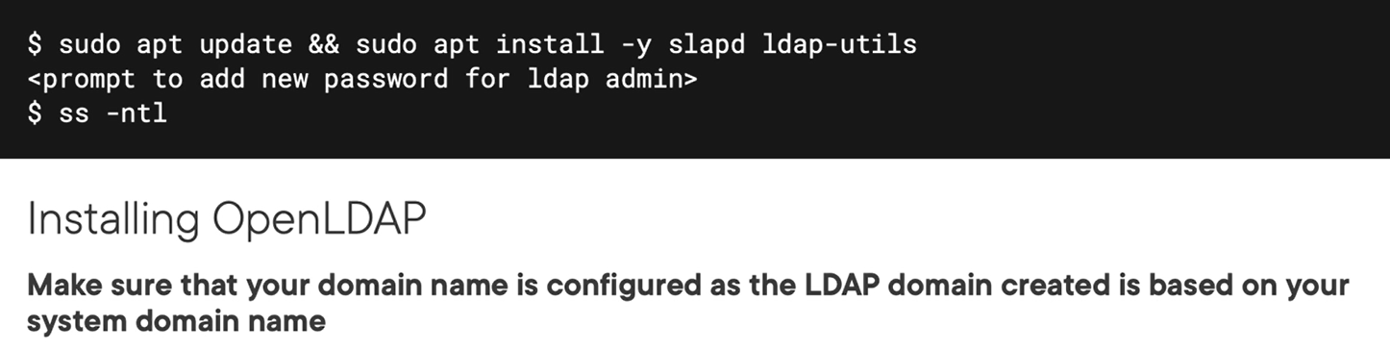

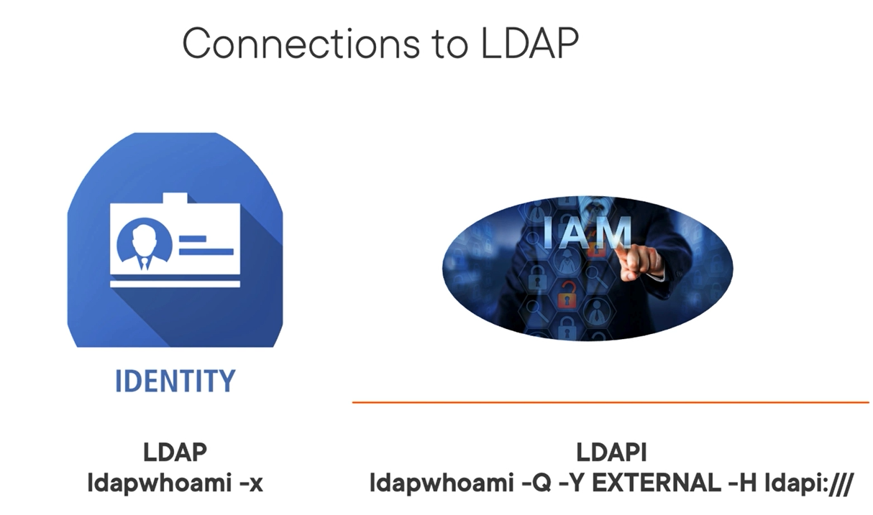

## Chapter 13.2: Installing OpenLDAP on Ubuntu 2004

Openldap running on port 389

Set hostname

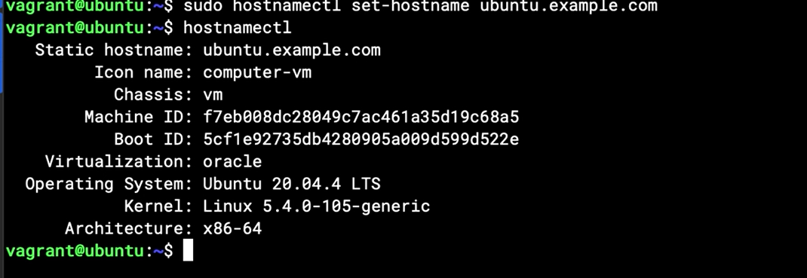



Checking ldap service after install with ldapwhoami

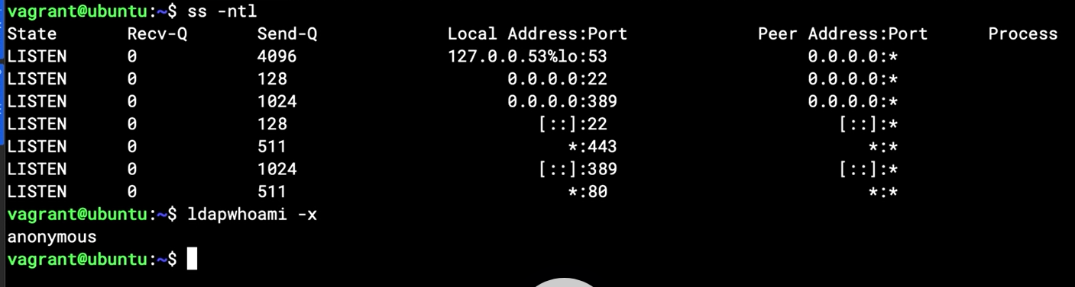

Checking the connection authentication to external system



Note: /// is local system

Checking the TLD on ldap localhost

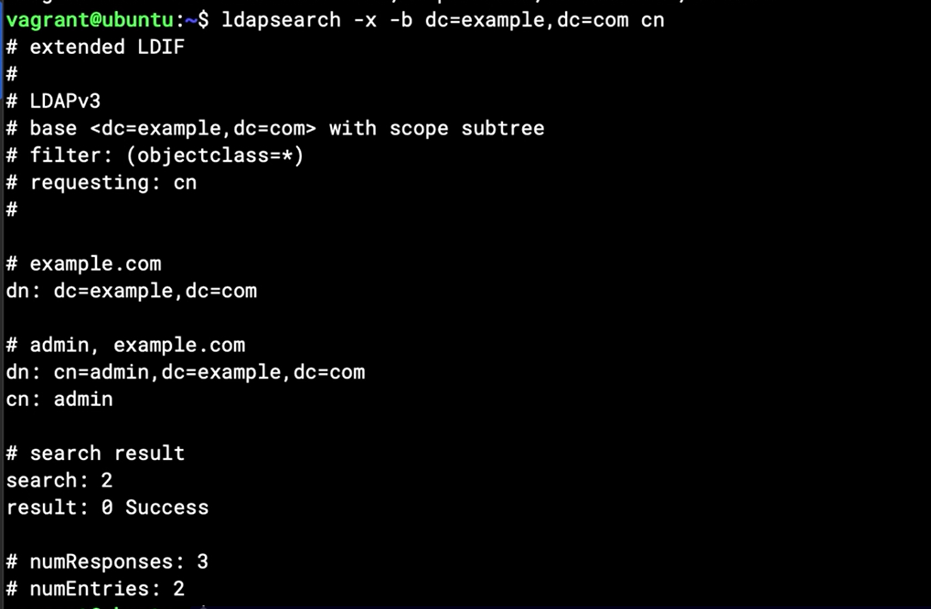

Reconfigure if need

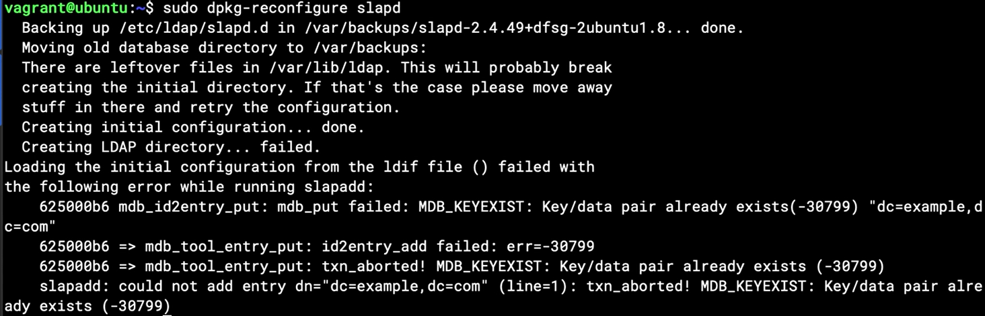

After reconfigure we will check again

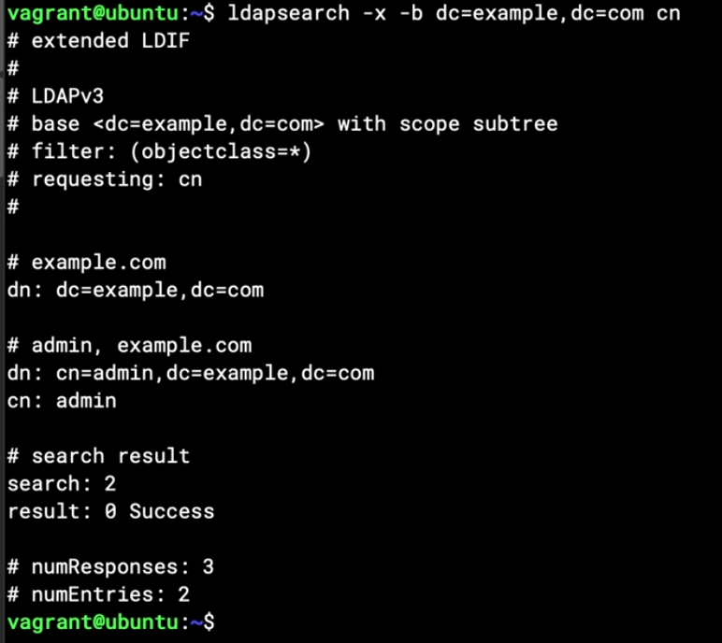

## Chapter 13.3: Adding and Searching Entries in OpenLDAP

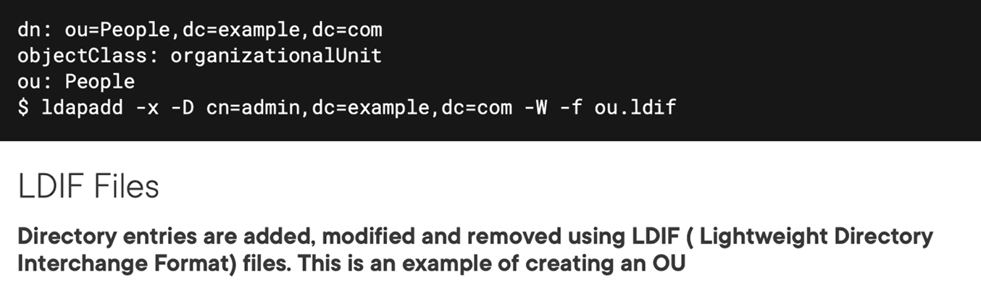

Creating new user on ldap

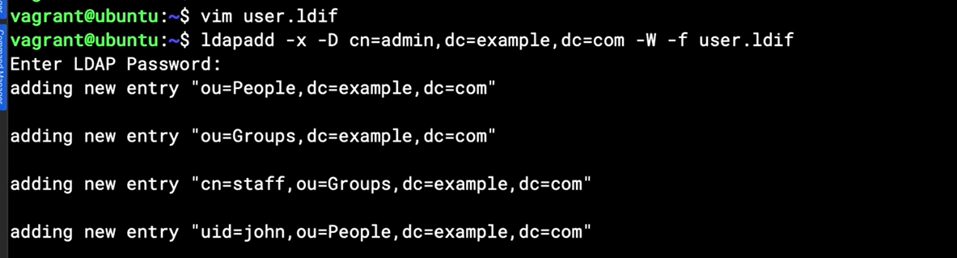

After creating user, just searching the infor, note that using parenthesis for filtering

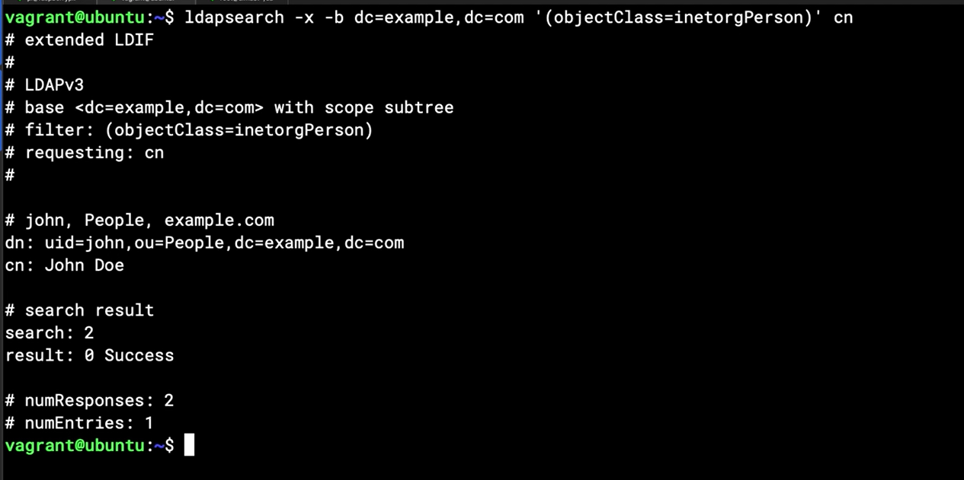

Above screen with cn empty is scan all that cn

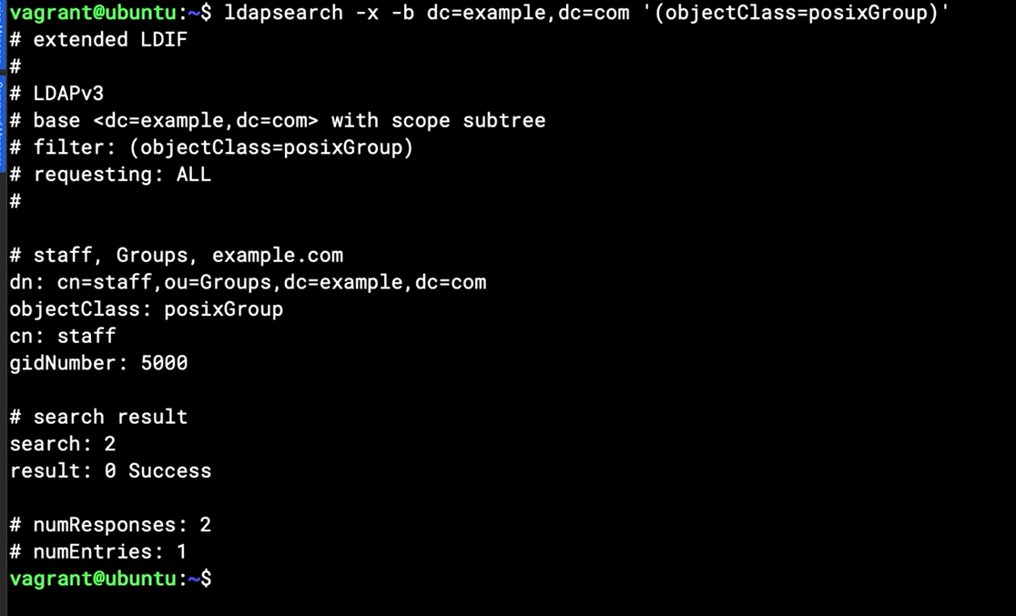

Change password for user on ldap



## Chapter 13.4: Understanding StartTLS

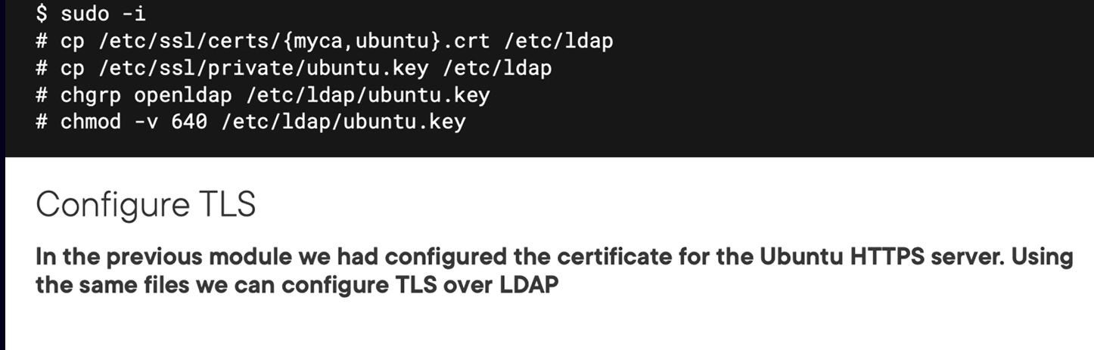

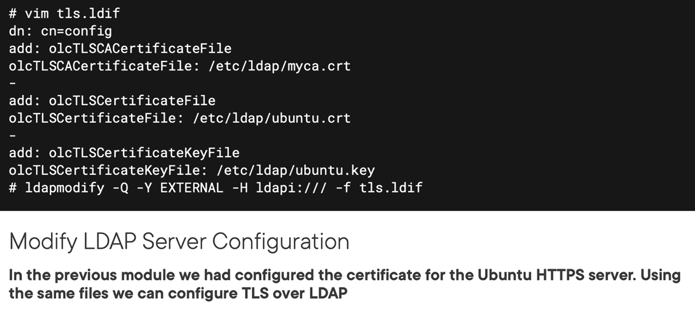

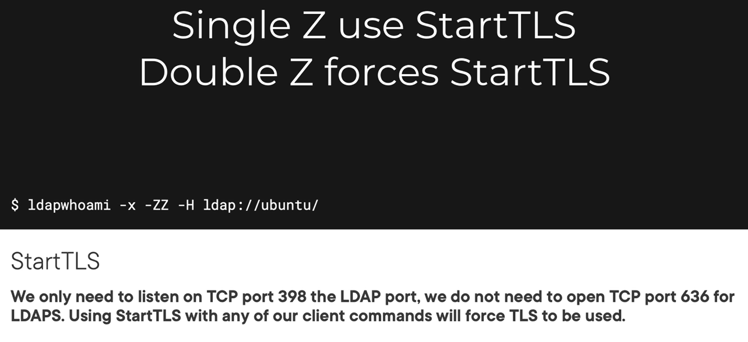

## Chapter 13.5: Configuring StartTLS in OpenLDAP

Demo

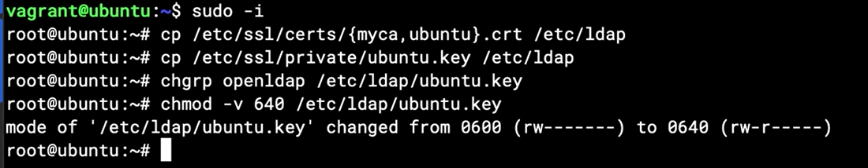

Vi tls.ldif

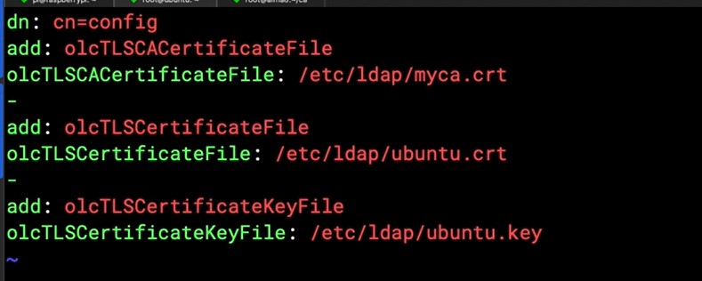

Take effective for above file

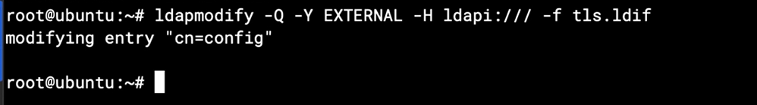

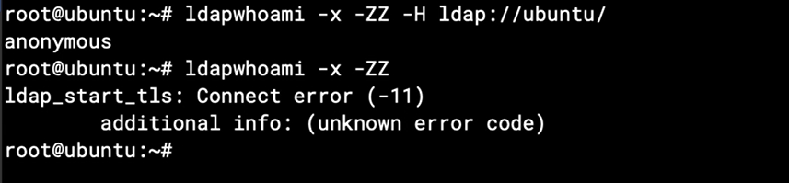

## Chapter 13.6: Configuring SSSD on Ubuntu

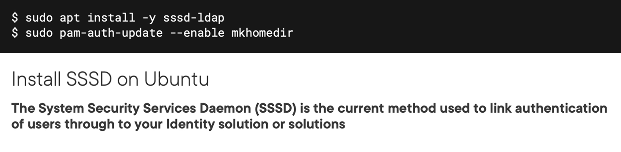

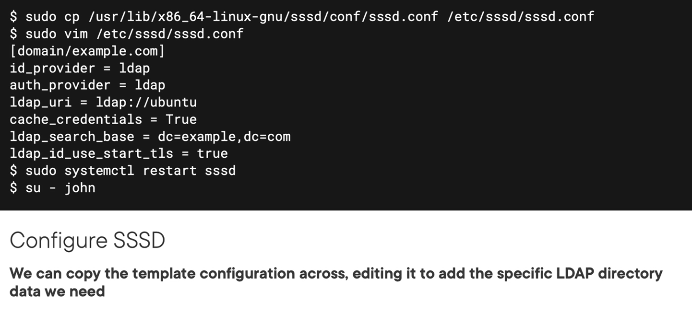

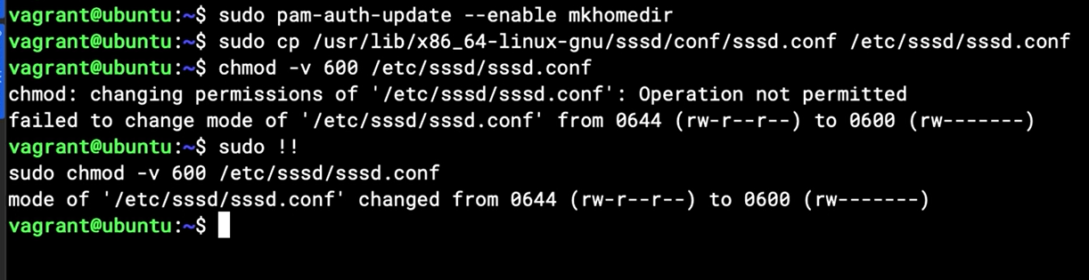

Edit sssd.conf

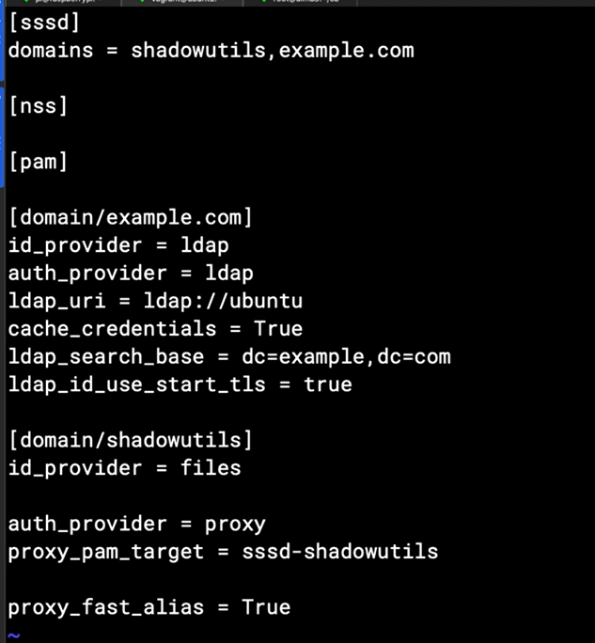

Restart systemctl restart sssd

## Chapter 13.7: Configuring SSSD on AlmaLinux

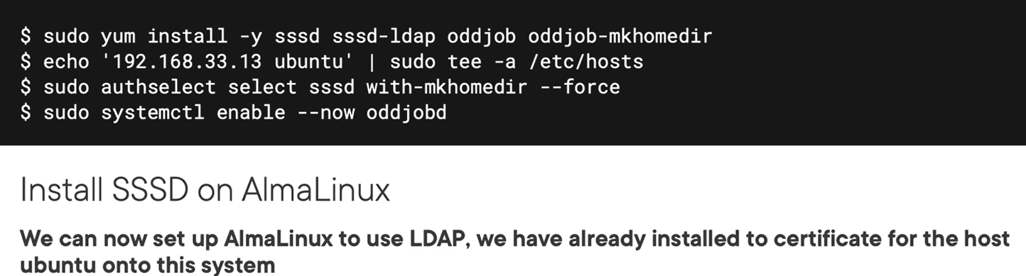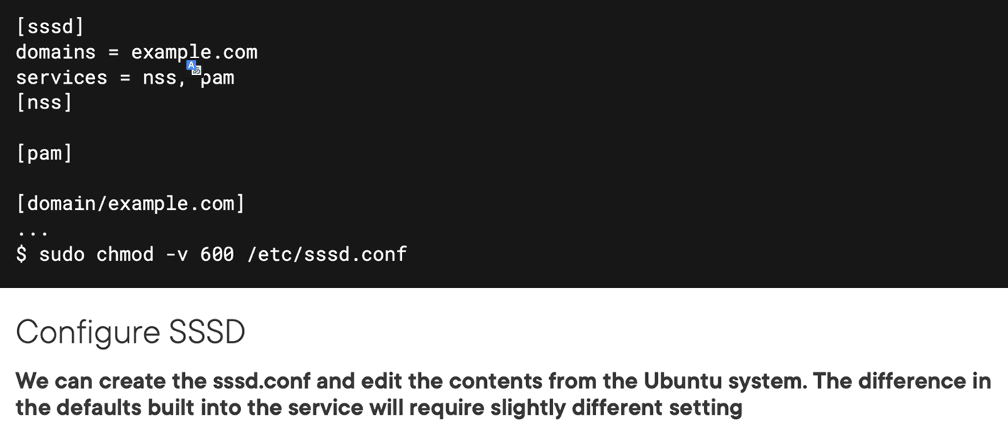

demo



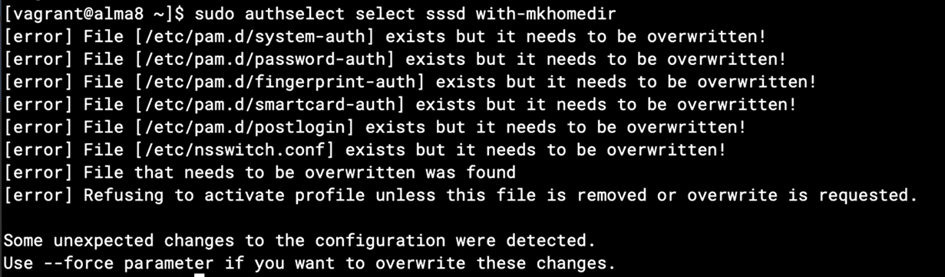

Over writing existing sssd profile

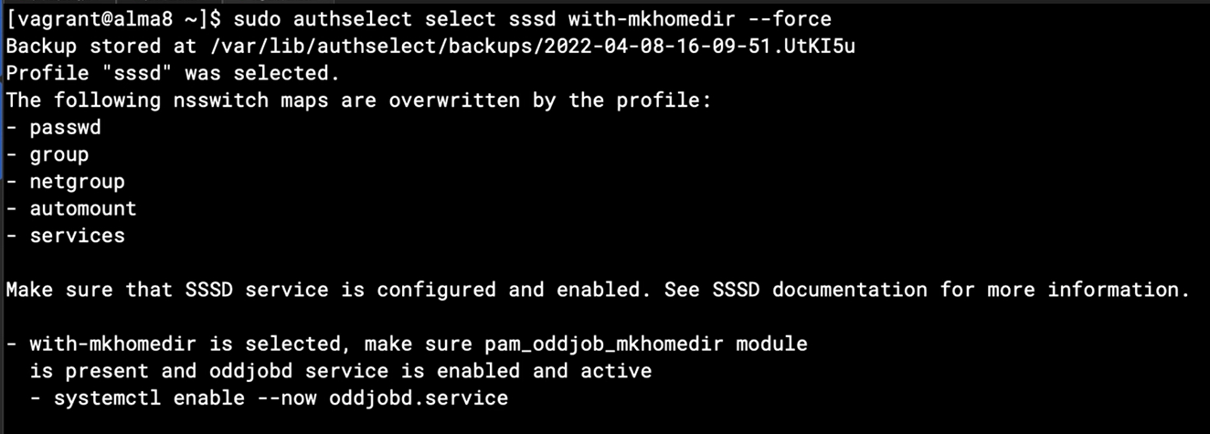



# Chapter 14: Hardening Your Linux Systems

## Chapter 14.1: Security Hardening in Linux

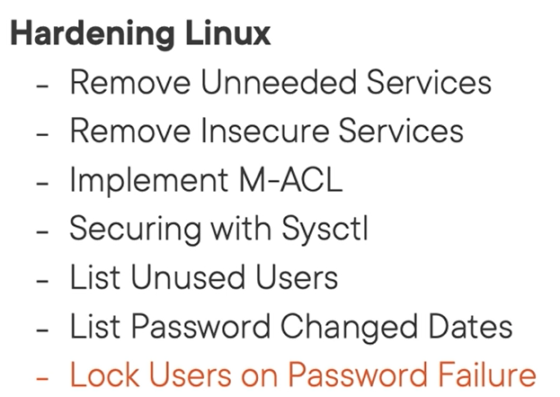

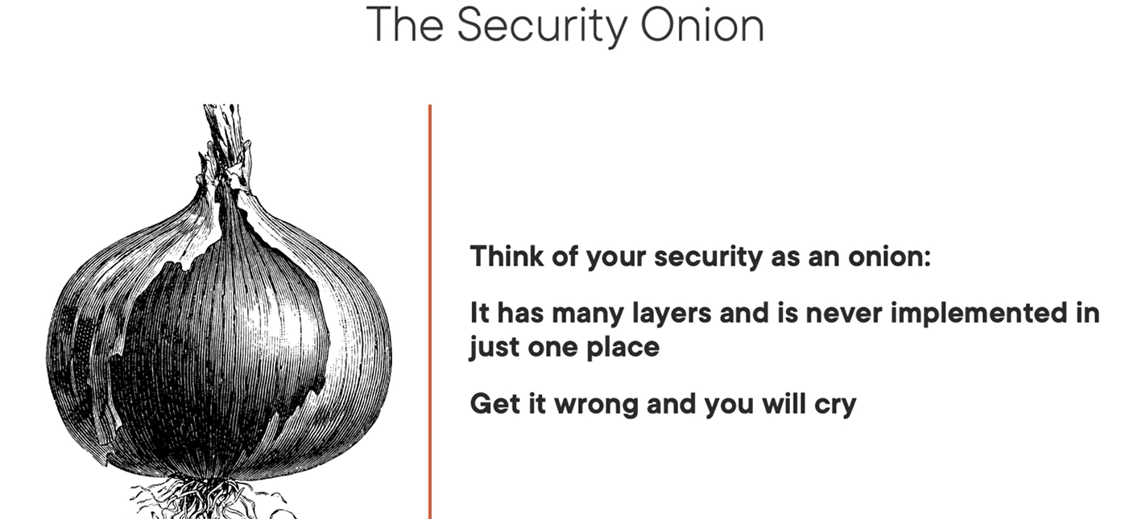

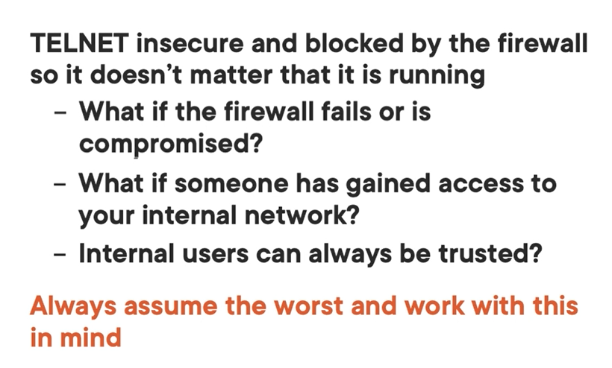

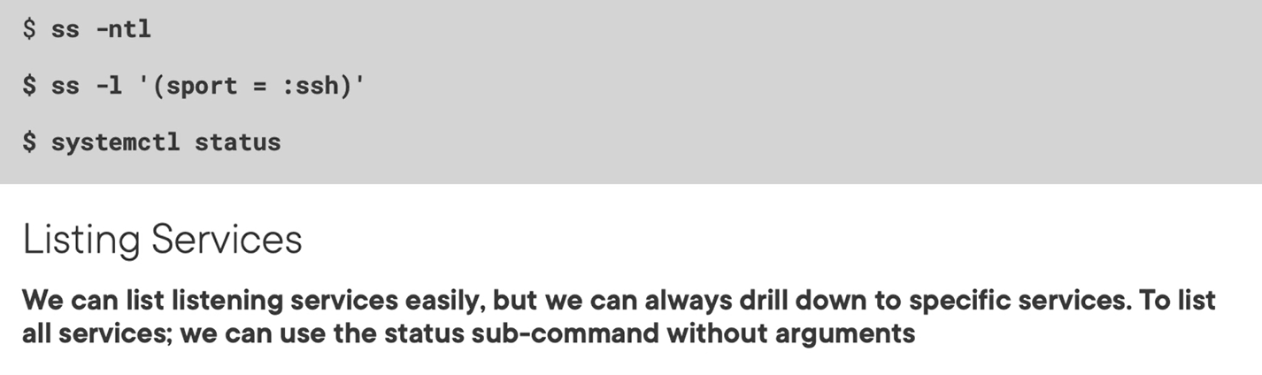

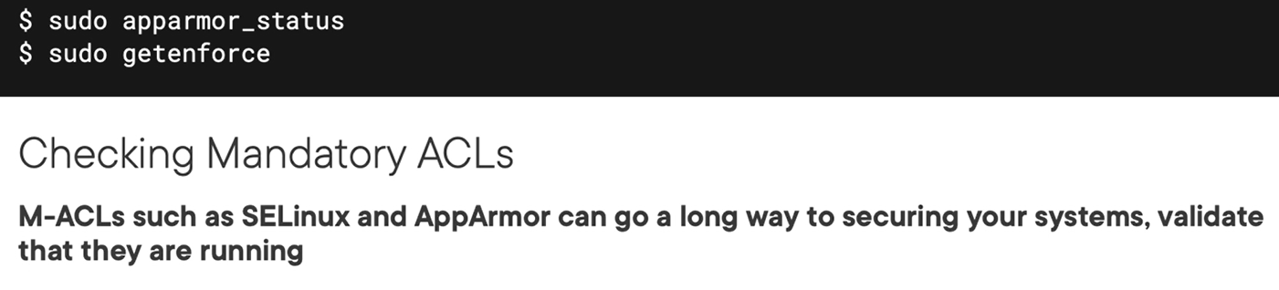

## Chapter 14.2: Checking Listening Ports and Restricting Access to SSSD

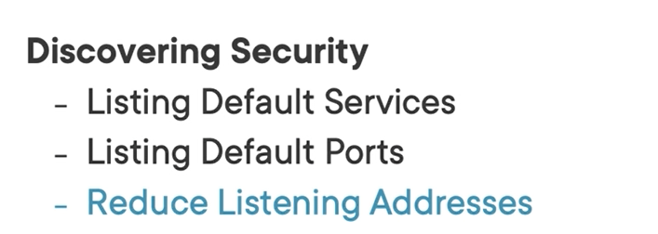

“Systemctl status “

Checking listening port on server

“ss -nlt”

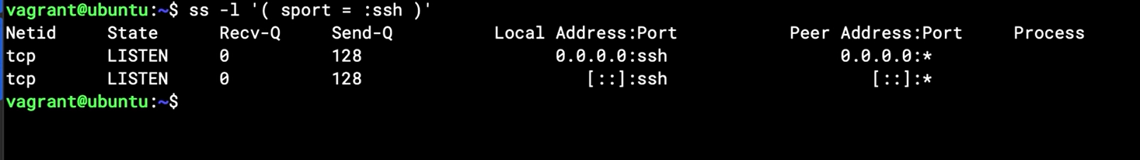

Configure on ssh.conf

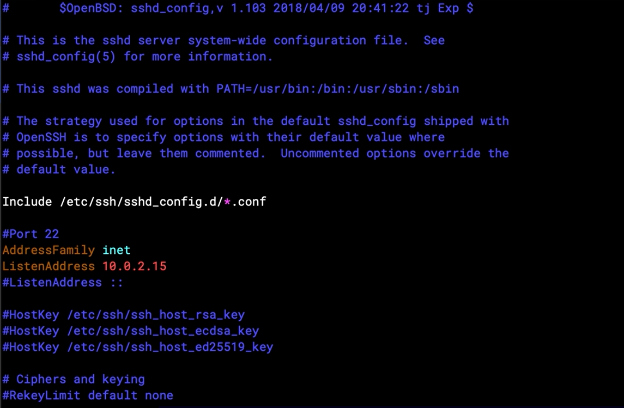

## Chapter 14.3: Removing Extra Services

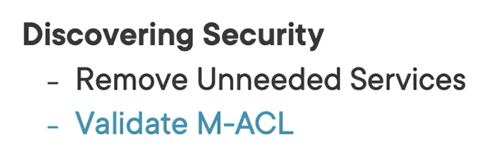

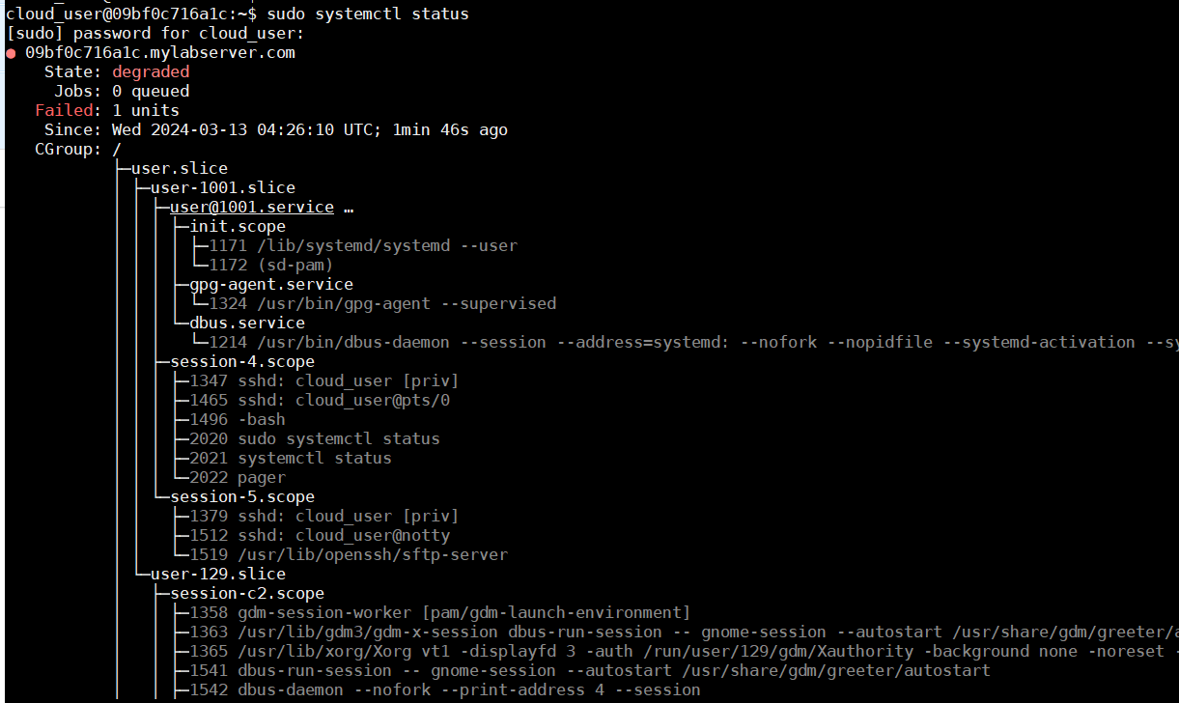

Also find some service related to that daemon and stop

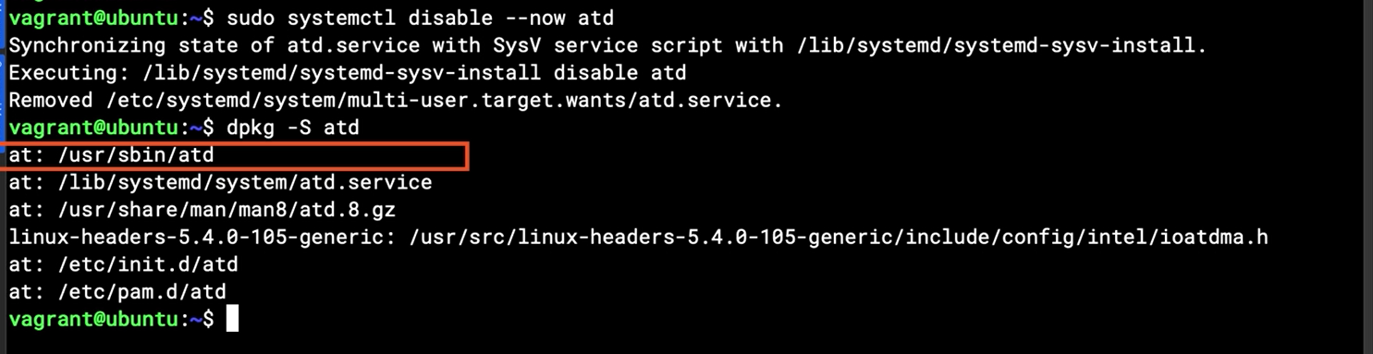

Remove the dependencies package related to that daemon

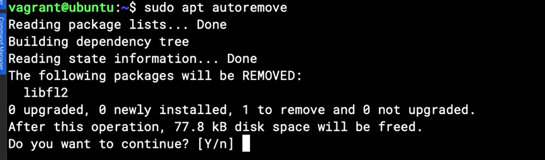

Checking the status of MAC – mandatory access control



## Chapter 14.4: Securing ICMP Access Using Sysctl

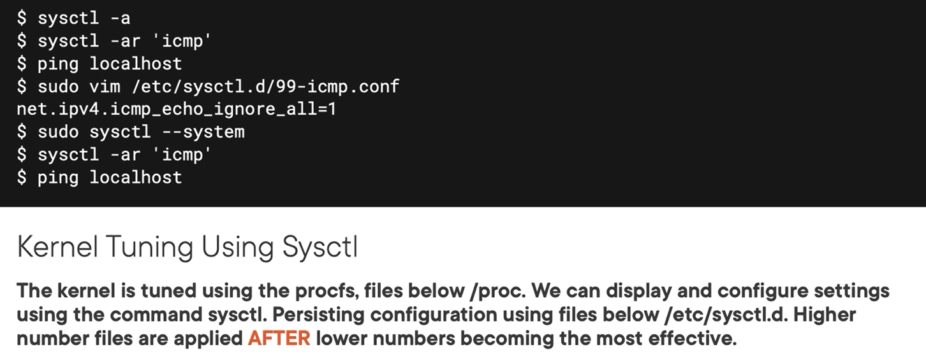

Checking all of the process on procfs are running

Sysctl -a // all of the process

sysctl -ar ‘icmp’ //just icmp process

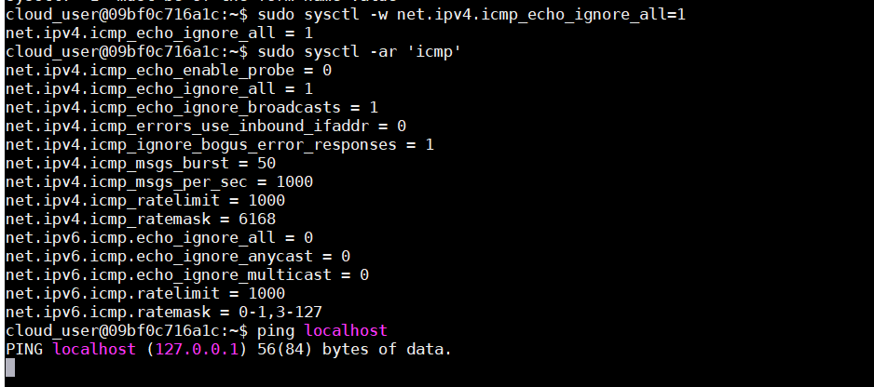

Set persistence that configureation:



## Chapter 14.5: Listing User Details

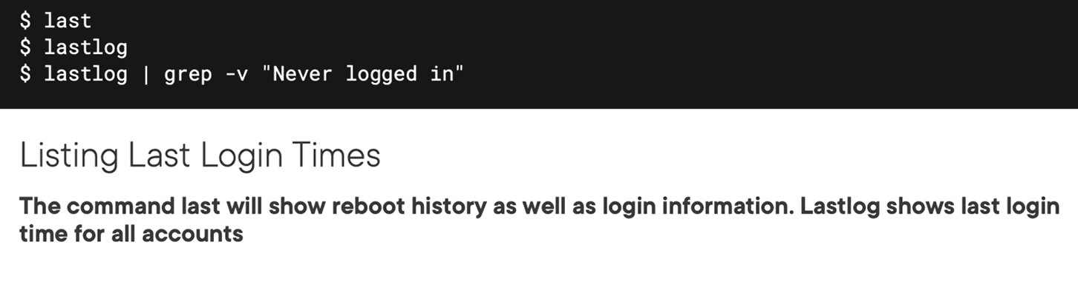

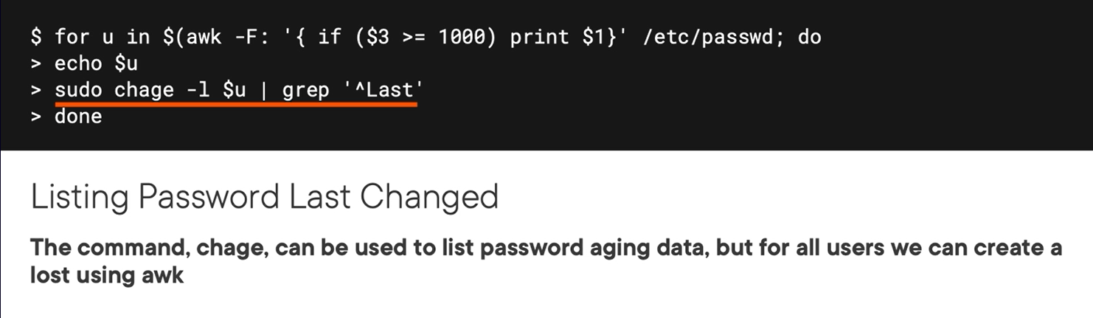

Demo

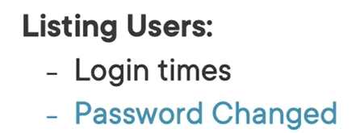

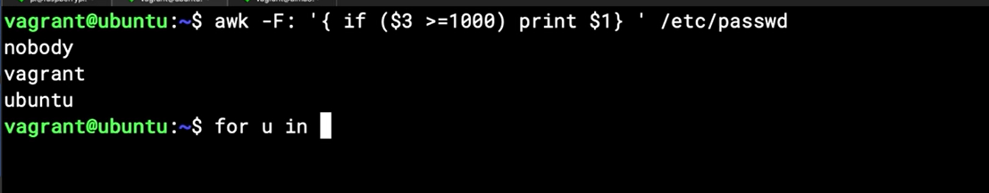

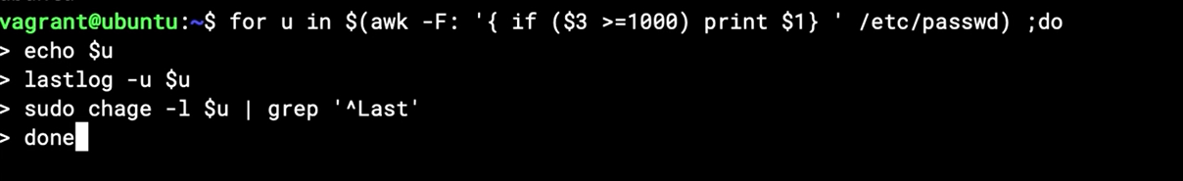

## Chapter 14.6: Locking Failed Login Attempts

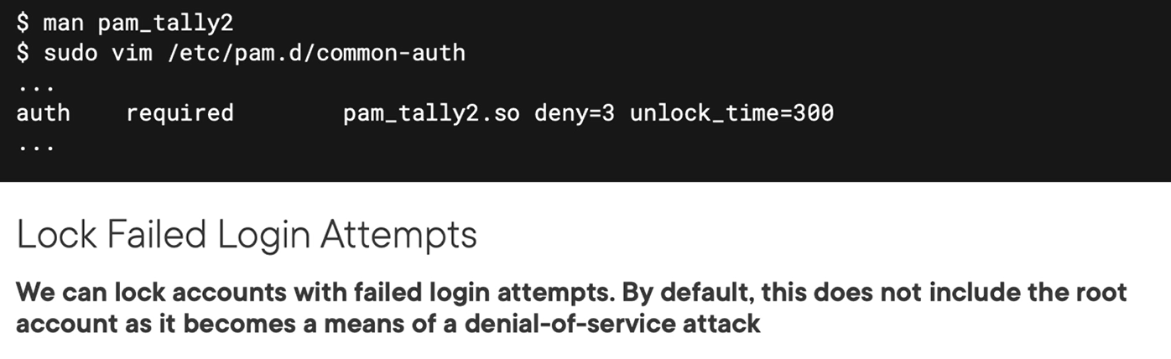

Demo

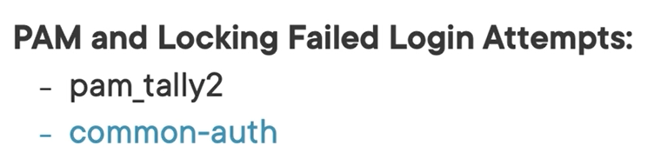

Pam module use for blocking fail login attempt



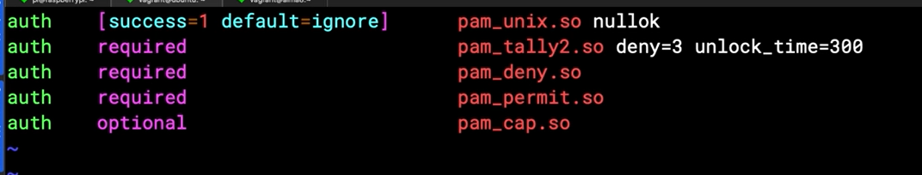

For the syntax of common-auth just see the man page “ man pam_tally2”

## Chapter 14.7: Summary and What's Next

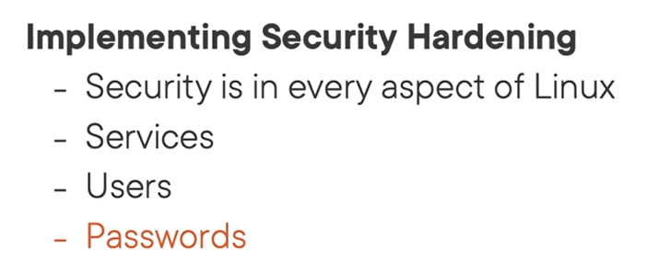

# Chapter 15: Implementing Firewalls with Firewalld

## Chapter 15.1: Introducing Firewalld as a Host Based Firewall

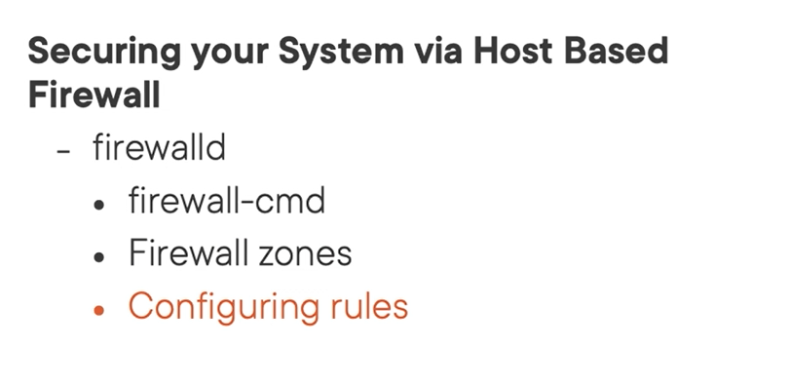

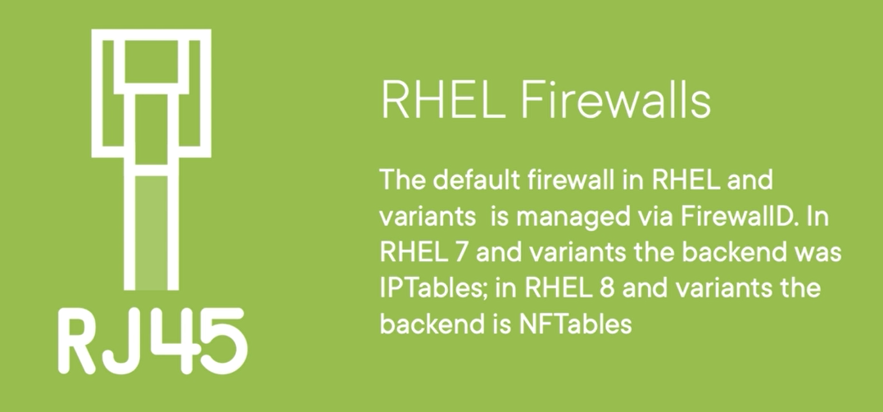

Rhel 7: iptables

Rhel 8: nftables

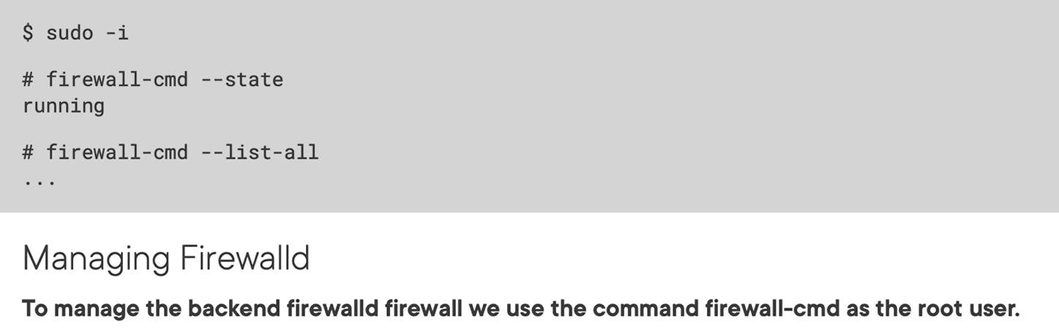

Rules stored in /usr/lib/firewalld, but will be overwrite by /etc/firewalld

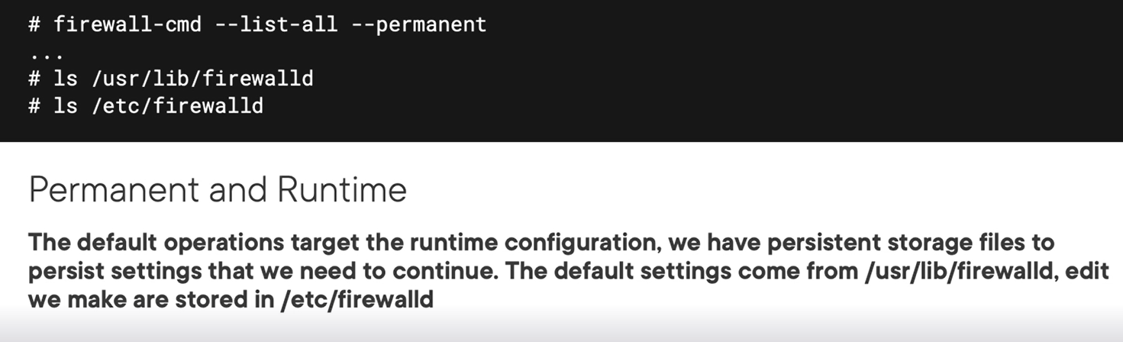

## Chapter 15.2: Basic Firewalld Management

Firewall-cmd --state // checking state

Firewalld-cmd –list-all //list rules

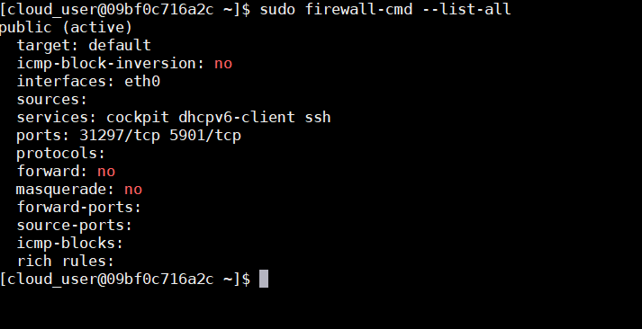

## Chapter 15.3: Adding and Removing Services

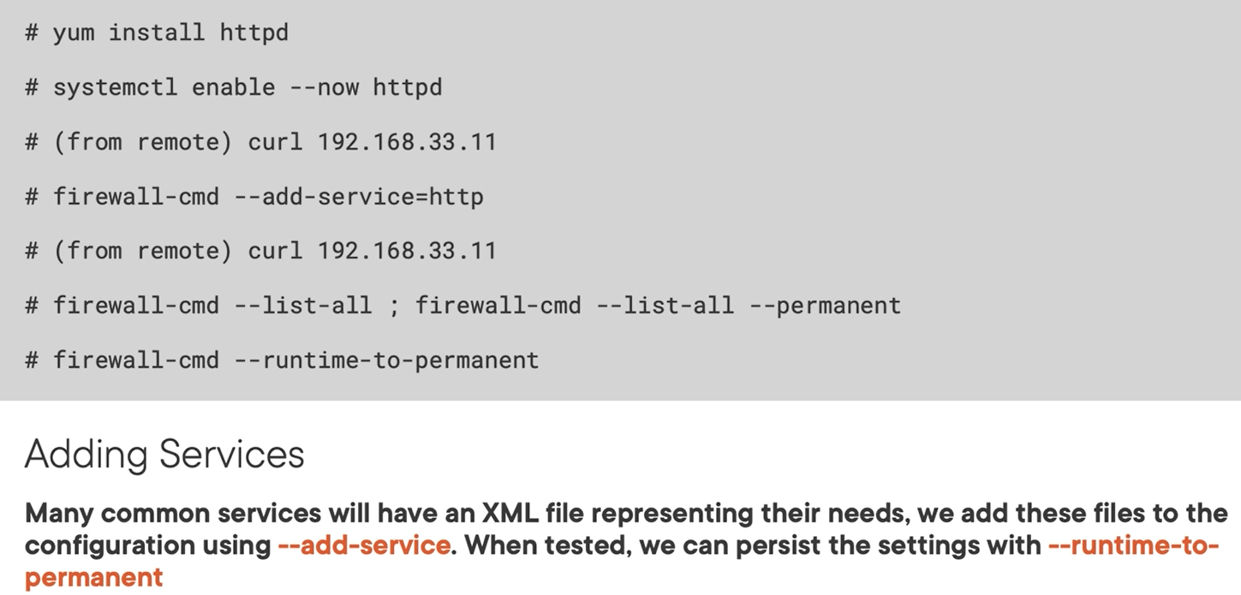

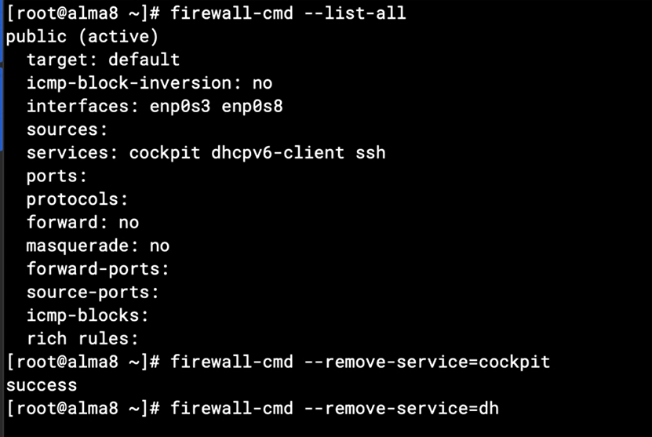

Flush to permanent from runtime

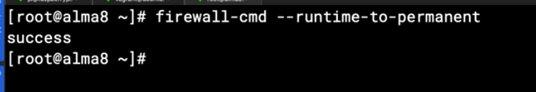

## Chapter 15.4: Adding Source Addresses

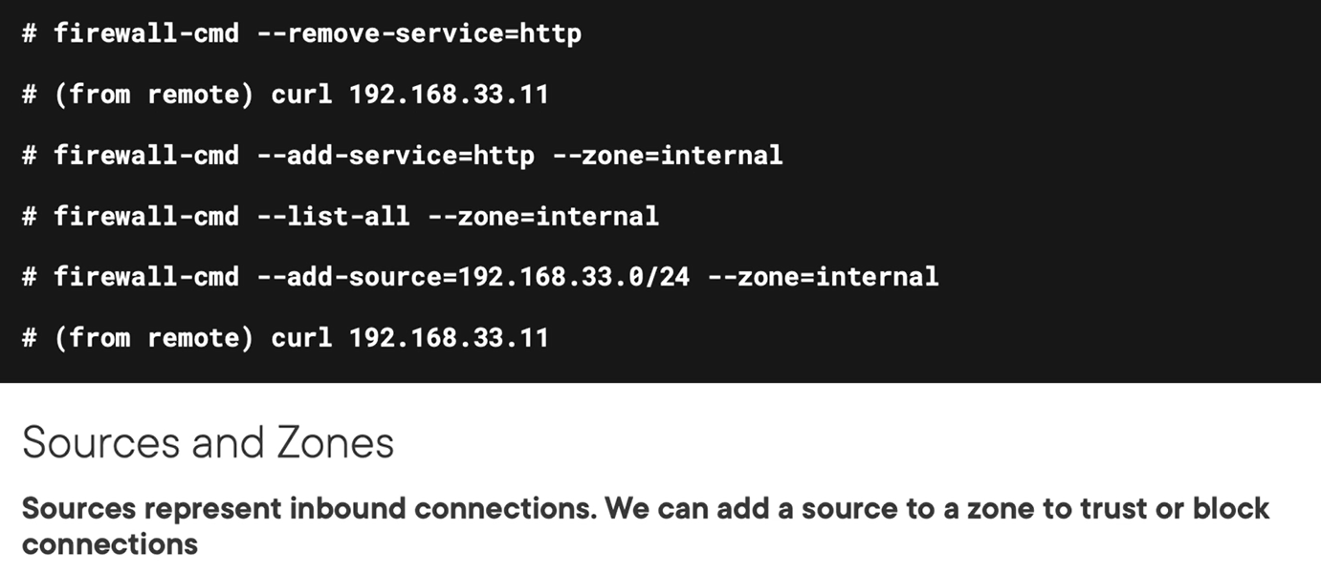

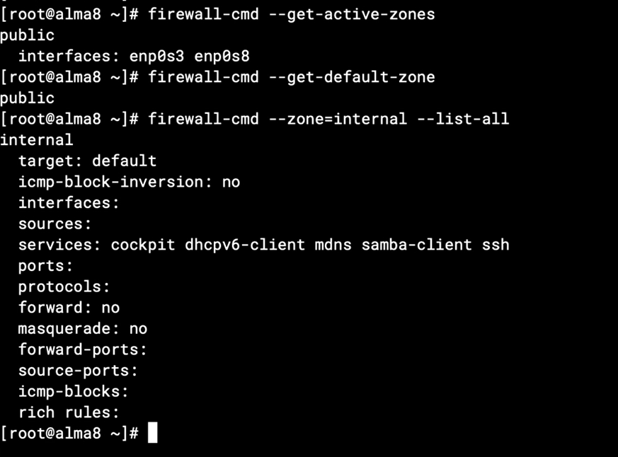

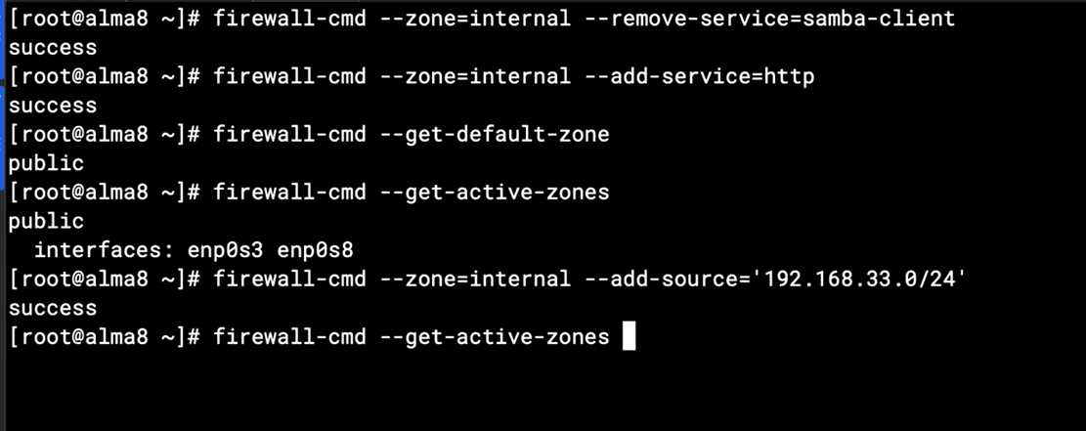

## Chapter 15.5: Editing Service Definitions

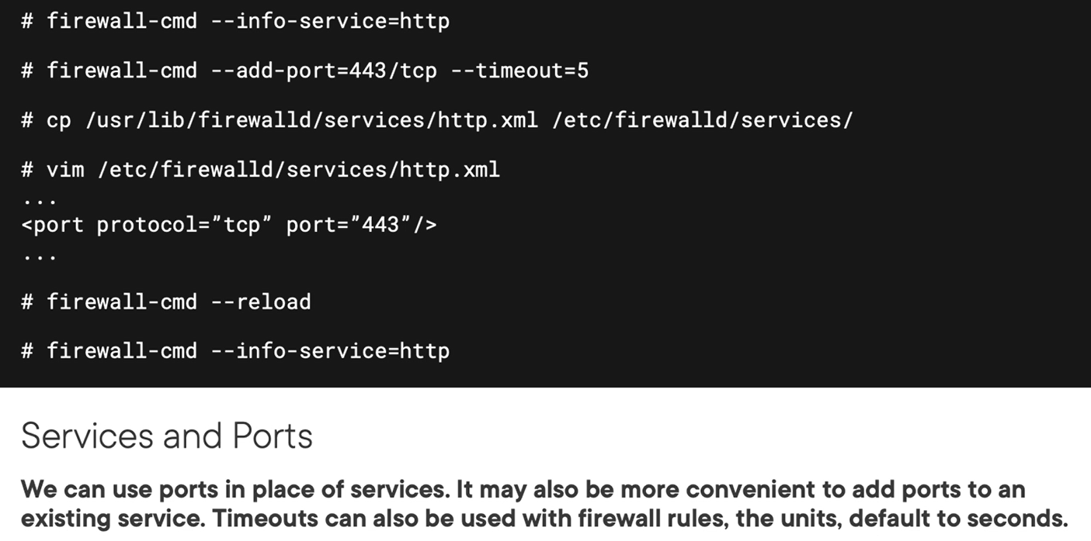

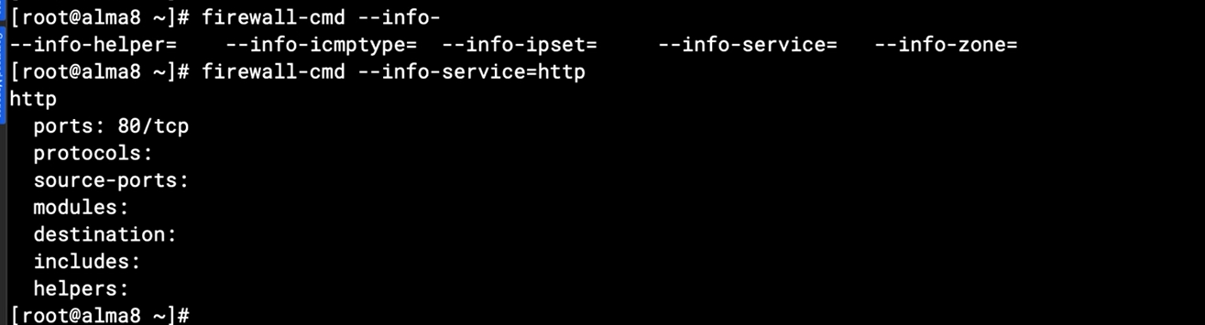

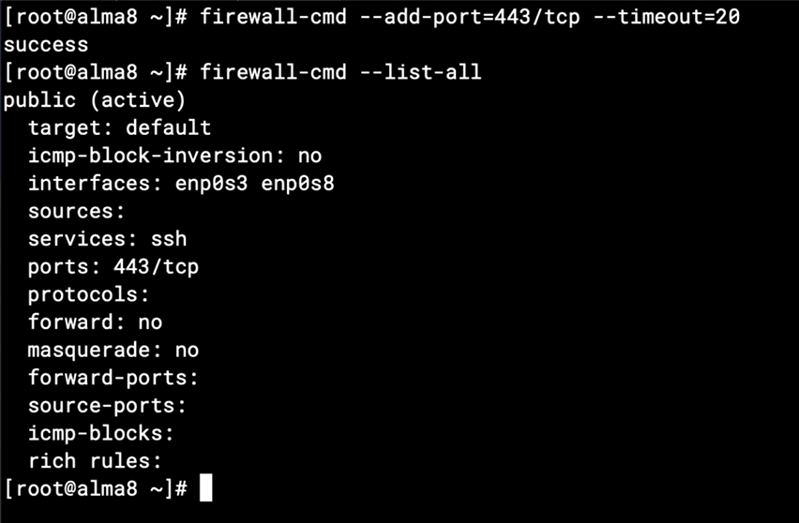

Maybe edit on /etc/firewalld/<service_file>.xml for permanent

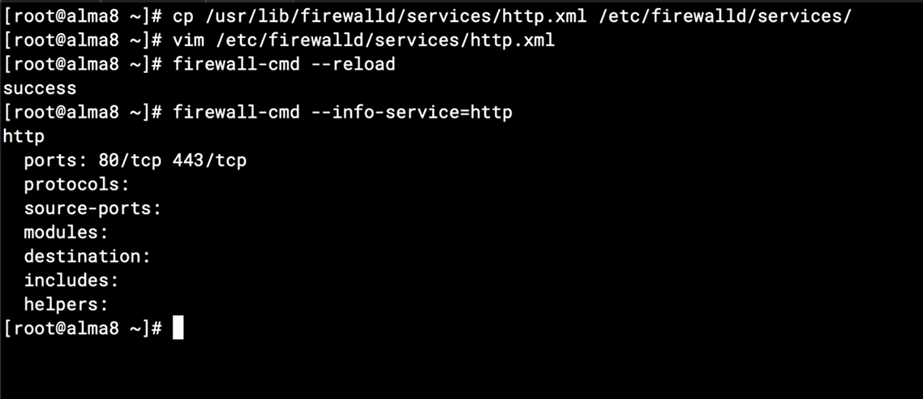

# Chapter 16: Implement Firewalls with UFW

## Chapter 16.1: Welcome to Uncomplicated Firewall

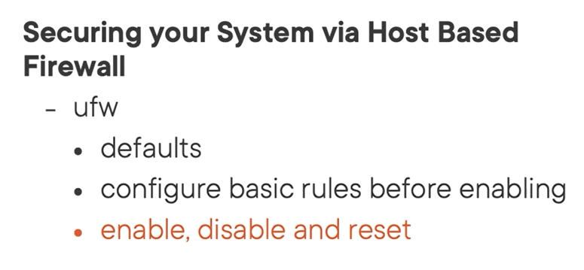

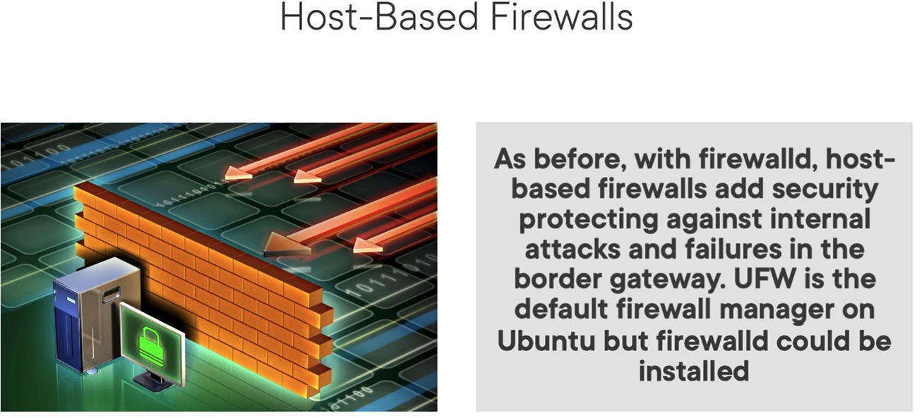

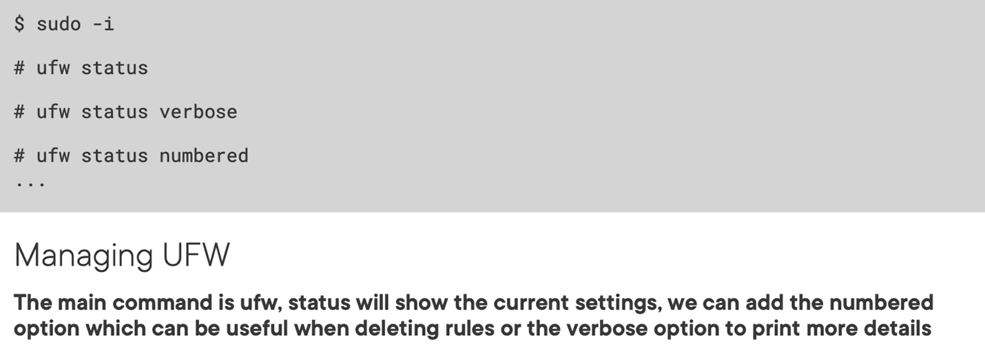

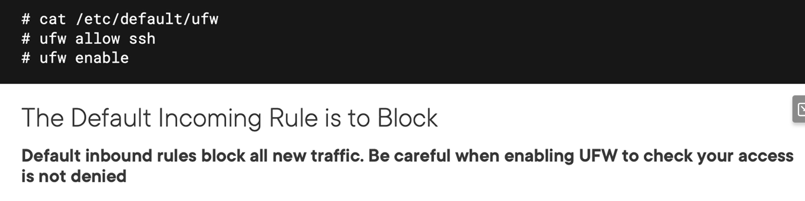

## Chapter 16.2: Adding Basic UFW Rules

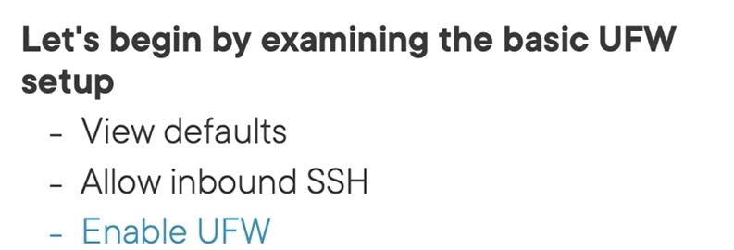

Default rule

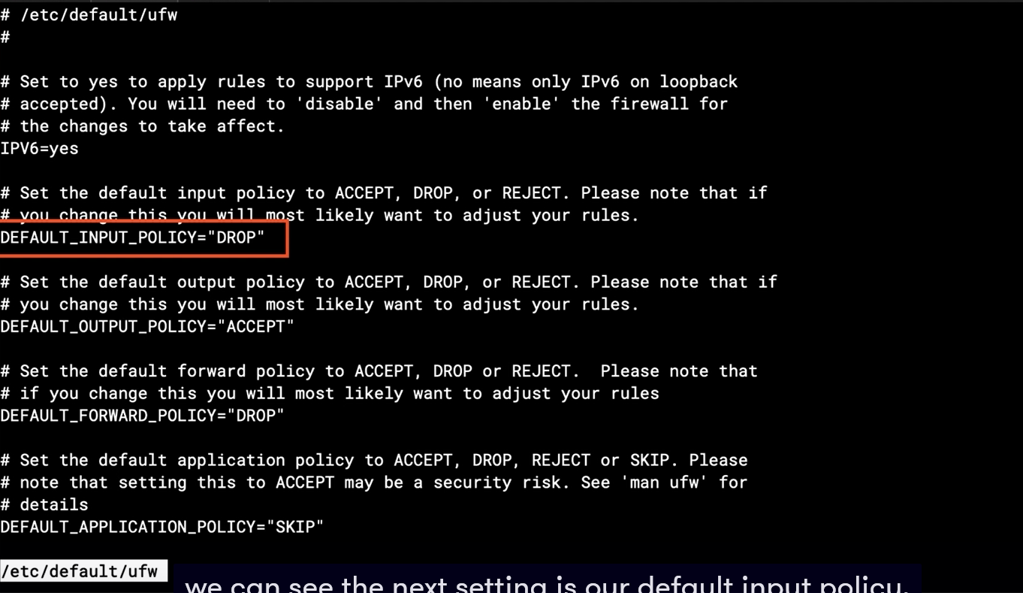

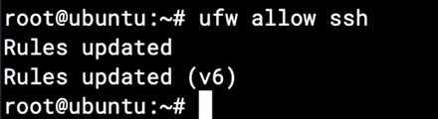

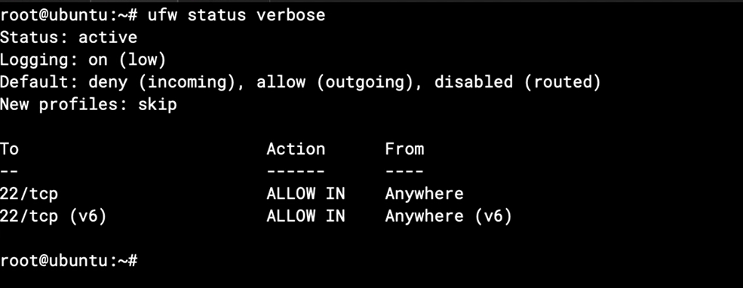

Usefull for delete rule

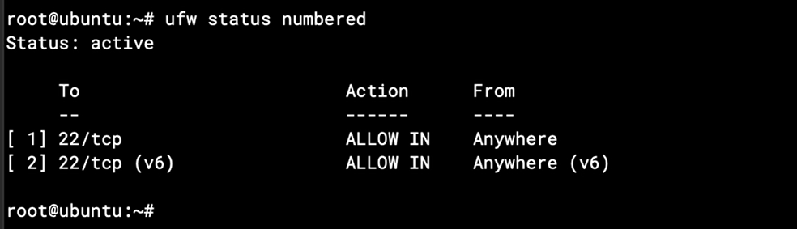

## Chapter 16.3: Tuning SSH Allow Rules

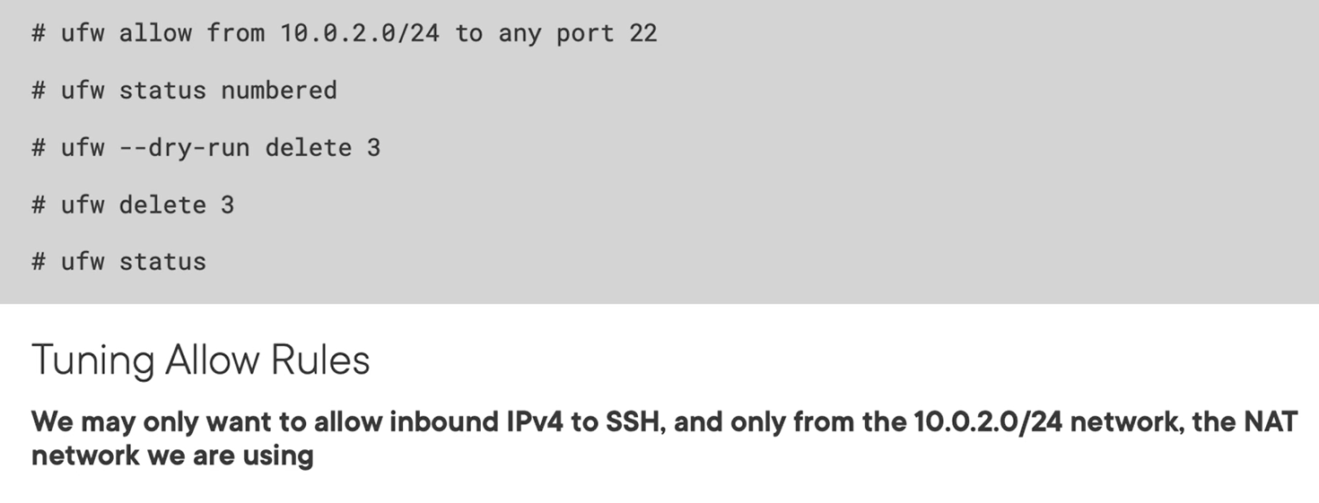

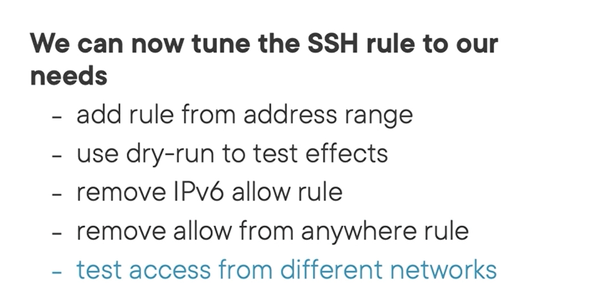

## Chapter 16.4: Allowing HTTP Access

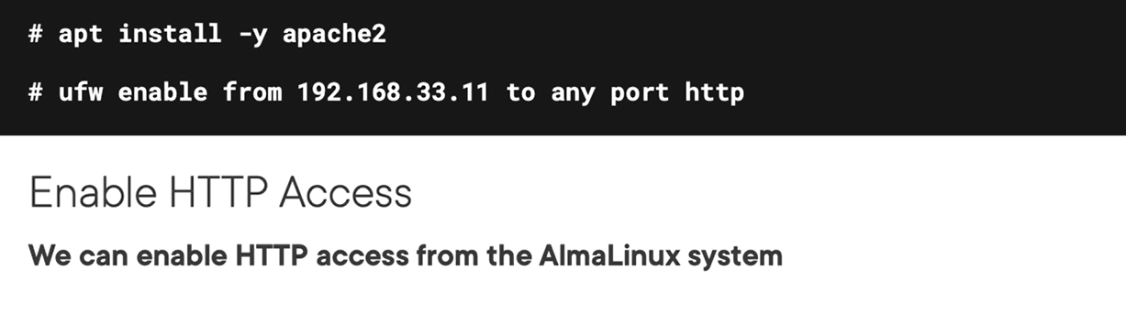

## Chapter 16.5: Reporting on Rules

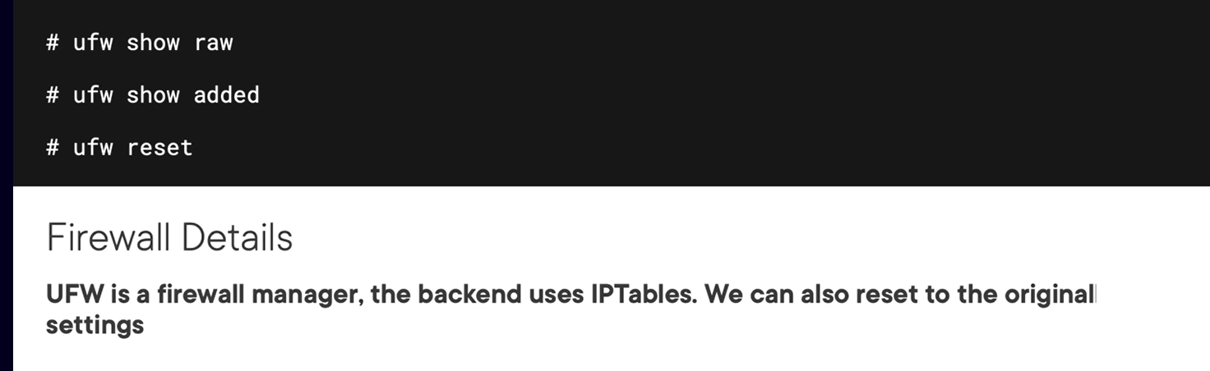

Backend of ufw firewall is iptables

Show rules added recently

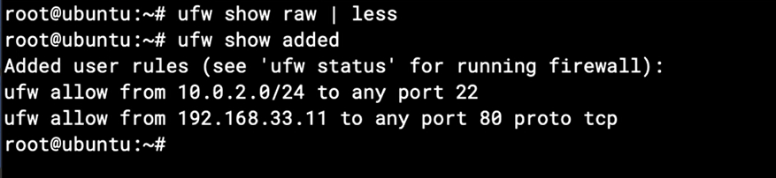

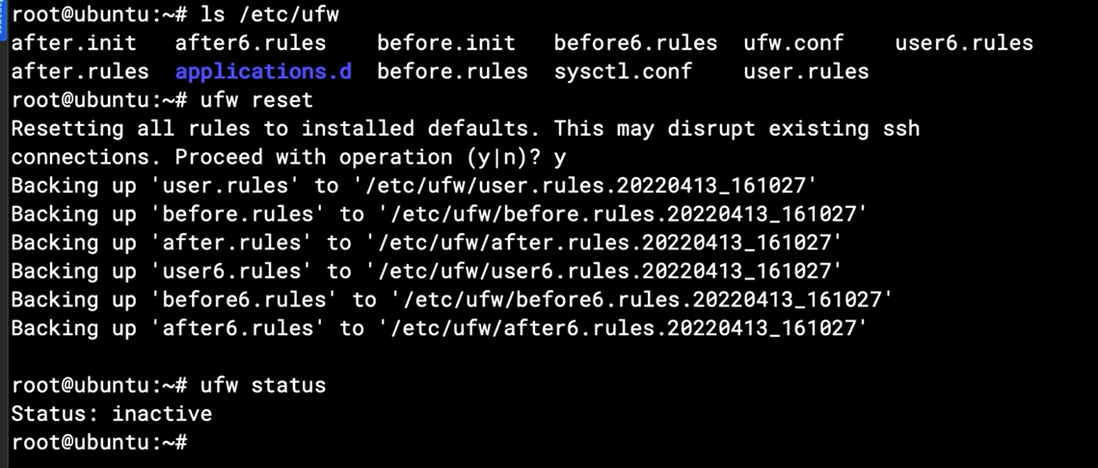

Note: Needed review chapter 10.2-10.7

# Resource

<https://learn.acloud.guru/course/d6741caa-b1d2-4ed1-9d77-da5bfe6888a3/dashboard>